1. **God will triumph (20:11)**
2. **From a Garden to a City (Ch. 21)**
   * **God is preparing a people for Himself who will live together with Him for all eternity.**
   * **OT parallels to the heavenly city in Rev. 21**

**Isa 65:17, Ezekiel 37:27, Leviticus 26:11-12, Isaiah 43:18-19, Isaiah 55:1, 2 Samuel 7:14, Ezekiel 40:1-2, Ezekiel 48:31-34, Isaiah 54:12, Isaiah 54:11, Isaiah 60:19, Isaiah 60:3, Isaiah 60:5, Isaiah 52:1, Daniel 12:1, Ezekiel 47:1, Zech. 14:8, Ezekiel 47:12, Zech. 14:11, Psalm 17:15, Psalm 118:27**

* + **The hope of God’s people**

1. **Conclusion**

*Questions or comments, please contact:*

***Core Seminars—New Testament***

**Class 22: Revelation:**

**The Return of the King**

**The Return of the King: Revelation**

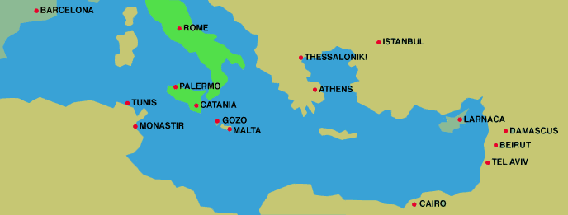

1. **Background**
   * **Author & Place**

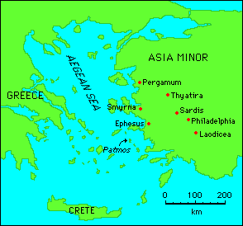

* + **Persecution**
  + **Purpose**

1. **Genre**
   * **Epistle**
   * **Apocalyptic**
2. **Outline**

|  |  |
| --- | --- |
| **The Church and the World** | |
| Chapters 1-3 | The Church in the World (Seven Lampstands) |
| Chapters 4-7 | The Church suffering trial and persecution (Seven Seals) |
| Chapters 8-11 | The Church protected and victorious (Seven Trumpets) |
| **Christ and the Dragon** | |
| Chapters 12-14 | Christ opposed by the Dragon & his helpers (Seven Visions) |
| Chapters 15-16 | Final judgment upon the wicked (Seven Bowls) |
| Chapters 17-19 | The Fall of Babylon and Beasts |
| Chapters 20-22 | The Dragon’s Doom and Christ’s Victory |

1. **Revelation as a Letter (Ch. 1-3)**
   * **Ephesus**
   * **Laodicea**
2. **The Throne (4:2-11)**
3. **The Lion, the Lamb on the Throne (Ch. 4-5)**
   * **Hearing and Seeing**
   * **Only the Lamb…**
4. **God’s Judgment (Ch. 6-16)**
   * **The Completeness of God’s Judgment**
   * **The Finality of God’s Judgment**
   * **The Horror of God’s Judgment**
   * **The Righteousness of God’s Judgment**