Roman Persecutions of Early Christians

Dates Emperor Famous Martyrs, Other Comments

AD 64 Nero Paul, Peter

c.90-96 Domitian (81-96) Clement of Rome, John (exiled to Patmos)

98-117 Trajan Ignatius, Symeon, Zozimus, Rufus
161-180 Marcus Aurelius Polycarp; Justin Martyr

202-211 Septimus Severus Irenaeus

235-236 Maximus the Thracian

249-251 Decius (249-251) libelli issued to those who sacrificed to
Roman gods

257-260 Valerian (253-260) Origen, Cyprian

303-311 Diocletian (284-305) perhaps the most vicious of the
Roman persecutions

Recommended for Further Reading:

Barnett, Paul. Jesus and the Logic of History. Nottingham, England : Downers Grove, IL: Apollos ; InterVarsity Press, 1997.
Bettenson, Henry Scowcroft, and Chris Maunder, eds. Documents of the Christian Church. 3rd ed., new ed. / edited by Chris Maunder. Oxford ; New York: Oxford University Press, 1999.
Chadwick, Henry. The Early Church. Rev. ed. Penguin History of the Church 1. London: Penguin, 1993.
Davidson, Ivor J. The Birth of the Church: From Jesus to Constantine, A.D. 30-312. Baker History of the Church, v. 1. Grand Rapids, Mich: Baker Books, 2004.
Houghton, S. M. Sketches from Church History. Edinburgh ; Carlisle, Pa: Banner of Truth Trust, 1980.
Wilken, Robert Louis. The First Thousand Years: A Global History of Christianity. New Haven: Yale University Press, 2012.

Teachers email: justin.sok@gmail.com; eric.beach@capbap.org; davidwilezol@gmail.com
Capitol Hill Baptist Church Church History – Class 1 CORE SEMINARS

Beginnings to AD 313: Expansion and Persecution

“…And there arose on that day a great persecution against the church in Jerusalem, and they were all scattered throughout the regions of Judea and Samaria,… Now those who were scattered went about preaching the word.” Acts 8: 1, 4

“Let us, therefore, hold steadfastly and unceasingly to our hope and the guarantee of our righteousness, who is Christ Jesus, who bore our sins in his own body upon the tree, who committed no sin, and no deceit was found in his mouth; instead, for our sakes he endured all things, in order that we might live in him. Let us, therefore, become imitators of his patient endurance, and if we should suffer for the sake of his name, let us glorify him. For this is the example he set for us in his own person, and this is what we have believed.” (Polycarp, Letter to the Philippians)

- What is church history and why is it important?

    - God commands us to be students of the past

    - We are 'relatives' of those who came before us

    - “There is nothing new under the sun”

    - We should be humbled and encouraged

- THE POLITICAL, CULTURAL, AND RELIGIOUS CONTEXT OF EARLY CHRISTIANITY

- Judaism

- The Roman Empire

- Greek philosophy and religions

- THE EXPANSION OF CHRISTIANITY

- Roman empire sets the stage

- Why did people become Christians?

- ROMAN PERSECUTIONS

- Reasons for Persecution

- Apostolic Martyrdom

-Paul: imprisoned under Nero, then beheaded in Rome
-James the brother of John: was beheaded by Herod (Acts 12:2)
-Thomas: shot with an arrow in India
-Peter: imprisoned under Nero, then crucified upside down in Rome
-Simon the Zealot: crucified in Africa
-Mark: founded the church in Egypt and was burned alive in Alexandria
-Bartholomew: beaten, crucified, and beheaded in Armenia
-Andrew: crucified in Ethiopia
-Matthew: killed with a spear in Ethiopia
-Philip: crucified and stoned in Greece
-James the brother of Jesus: ordered stoned by the Sanhedrin in Jerusalem
-John the apostle: exiled to Patmos, died of natural causes

- Major Persecutions:

- The Church survives persecution…Can it survive
acceptance?

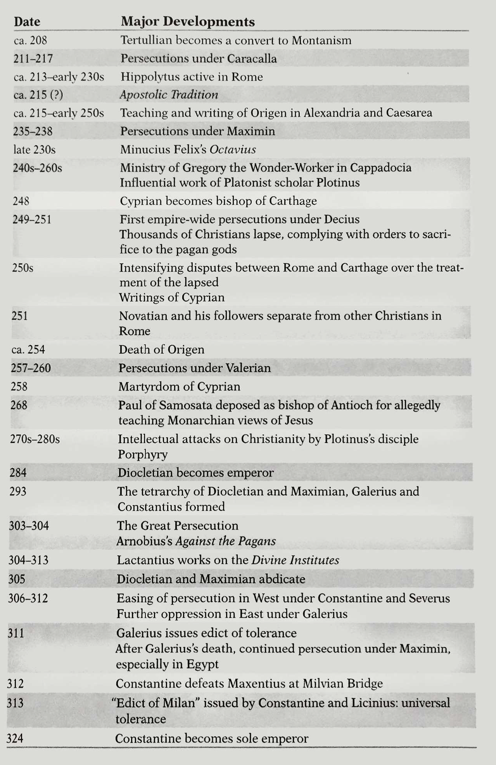

Timeline of Early Christianity
(Source: Davidson, The Birth of the Church.)
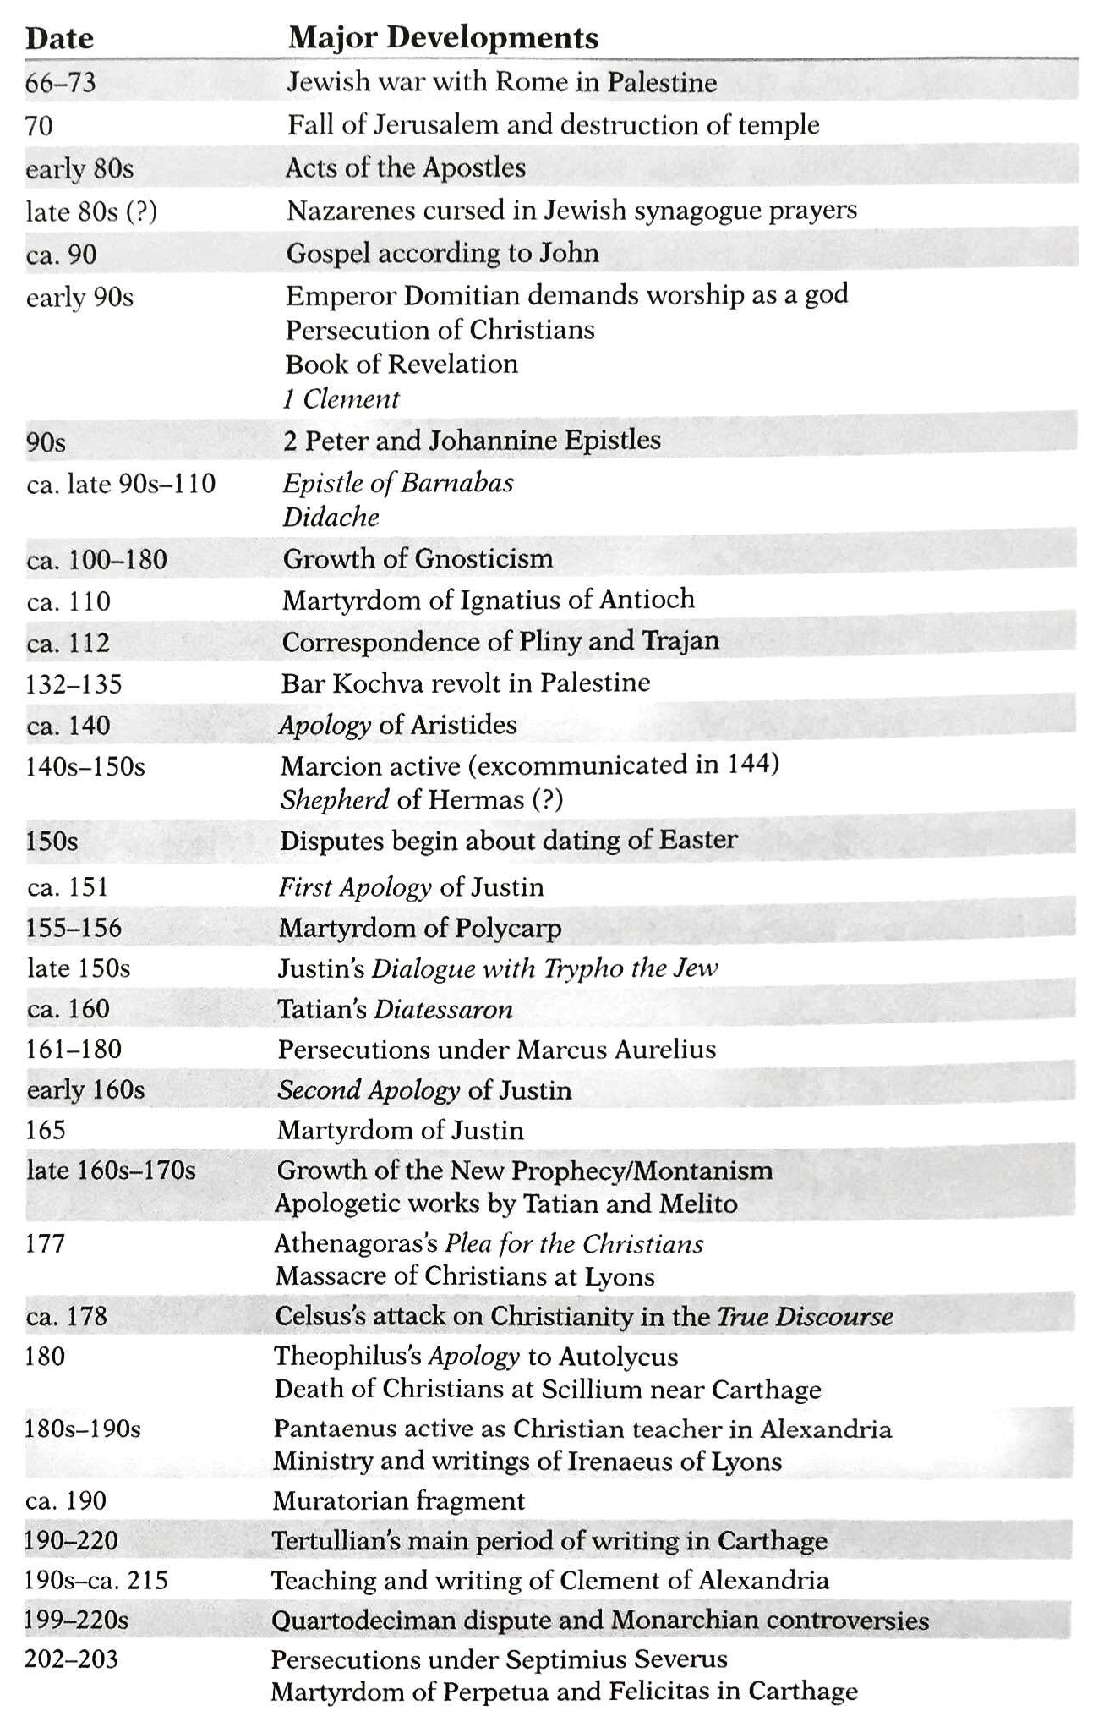

Source ESV Study Bible
