

**Core Seminar**

# Church History

# Class 11: The Church and the (Changing) World, 1750-1850

“*See to it that no one takes you captive by philosophy and empty deceit, according to human tradition, according to the elemental spirits of the world, and not according to Christ. For in him the whole fullness of deity dwells bodily*,” (Colossians 2:8-9 ESV)

**Introduction**

Paul warns us in Col.2:8-9 to not allow the ideas and philosophies of humanity, the fallen wisdom of the world to lead us away from Jesus. Last week we traced the forerunners of what we call evangelicalism in the lives and ministries of Jonathan Edwards and George Whitfield. This morning, want to track the dramatic shift that occurred from 1750 to 1850 that affected the human understanding of the world and affected Protestant Christianity in the US in particular.

I want to accomplish this by looking at the Enlightenment and the responses to this shift in thought. The major event in American history shaped by Enlightenment thought was the American Revolution. But religiously there was significant change in the beginnings of protestant liberalism and the expansion of Evangelicalism, through revivalism.

**What is the Enlightenment?**

The Enlightenment was an intellectual movement that stressed reason as the way to truth a world based on perfectly ordered natural laws and a self-confident and optimistic belief in human ability to make progress.

To put it simply this was a shift in the way that humans understood the world around them and their role in that world. Who were some of the thinkers that embodied this thought: Isaac Newton; John Locke; David Hume; Voltaire

These thinkers shared the common idea that: Humans have the ability to understand the world; and the ability to transform the world. Enlightenment thinkers believed that the basic ideas of religion could be derived from reason alone. Religion served only to promote morality and virtue.

Religion is embedded in nature, and unaided reason can determine its major tenants; hence, the ideas that religion is natural or rational. Enlightenment writers talked up reflection leads to three essential religious ideas. First, influenced by Newton's mechanistic view of the universe they suggest that God is chiefly a great designer who created the world and provides natural laws for its perpetual motion. Second, people everywhere experience a sense of obligation or ethical demands toward neighbors. Therefore, third, because of the sense of right and wrong, it is reasonable to conclude that there will be an afterlife in which we all will be rewarded and punished. Thus there is an attempt to reduce religion and its simplest and most prominent features.

Religious teachings of the Enlightenment challenge traditional Christianity at several points:

(i) Scripture had always been considered the authority truth in classic Protestantism, before Enlightenment thinker’s reason is the primary source of knowledge. (ii) God is Creator, but the doctrine of the Trinity is contrary to reason and therefore must be abandoned. The notion of the active providence of God also was diminished. (iii) Jesus taught the ethical norm Christian should follow his divinity must be rejected since the notion that is fully God and fully man is contrary to experience and reason. Atonement comes through the moral influence of the teachings and deeds of Jesus, not through God requiring his death. (iv) Because of a strong belief in causality, miracles, which were understood as interruptions of natural law, we're considered impossible. (v) Enlightenment religion provided an alternative to Calvinism in American Protestantism. It began with the assumption of human free will and challenged Calvin's teaching on Original Sin, Limited atonement and predestination. Calvinism was widely modified or abandoned by American Protestants in the 19th century. So what event at the end of the 18th century occurred during the time of this prevailing thought-- the American Revolution and the founding of American Republic.

**The Founding of the American Republic**

I do not want to spend too much time here, but because there is a tendency to look back to the founders as a source of secularism or as the golden age of Christian statesmanship a few moments here are worth examining. I want to mention to we should be careful to use history as ammunition for our agendas today. The hot question as by many Christians is: was the United States founded as a Christian nation? I want to suggest that this is not the right question. Christians start with their understanding from God’s revelation in his word. Taken as a whole we can see that it was never God’s desire to see a nation state established in the new covenant, rather His people would be of every tribe, tongue and nation. That is the theological assessment of that question.

But since this is the church history class, there are those who still want to try to put the American founding leaders into neat boxes of “Christian” or “deist”. I believe that is too simplistic. Gregg Frazer, a professor at The Master’s College in CA, recently offered a thesis that draws a middle ground between the two (I should say his thesis is not new) called *theistic rationalism.* Frazer argues first that the founders were a diverse group of men and women whose belief systems varied, but a uniting factor in their religious belief was this *theistic rationalism*.

The main founders (and many others) were products of the Enlightenment. They had an extremely high view of human ability and reason. But they certainly came of age in a time when the larger society was nominally Christian. Frazer defines *theistic rationalism* as “a hybrid system mixing elements of natural religion, Christianity, and rationalism, with rationalism as the predominant element.”[1] [“Natural religion is a system of through centered on the belief that reliable information about God and about what He wills is best discovered and understood by examining the evidence of nature and the laws of nature, which He established”[2]]

So it should not be surprising that the Founders would use language that would sound very Protestant. But we should not mistake this as a clear sign of saving faith. In fact, I would argue that these men were also politicians who knew the consequences of their words, and to the extent that their language would influence people, they would employ it. Their language of rights, self-evident truths and others that we are very familiar with exploded the Enlightenment ideas to a more popular level. So how did American Christians respond to these Enlightenment ideas?

**The Christian Response**

As I mentioned above the Enlightenment brought many challenges for Christianity. It is regrettable that some responded by surrendering great areas of the faith. I want to look at two individuals

***Freiderich Schleiermacher (1768-1834)***

Troubled by the Enlightenment charge that, Christian doctrines were not “rational,” essentially conceded the victory to the rationalists. Schleiermacher argued that doctrine and historical evidence mattered little, and the true essence of Christianity was a “feeling of absolute dependence” on God. Developing this idea Schleiermacher argued: (1) God is that on which we feel dependent; (2) Sin is a failure of our sense of dependence; (3) Christ is the man who was utterly dependent upon God in every though, word and action; (4) This dependence added up to an existence of God in him; (5) Christ’s mission was to communicate this sense of dependence to others. This legacy persists in some areas of the church, which emphasize emotion and experience over the knowledge of the living God.

While our feelings are a gift from God and an important part of who we are, they must always submit to the objective work of Christ on the cross and the objective truth of God in our lives and His word.

***Soren Kierkegaard (1813-1855)***

Danish philosopher who was grew troubled with the Established church and the Enlightenment rationalism around him. Downplaying both doctrine and morality, he held radical free will and radical faith to be the essence of the Gospel. SK developed the idea of Christian existentialism, or the emphasis on each individual’s own subjective search for meaning (“truth is subjectivity”).

Each person needed to make a “leap of faith” towards God—even when those leap seemed to have no basis in fact or objective truth. Though not as harmful as harmful as Schleiermacher, SK’s thought still conceded too much to rationalism, left too little to the church and risked leaving too many people wallowing in their angst.

***Scottish Common Sense Realism***

A number of Christian thinkers, many centered at Princeton, held fast to the true faith in the face of these challenges. In the 18th century, John Witherspoon (1723-1794), a Presbyterian minister who served as President of Princeton University (and the only clergyman to sign the Declaration of Independence), imported from Scotland and helped plant in America the system of philosophy known as Scottish Common (Universal) Sense (Experience) Realism. Though it shared some of the Enlightenment’s confidence in human reason, Common Sense Realism appealed to universal experience to reinforce the truth of Christianity, rather than undermine the faith. Witherspoon and others contended that a plain look at the world would reveal the existence of God and a universal moral code, and a plain reading of the Bible would demonstrate the truth of Christ and the need for salvation.

In the 19th century, two other theologians at Princeton Seminary eagerly and ably defended historic Christianity from the assault of rationalism and other Enlightenment philosophies.. Archibald Alexander (1772-1851), the Seminary’s first professor, and then his student Charles Hodge(1797-1878), who went on teach at Princeton for half a century, balanced a fervent commitment to the Reformed faith with an active engagement with the intellectual challenges to Christianity.

Princeton's theologians advocated Reformed confessionalism. In his famous remark that "a new idea never originated in this Seminary: Charles Hodge epitomized Princeton's claim to be merely a bearer of an unbroken and unaltered Calvinism.

[As modern theologians mounted attacks against orthodoxy, each Princeton generation responded by refining its predecessors' view of Scripture. After Alexander defended the Bible against deism and Charles Hodge met the first onslaught of European biblical criticism, A. A. Hodge and Warfield taught that God's verbal and plenary inspiration produced a Scripture inerrant in the original autographs yet possessing human characteristics. While fully supporting critical inquiry of Scripture, Warfield adamantly opposed criticism predicated on naturalistic premises. Modern scholarship distorted Christianity's essence by denying biblical supernaturalism. Princeton's defense of Scripture relied heavily on the principles of Scottish Common-Sense philosophy that empirical induction is the primary source of truth and that all reasonable people intuit moral absolutes. Princeton's apologists proposed to refute secularism by establishing God's existence, the Scripture's veracity and authenticity and the necessity of biblical religion. Critics have pointed out Princeton's failure to recognize the areligious nature of scientism and the conflict between Scottish philosophy’s principles and John Calvin's teaching that the noetic effect of sin precludes any natural theology. Usually, however, Princeton theologians evaluated philosophy through the lens of biblical revelation.]

So you can see the broad intellectual concerns and how they were playing out at this time. What about what was happening in the experiences of those outside of the academy?

**The Second Great Awakening**

Many American Christians responded to the doubts of the Enlightenment and the spiritual depression after the Revolution by going out and preaching the simple Gospel message. They just charged out and began preaching the Gospel in every corner of the new nation – and beyond. From about 1795 into the first decades of the 1800s, a tremendous series of revivals known as the “Second Great Awakening” swept through America, and forever changed the infant nation.

Most of the Second Great Awakening took place in the towns, villages, and camps of America, particularly the frontier. Denominational distinctive also began to blur, as Presbyterians, Methodists, and Baptists all joined together to preach huge outdoor revivals. Cane Ridge, Kentucky provided the site of one such legendary “camp meeting” in 1801, as up to 25,000 people converged in the fields of the town over a period of weeks to hear numerous preachers proclaim the good news. Many were converted, yet by some measures the enthusiasm became excessive, as bodily convulsions, laughing, and hysterical noises took over some of the participants, including the “barking exercise,” in which new converts, like hunting dogs, would “bark” until they scared the Devil up a tree. For better or for worse, Cane Ridge marked the beginning of decades of revival camp meetings in the new country – some of the Spirit, others more suspect.

[As one historian puts it, “the results at Cane Ridge were electrifying. Some of the unusual bodily effects—the jerks, dancing, laughing, running, and the “barking exercise”—can be attributed to powerful psychological release. Isolated families, subject to hard and perilous life, were responding with their emotions to stirring messages from charismatic leaders. Other effects—such as the rapid establishment of churches that followed camp meetings—were more clearly religious.”[3]]

We last week we walked through what the First Great Awakening was like under Edwards and Whitfield. It is worth talking through some of the comparison and differences between these two time periods. Both driven by a desire to see people saved, both were not just kept to these shores, but were international, taking place in Wales, Scotland and the European continent. But there were some differences as well, and in these differences you can see how Enlightenment thought and rationalism crept in.

Recall that the 1st GA = Edwards & Whitefield & Gilbert Tennent: (monergism) – God’s sovereign grace in saving sinners – man dead in transgressions, they were more expressly Calvinistic in the theology. However in the 2nd GA – synergism (Enlightenment – individual, human ability) – God and man cooperate in salvation (Man can accept or reject God’s offer of grace; After conversion, strive for “perfection” – end to willful sin). There was a significant backlash against Calvinism, which chaffed at the sovereignty of God over and against man.

But there wasn’t just a theological difference there was a difference in ecclesiology and practice. Numerous organizations committed to spreading the Gospel, but were created outside of the local church. By 1827, the six largest of these were the American Bible Society, the American Sunday School Union, the American Tract Society, the American Home Missionary Society, the American Education Society, and the American Board of Foreign Missions.

Additionally, there was a change in the practice of church and evangelism, an idea called revivalism. I want to talk about this idea through the lens of two important figures: Francis Asbury and Charles Finney.

***Francis Asbury (1745-1816) - Methodist***

Born in England, answered Wesley’s call to spread the Gospel in the New World. Asbury was distressed to find so many Methodist preachers in America “settled” in one location, principally in cities. He set out immediately to prod them into “circulation,” the better to reach persons with the Methodist message.45 years preaching throughout the United States, traveling over 300,000 miles on horseback – crossed Appalachian Mountains over 60 times.

***Charles Finney (1792-1875)***

Finney was the best-known revivalist of the 1800s. He joined evangelism with social reform and used his platform to work on abolishing slavery, promoting temperance, caring for the poor, and promoting education. He had a seriously flawed theology and evangelistic methods. Low view of sin and a high view of humanity; Man can choose God on our own – Wesley said God prepared man with grace (prevenient grace) – for Finney anyone could come to God. His evangelistic methods were known as “New Measures”; By setting the proper atmosphere, using the right methods (note the modernity in this) you could persuade someone to convert. The famous method was the “anxious bench” – led to the coming to the altar call. Previously evangelists left the timing to God – Finney called for conversion now.

Despite these errors and excesses – countless faithful pastors and itinerant evangelists labored to preach the Gospel and the Lord used them to draw many to the Kingdom.

By 1850 Christianity in America had changed significantly – the 2nd Great Awakening had brought a Christian revival to the nation but it looked different. Where Anglicans and Congregationalists had been the largest denominations – now it was the Methodists, Baptists and Presbyterians. Many were wrestling with the challenges of modern thought, but many remained faithful to the authority of Scripture alone in pursuing and worshiping God.

**Appendix A: The Enlightenment and Knowledge**

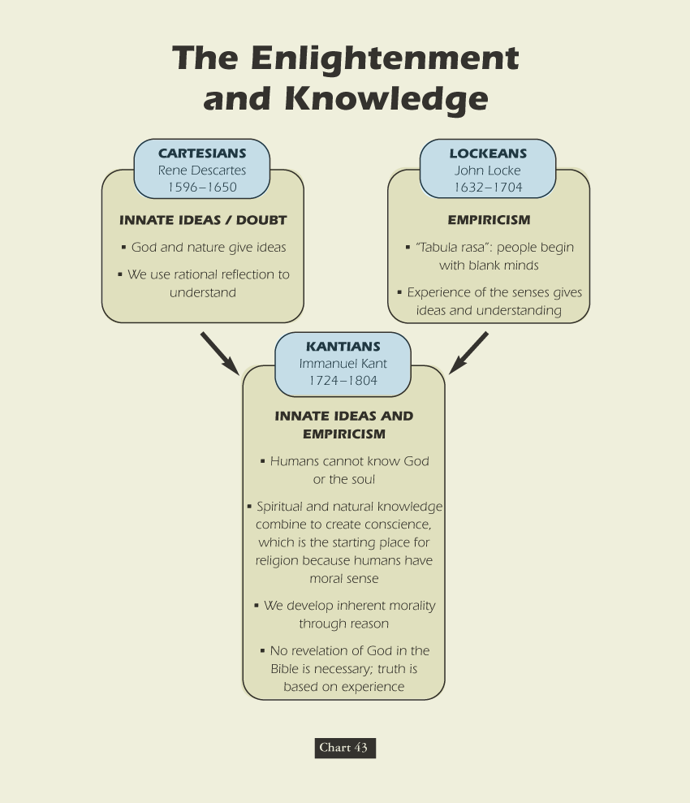

1. Gregg L. Frazer, *The Religious Beliefs of America’s Founders: Reason, Revelation, and Revolution*, American Political Thought (Lawrence, Kan: University Press of Kansas, 2012), 14.
2. Ibid., 15.
3. Mark A. Noll, *A History of Christianity in the United States and Canada* (Wm. B. Eerdmans Publishing Company, 1992), 167.