Questions? zach.schlegel@capbap.org or jamie@capbap.org
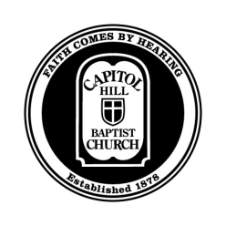

CORE Seminars – Theology of the Church

Capitol Hill Baptist Church

Introduction

Overview:

- What is a Church?
- The Keys: Church Membership
- The Keys: Church Discipline
- Ordinances: Baptism and the Lord’s Supper
- Church Governance
- Church Gathered & Scattered

What is a Church?

What a church is NOT:

- It’s not

- It’s not

Universal Church vs Local Church

Defining the Church:

“A local church is a group of Christians who regularly gather in Christ’s name to officially affirm and oversee one another’s membership in Jesus Christ and his kingdom through gospel preaching and gospel ordinances.”

The Church Displays the Image of God

- Creation

- Fall

- Israel

- Christ

- Church

- Glory

New Testament Pictures of the Church

- A body (1 Corinthians 12:12-27)
- A family (1 Timothy 5:1-2)
- A flock of sheep (1 Peter 5:2)
- A house (1 Peter 2:5)
- A priesthood (1 Peter 2:9)

Two Implications

- The Church is the focal point of God’s plan to display His glory to the nations

- The church is to be distinct from the world

Discussion…

