2017 Systematic Theology Schedule - Part 2

Week 1 – Introduction & Review

Week 2 – Person of the Holy Spirit

Week 3 – Work of the Holy Spirit Part 1

Week 4 – Work of the Holy Spirit Part 2

Week 5 – Work of the Holy Spirit Part 3

Week 6 – Plan of Redemption Part 1

Week 7 – Plan of Redemption Part 2

Week 8 – Plan of Redemption Part 3

Week 9 – Plan of Redemption Part 4

Week 10 – Doctrine of the Church Part 1

Week 11 – Doctrine of the Church Part 2

Week 12 – Eschatology Part 1

Week 13 – Eschatology Part 2

**Questions or Comments?**

***Please feel free to email:***

John Joseph at [john.joseph@capbap.org](mailto:john.joseph@capbap.org); or

Charles Hedman at [charles.hedman@capbap.org](mailto:charles.hedman@capbap.org); or

James Choi at jjschoi@gmail.com

**Capitol Hill Baptist Church Systematic Theology**

# Core Seminars Session VII

**Class Notes**

### The Person of the Holy Spirit

1. Introduction
2. The Person of the Holy Spirit
   1. Personal Pronouns

(Acts 10:19-20, 13:2)

* 1. Personal Properties

(1 Cor. 12:11)

1. Personal Activities

(Rom. 15:30, 1 Tim. 4:1, Rev. 2:7, Luke 12:12, John 16:13; John

14:26)

1. The Holy Spirit is God
   1. The Holy Spirit possesses divine attributes

(Heb. 9:14, Ps. 139:7-10, 1 Cor. 2:10-11)

* 1. The Holy Spirit does Divine work

(John 3:5-6)

* 1. Scripture identifies Him as God

(Acts. 5:1-4)

* 1. The Holy Spirit is identified as the Yahweh of the OT

(Isa. 6:9-10/Acts 28:25-27, Ps. 95:7/Heb. 3)

* 1. Though distinguished from the Father and the Son, the Holy Spirit is represented as equal with the Father and the Son in the great Trinitarian passages of the New Testament

(Matt. 3:16, Matt. 28:19, Eph. 2:18)

[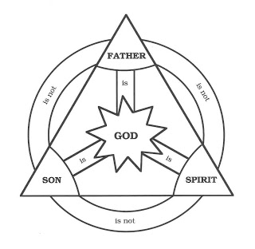](http://3.bp.blogspot.com/_qQAzVXfVvEQ/SrdtE1fGOWI/AAAAAAAAAN4/BVwsidZm5bU/s1600-h/trinity.jpg)

\

* 1. The Holy Spirit comes from the Father, and is sent by the Father and the Son

(John 14-16; 1 Cor. 11:3)