**2017 Systematic Theology Schedule - Part 2**

Week 1 – Introduction & Review

Week 2 – Person of the Holy Spirit

Week 3 – Work of the Holy Spirit Part 1

Week 4 – Work of the Holy Spirit Part 2

Week 5 – Work of the Holy Spirit Part 3

Week 6 – Plan of Redemption Part 1

Week 7 – Plan of Redemption Part 2

Week 8 – Plan of Redemption Part 3

Week 9 – Plan of Redemption Part 4

Week 10 – Doctrine of the Church Part 1

Week 11 – Doctrine of the Church Part 2

Week 12 – Eschatology Part 1

Week 13 – Eschatology Part 2 & Review

**Questions or Comments?**

Please feel free to email:

Justin Sok (Justin.Sok@gmail.com)

John Joseph (john.joseph@capbap.org)

Charles Hedman (Charles.Hedman@capbap.org)

James Choi (jjschoi@gmail.com

**Capitol Hill Baptist Church Systematic Theology**

# Core Seminars Session XXV

**Class Notes**

### Introduction to Eschatology

1. Introduction

(Hebrews 1:1-4)

Article XVIII, **Of the World to Come**, CHBC Statement of Faith

***We believe that the end of the world is approaching; that at the last day Christ will descend from heaven, and raise the dead from the grave to final retribution; that a solemn separation will then take place; that the wicked will be adjudged to endless punishment, and the righteous to endless joy; and that this judgment will fix forever the final state of men in heaven or hell, on principles of righteousness.***

1. The Second Coming of Christ

(I Thess. 4:16; Mt. 24:30-31, 26:64; Rev. 1:7; Jas. 5:7-8; 2 Thess. 2:1; Tit. 2:13; Zeph. 1:15-18; 3:8-9; Acts 1:11)

1. There will be a sudden, personal, visible, bodily return of Christ.

(Jn. 14:3; Acts 1:11; 1 Thess. 4:16, 5:2; Mt. 16:27)

1. The time of Christ’s coming is unknown

(Mt. 24:36, 42; Mk. 13:34-37; Luke 21:11; Acts 1:7; 2 Pet. 3)

1. Christians should eagerly await Christ’s return

(Rev. 22:20; Tit. 2:12-13; Phil 3:20; I Pet. 4:13; John 14:3)

1. The Millennium

(Rev. 20:1-10)

1. Postmillennialism

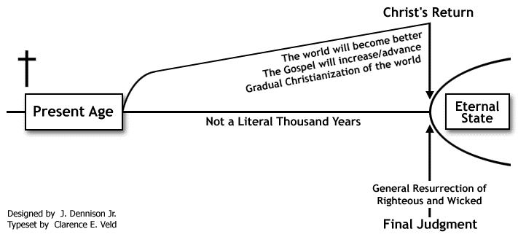

1. Amillennialism (“Realized” or “Inaugurated” Millennialism)

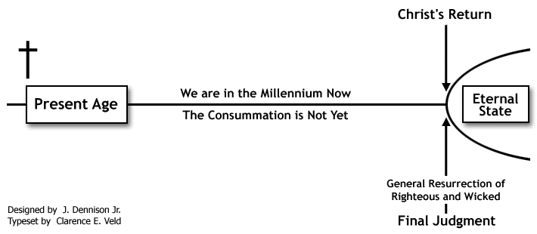

1. Historic (Classic) Premillennialism

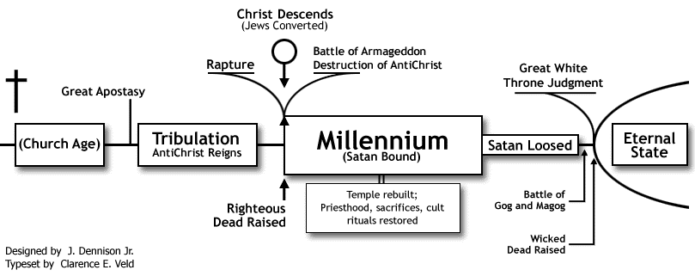

1. Dispensational Premillennialism (Pretribulational Premillennialism)

