Select books on topics covered in class…

Doctrine of the Holy Spirit
Bavinck, Herman. Saved by Grace: The Holy Spirit’s Work in Calling and Regeneration. Grand Rapids, Mich: Reformation Heritage Books, 2008.
Ferguson, Sinclair B. The Holy Spirit. Contours of Christian theology. Downers Grove, Ill: InterVarsity Press, 1996.

Plan of Redemption
Murray, John. Redemption Accomplished and Applied. Wm. B. Eerdmans Publishing Company, 1984.
Morris, Leon. The Atonement, Its Meaning and Significance. Downers Grove, Ill., USA: Inter-Varsity Press, 1983.
Peterson, Robert A. Salvation Applied by the Spirit: Union with Christ. Wheaton, Illinois: Crossway, 2015.
Schreiner, Thomas R. Faith Alone: The Doctrine of Justification. Grand Rapids, Michigan: Zondervan, 2015.

Doctrine of the Church
Dever, Mark. Nine Marks of a Healthy Church. Third edition. 9Marks. Wheaton, Illinois: Crossway Books, 2013.
———. The Church: The Gospel Made Visible. 9Marks. Nashville, TN: B&H Academic, 2012.
Leeman, Jonathan. The Church and the Surprising Offense of God’s Love: Reintroducing the Doctrines of Church Membership and Discipline (IX Marks). Crossway Books, 2010.

Eschatology
Bavinck, Herman. Reformed Dogmatics, v. 4. Grand Rapids, Mich: Baker Academic, 2003.
Beale, G. K. A New Testament Biblical Theology: The Unfolding of the Old Testament in the New. Grand Rapids, Mich: Baker Academic, 2011.
Hoekema, Anthony A. The Bible and the Future. Wm. B. Eerdmans Publishing Company, 1994.

Questions or Comments?
Please feel free to email:

Justin Sok (Justin.Sok@gmail.com)
John Joseph (john.joseph@capbap.org)
Charles Hedman (Charles.Hedman@capbap.org)
James Choi (jjschoi@gmail.com
Capitol Hill Baptist Church Systematic Theology

Core Seminars Session XXVI
Class Notes

Eschatology, Part 2

Article XVIII, Of the World to Come, CHBC Statement of Faith
We believe that the end of the world is approaching; that at the last day Christ will descend from heaven, and raise the dead from the grave to final retribution; that a solemn separation will then take place; that the wicked will be adjudged to endless punishment, and the righteous to endless joy; and that this judgment will fix forever the final state of men in heaven or hell, on principles of righteousness.

- Introduction

Ecclesiastes 12:13-14
“The end of the matter; all has been heard. Fear God and keep his commandments, for this is the whole duty of man. For God will bring every deed into judgment, with every secret thing, whether good or evil.”

- Final Judgment
(Rom. 2:5; Acts 17:30-31; Rev. 20:11-15; Acts 10:42; Mt. 25:31-34, 41; Rom. 2:6,8; 1 Cor. 3:12-15)

- Jesus Christ will be the Judge

- Unbelievers will be judged according to their works and condemned to eternal punishment

- Believers will be judged according to their works.

- The New Heaven and The New Earth
(Rev. 21-22; Rom. 8:19)

Revelation 21:1-4 Then I saw a new heaven and a new earth, for the first heaven and the first earth had passed away, and the sea was no more. ² And I saw the holy city, new Jerusalem, coming down out of heaven from God, prepared as a bride adorned for her husband. ³ And I heard a loud voice from the throne saying, “Behold, the dwelling place of God is with man. He will dwell with them, and they will be his people, and God himself will be with them as their God. ⁴ He will wipe away every tear from their eyes, and death shall be no more, neither shall there be mourning, nor crying, nor pain anymore, for the former things have passed away.”

“When we get to heaven there will be nothing that is abrasive, irritating, agitating, or hurtful. Nothing harmful, hateful, upsetting or unkind. Nothing sad, bad, or mad. Nothing harsh, impatient, ungrateful or unworthy. Nothing weak, or sick, or broken or foolish. Nothing deformed, degenerate, depraved or disgusting. Nothing polluted, pathetic, poor or putrid. Nothing dark, dismal, dismaying or degrading. Nothing blameworthy, blemished, blasphemous or blighted. Nothing faulty, faithless, frail or fading. Nothing grotesque or grievous, hideous or insidious. Nothing illicit or illegal, lascivious or lustful. Nothing marred or mutilated, misaligned or misinformed. Nothing nasty or naughty, offensive or odious. Nothing rancid or rude, soiled or spoiled. Nothing tawdry or tainted, tasteless or tempting. Nothing vile or vicious, wasteful or wanton! Wherever you turn your eyes you will see nothing but glory and grandeur and beauty and brightness and purity and perfection and splendor and satisfaction and sweetness and salvation and majesty and marvel and holiness and happiness. We will see only and all that is adorable and affectionate, beautiful and bright, brilliant and bountiful, delightful and delicious, delectable and dazzling, elegant and exciting, fascinating and fruitful, glorious and grand, gracious and good, happy and holy, healthy and whole, joyful and jubilant, lovely and luscious, majestic and marvelous, opulent and overwhelming, radiant and resplendent, splendid and sublime, sweet and savoring, tender and tasteful, euphoric and unified! Why will it be all these things? Because we will be looking at God.”

Rev. 22:20-21 He who testifies to these things says, “Surely I am coming soon.” Amen. Come, Lord Jesus! The grace of the Lord Jesus be with all. Amen.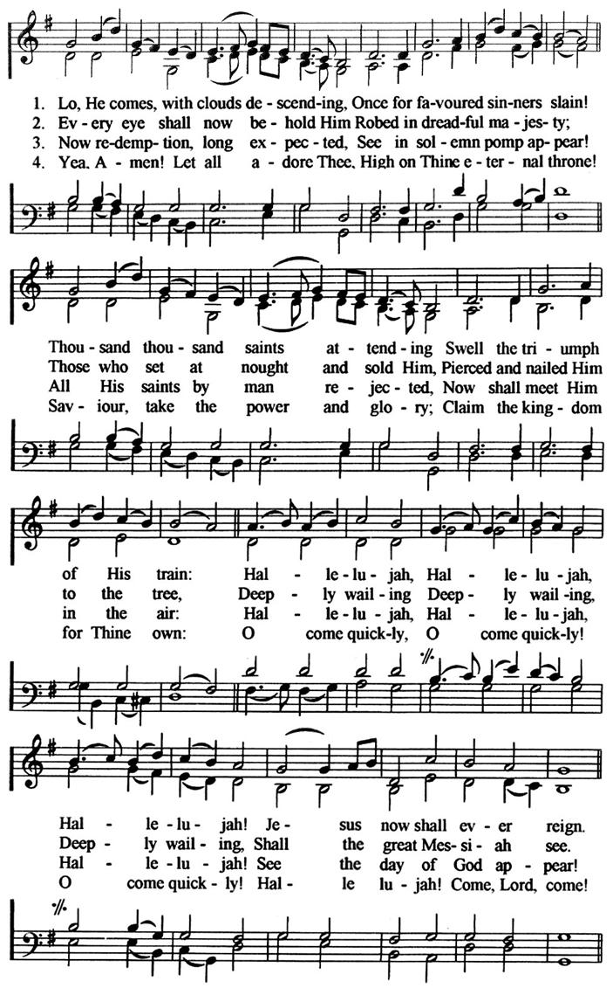
(“Lo, He Comes” by John Cennick, published & altered by Charles Wesley (1758))

Sam Storms, One Thing: Developing a Passion for the Beauty of God (Geanies House, Fearn, Ross-shire, Scotland, Great Britain: Christian Focus, 2004), 178-179.

