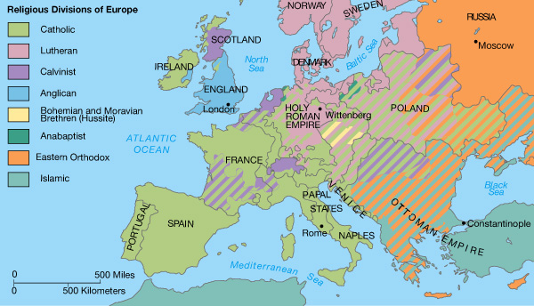

***Predominant Religious Bodies in Europe in the Mid-16th Century***

Image Source: <http://wpscms.pearsoncmg.com/wps/media/objects/1748/1790587/chap_assets/maps/atl_map14_1.html>

Questions? Email [bobby.jamieson@capbap.org](mailto:bobby.jamieson@capbap.org)

Core Seminars

**Global Christianity**

***Week 6***

**Christianity in Western Europe**

### Introduction

We’ll tell three stories, then gather three common threads. Focus is on Reformation to the present.

### I. France and Spain: Where Reform Never Took Root

**Spain:**

* Militant Roman Catholicism kept Reformation out
* Today only 3% Protestant

**France:**

* 1572, St. Bartholomew’s Day Massacre
* Today: laïcité, extremely strict separation of church and state, religion and public life
* Today only 3% Protestant (1% evangelical)

### II. Germany and Scandinavia: Secular Lutheran Lands of the North

**Germany:**

* Reformation proceeded by ruler adopting new position
* Wide gap between ruler’s profession and people’s practice

**Scandinavia**

* (1) “Christianization” in the middle ages
* (2) Adoption of Lutheranism in the sixteenth century
* (3) Rapid and early secularization
  + 1890 – only 5% of Sweden’s urban population attended church at least once a month
  + 1927 – Only 5.6% of whole Swedish population attended church regularly
  + 1950s – 3% of Swedes attend Lutheran church
  + Minor exception: Swedish Baptists
  + Brian Stanley, in *Christianity in the Twentieth Century*:“Last in, first out . . . The narrative of Scandinavian Christianity is as much one of long-term failure in Christianization as one of twentieth-century secularization” (111, 114).

### III. England: A Partly-Reformed Establishment in Need of Reformation and Revival

* 1558–59 – Elizabethan religious settlement
* 1662 – Act of Uniformity; Puritan pastors expelled from the Church of England
* 1730s–40s – Great Awakening; widespread revival
* Church of England today: only 1.4% of the population attends
* State of play today?
* Pressures on being Baptist

### IV. Common Threads

1. The fallout of the Enlightenment.

2. Secularism accelerating in the wake of the sexual revolution.

3. The largely counter-productive presence of state churches.