Lessons from Christianity in Korea
1. Past church growth or revival is no guarantee of future spiritual growth
2. Our missionaries must be well-equipped and taught good missiology
3. Not all “growth” is good growth
4. Material prosperity can often become a major snare for the church
5. The church must focus on the fundamentals: prayer, the Bible, evangelism
6. Integrity and holiness are critical to Christian witness
What about Christianity in North Korea?
- Church has been quenched since Kim Il Sung came to power (1948)
- Bible is banned, Christians are imprisoned and tortured
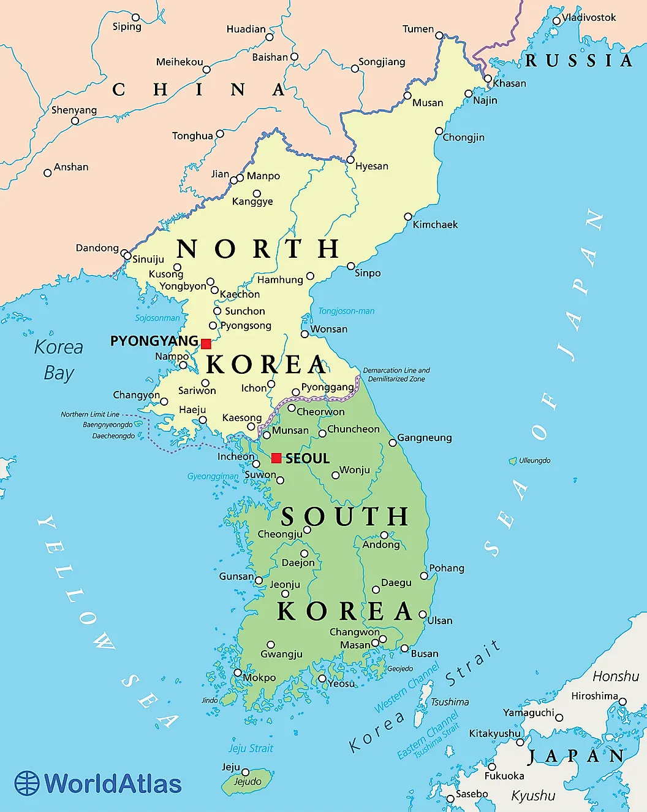
Questions? Send me an email at kev.js.kim@gmail.com
CHBC Core Seminars  Global Christianity  Week 6 - November 13th, 2022 | 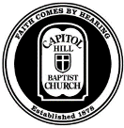

Christianity in the Korean Peninsula
Intro to Korea
South Korea
- 12th largest global GDP, 52 million people
- 20% of the population is Protestant Christian
North Korea
- One of the most oppressive communist regimes of all time,
estimated 26 million people
- Estimated ~1% of the population is Christian
1800-1900: The Arrival of Early Presbyterian Missionaries
John Ross (1842-1915)
- Completes first translation of the Bible into Korean (1882)
- Ross’s theological and missionary foresight
1) Get people God’s Word
2) Native evangelism
Horace Allen (1858 - 1932) and Horace Underwood (1859 - 1916)
- First truly resident Protestant missionaries
- Establish important institutions: churches, schools, and hospitals
John Nevius (1829 - 1893) and the Three-Self Plan
- In 1890 is invited to speak on Nevius Method: How to establish self- propagating, self-governing, and self-supporting churches
1) Converts continue living their lives in neighborhoods
2) Missionaries only help establish programs and institutions
that the native church wanted and could support
3) The native church identifies and supports its own pastors
4) Churches should be built in the local style with money and
materials largely from its own members
5) Intensive theological instruction for church leaders each year
1900-1910: Rapid Chrstian Growth and the Korean Pentecost (the Pyongyang Revival of 1907)
Japanese occupation (1894) and annexation (1910)
- Gospel hope in the midst of hardship
Pyongyang Revival (1907)
- Uniqueness of this revival:
1) East Asian xenophobia
2) Short time of Christian witness
\
1910-1950: Japanese Occupation and Soviet Communism
Persecution of Christians
1) Political conspirators

2) Shinto Shrine Controversy (1925)
- Patriotism and idolatry

1950-2022: The Modern Era
The Korean War (1950-1953 Armistice)
- Massive destruction and casualties
Rapid Church Growth
- Doubles in size from 3% to 6% by late 1960s during recovery
- 20% of the population claims to be Protestant by 1995
- Huge increase of social and evangelistic programs in 1960s
Korean Missionary Movement
- One of the world’s largest exporters of the Gospel
- 20,000 missionaries in over 180 countries (2012)
The Church in South Korea Today
- Wheat: True Gospel witness and church growth
- Tares: Prosperity Gospel and Pentecostalism
- Current trends: Secularism and young people leaving the church

