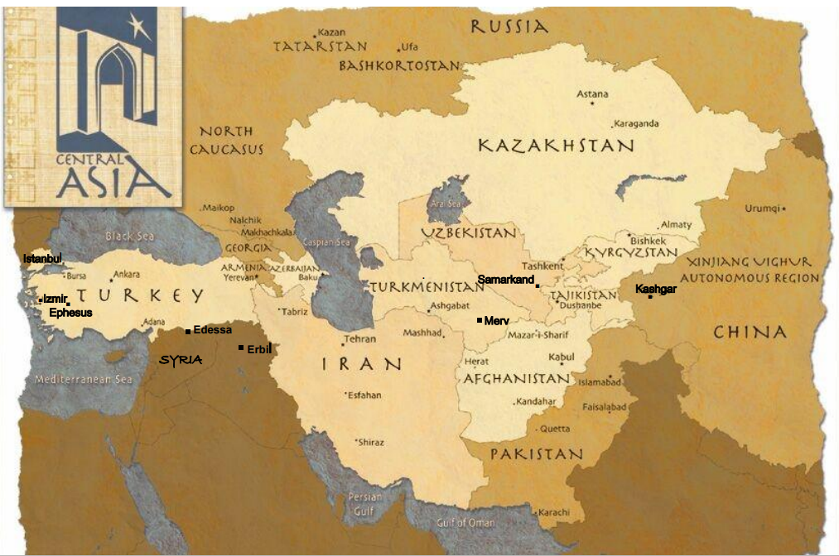

**.**

******Core Seminars

**Global Christianity**

***Week 7***

**The History of Christianity in Asia**

Missionary and historian Dr. Samuel Moffett "The church began in Asia. Its earliest history, its first centers were Asian. Asia produced the first known church building, the first New Testament translation, perhaps the first Christian king, the first Christian poets, and even arguably the first Christian state. Asian Christians endured the greatest persecutions. They mounted global ventures in missionary expansion the West could not match until after the thirteenth century." (A History of Christianity in Asia Vol 1)

1. **The left side of the graph**
2. **NT period (I Century A.D)**

Jews still in Central Asia from Babylonian Captivity

Central Asians repent and believe at Pentecost (Acts 2)

Early churches in Central Asian cities

Paul and coworker’s difficulties in Ephesus (Eph 19 and 2 Cor 1:8)

John writes Revelation from an island off the coast of Central Asia

1. **Pre-Islamic Period (100 AD to 800 AD)**

First translation of the NT into Syriac (Peshitta) Northern Iraq/Syria

Arbela (Erbil, Northern Iraq) was the center for missionary advance into Central Asia.

**Eastern Church in Central Asia- Nestorian Church**

Nestorius preferred the term Mother of Christ (Kristotokos) for the Mother of Jesus rather than Mother of God (Theotokos).

Council of Chalcedon (Istanbul/Kadikoy) in 451 splits Christianity into Eastern and Western

1. **Islamic Central Asia 800-1300 AD**

(Nestorian churches continue to expand and spread gospel in Islamic, Buddhist and Shamanist context)

Minority Status-persecution-marketplace Christians have some influence

**Tamerlane and Mongol Rulers (Ghengiz Khan)**

Near destruction of church by Tamerlane. Some toleration by Ghengiz Khan and Monghol rules.

**V. Soviet Central Asia- (20th Century until 1990)**

Churches and believers endure persecution and survive

1. **Central Asia in 21 century (1990 - present)**

Christian workers from Singapore, Korea, S Africa, Latin American, North American and a few from China refresh the effort to evangelize, disciple and start churches in Central Asia.

Some existing, persecuted churches (Armenian, German and Russian Baptists) engage Central Asian peoples.

**VII.** **Takeaways or Themes to remember:**

Minority Status and Persecution persists

Marketplace Christians and the Silk Road Network

Pray for CA church: 2 Corinthians 1:8-11 and 1 Timothy 2:1-7

Bible translations needed! Gospel can spread where the Word is available.