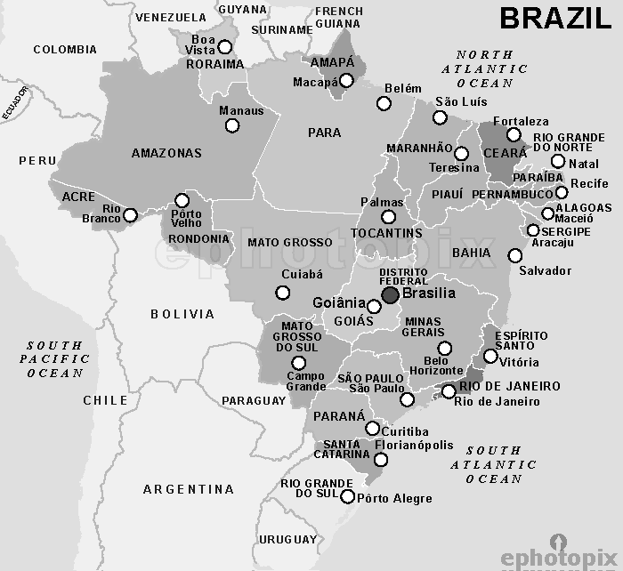

Questions? Email [bobby.jamieson@capbap.org](mailto:bobby.jamieson@capbap.org)

Core Seminars

**Global Christianity**

***Week 4***

**The History of Christianity in Brazil**

### I. Introduction

South America today has “the strongest Christian community in the world.”

### II. Early Origins

* Portuguese colonization began in 1500 with Pedro Álvares Cabral. Their first official act was to celebrate Roman Catholic mass.
* For the next 400 years, Brazil—first as part of Portugal, then an independent Empire, then a Republic—would have the Roman Catholic Church as its established religion.
* French Calvinists (Huguenots) arrived as part of a small French Colony in 1555. Shortly afterward, some pastors were sent from Calvin’s academy in Geneva. But the colony was quickly destroyed by the Portuguese.
* In 1558, some of these Huguenots wrote the first Protestant writing in all of the Americas, the Guanabara Confession of Faith.
* From the beginning, Roman Catholicism in Brazil was a syncretistic mix of official church teaching and practice with indigenous spiritsm and African religions that slaves brought with them.

### III. Empire and Republic

* Pedro I declared Brazil’s independence from Portugal in 1822.
* The Empire’s constitution, adopted in 1824, included a number of liberties, including limited freedom of religion.
* In 1849 Pedro II banned the slave trade in Brazil. This led to more European immigrant wage earners replacing slaves. They brought Protestantism with them.
* European Protestants who settled in Brazil and eventually sent missionaries: Anglicans, Lutherans, Congregationalists, Presbyterians, Baptists.
* Significant growth of Protestantism from late-19th through mid-20th century. By 1935, 1.5 million members of Protestant churches.

### IV. Post-War Brazil

* In 1940, evangelicals were only 2.6% of the Brazilian population. In 1950, they had reached 3.4%. From there, they continued to increase, reaching 6.6% in 1980, then 9% in 1991, 15.4% in 2000, 22% in 2010.

*Theological Liberalism*

* Following trends in the US and Europe, widespread departure from historic Christian orthodoxy in the main Protestant denominations.
* But, in many ways the tide has turned against theological liberalism, back to historic orthodoxy. One example: the Presbyterians, and Mackenzie University.

*Pentecostalism*

* Quick arrival in Brazil: Luigi Francescon and Rosina Balzono (1909); also Daniel Berg, a Swedish Baptist-turned Pentecostal preacher, who founded the Assemblies of God in Brazil.
* By 2000, Assemblies of God in Brazil had more than 14 million members.
* Pentecostal distinctives: “baptism in the Holy Spirit” shown by speaking in tongues; expressive corporate worship; intensely supernatural; prophets whose prophecies are given weight equal to, or greater than, Scripture.
* Emergence of some Reformed Pentecostals, or “Pentecostals-turned-Reformed.”

### V. Conclusion

* Where does all this leave us? Today, theologically rooted evangelical Protestants in Brazil find themselves pressured by:
  + the Roman Catholic Church, with its longstanding syncretic mix of spiritism and popular piety;
  + the overwhelming prevalence of Pentecostalism and the prosperity gospel
  + increasing secularism whose overall impact remains to be seen.