“Take, Eat; This is My Body.”
Matthew 26:26-28
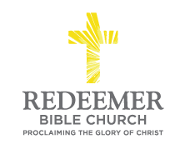
Angelo L. Tolentino / Morning Service / El Corazon Senior Center / Oceanside, CA / March 5, 2023

Intro:
²⁶ Now while they were eating, Jesus took some bread, and after a blessing, He broke it and gave it to the disciples, and said, “Take, eat; this is My body.” ²⁷ And when He had taken a cup and given thanks, He gave it to them, saying, “Drink from it, all of you; ²⁸ for this is My blood of the covenant, which is being poured out for many for forgiveness of sins.

Matthew 26:26-28

Preaching Point: This morning, our prayer is that you would _____________
________________________________________________________________

- Take

- Eat

Conclusion:

