CONTENTS

Worship
Word
Works
Upcoming:
Preaching Schedule
Event Highlights
Equip courses

WORSHIP (Praise and Prayer)

- Prayer Focus

      - Malaysia: The Church – The Government
Pray:
- To have godly fear in carrying out their duty to serve the rakyat
- To have wisdom and understanding to govern justly
- To have sound judgment based on good insight and counsel

      - Pakistan – Asia Bibi’s blasphemy case
We interceded for Pakistan and also Asia Bibi on 21 October. Praise the Lord for Asia Bibi’s death penalty conviction was overturned by the Supreme Court of Pakistan on 31 October. Let us continue to pray:
- For the release of others who have been wrongly imprisoned
- That many more people in Pakistan will learn about Isa al-Masih and turn to Him

WORD (60 minutes)

Missions Weekend: Out of Our Comfort Zone
(John 12:24)
By Beram Kumar of STAMP (guest speaker)

- Read the scripture passage.
- Do a THREE-MINUTE SUMMARY of the sermon highlighting the KEY POINTS. Do not preach the whole sermon again, as majority of your members would have heard the sermon already. Allocate more time for sharing in the cell through the application questions below.
- Sermon Resource at: http://www.dumc.my/resources/sermons/

Reflection & Application Questions:
            - Which of the items listed below here would constitute ‘out of your comfort zone’? If it does, explain why. If you have no ‘fear’ at all, why not?
- Praying regularly at least 10 minutes a day
- Interceding for others/situations regularly (e.g. salvation, missions, church)
- Going for a short-term mission trip (Challenge to attend coming MCPP1 for starters)
- Committing to serve for at least one year in a ministry (inside or outside DUMC)
- Giving up something significant and stepping courageously to serve God in the unknown (e.g. your job, stepping into a new community, moving to a new country to serve as a missionary, going ‘full time’)

            - Here is only one thing that makes a dream impossible to achieve: The fear of failure (Paulo Coelho). Would you agree or disagree with this statement? How does your life reflect you stepping out of your comfort zone and stepping into God’s faith journey into the untraveled (i.e. the unknown)?

            - Read Habakkuk 1:5. What does this mean to you, especially after last weekend’s sermon. What is God challenging you to step into, especially into 2019?

            - Draw a picture of a cube, representing a ‘room’. Write in the room words that currently pre-occupy you most in your daily routine. If God was asking you to ‘make room for a miracle’, which items will you surrender to allow God to work His miracle through you?

Note to Word leader:
For this particular “Questions for Discussion” session, would strong encourage that there will be two groups, one for men and the other for women. The reason for this is to encourage greater openness, freedom and depth in sharing.

As you are preparing for this session, this is a great time to pray that the Holy Spirit will guide you to use the questions efficaciously. You can select, modify or entirely create your own questions, according to the needs of your CG.

WORKS (Ministry and Bearing Witness)

As a cell group explore this as a commitment to support missions through prayer and encouragement.

When we support them in this way, we join them in the work of the Lord in these nations to reach out to people groups whom the Lord loves and who have yet to hear & receive the Gospel into their lives.
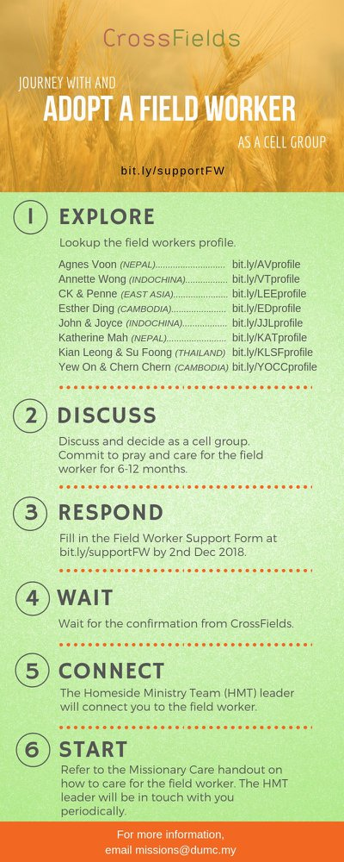

Share your personal testimonies of God’s goodness and transformation to pre-believing family and friends this week.

- Share Your Story (Your Story, His Glory)
- Whether your story is about how you came to know Christ, of illness healed, an act of kindness in your times of need, or of how you served people or how people have served you, give glory to God. Share your story so that more people will be encouraged and God's love is known.
- If there are any good testimonies, ask your members to write out their testimonies and submit to the church: http://dumc.my/connect/individual-care/share-your-story/

- Personal: Bible Reading and Journaling
- Subscribe to the Bible Reading Plan from: YouVersion – OwnIt365 One Story Plan.
- Request one of your members to share a journal entry. Pair up members to share with, and pray for one another.

- Scripture Memory
Every cell meeting, do get your cell members to recite the following together:
- Ephesians 5:15-16 (Theme verse for 2018)
- Ephesians 4:1-2
¹As a prisoner for the Lord, then, I urge you to live a life worthy of the calling you have received. ² Be completely humble and gentle; be patient, bearing with one another in love.
- Matthew 6:9-13
9 “This, then, is how you should pray:
“‘Our Father in heaven,
hallowed be your name,
10 your kingdom come,
your will be done,
on earth as it is in heaven.
11 Give us today our daily bread.
12 And forgive us our debts,
as we also have forgiven our debtors.
13 And lead us not into temptation,[a]
but deliver us from the evil one.
(For Yours is the kingdom and the power and the glory forever. Amen)

- Short Term Mission Field

CROSSFIELDS 2018
*Crossing into the harvest field with the message of the Cross
Myanmar | 23-30 Nov 2018
Nepal | 6-16 Dec 2018
Sarawak Iban | 8-14 Dec 2018
MCPP1 | 17-18 Nov | Empress Hotel Sepang
For more info, contact Eunice Tan @ 03 7958 7388 or eunice.tan@dumc.my

- CMS: Steps to Fill in the Salvation Form
- Select “More”
- “Form”
- Select “Form Lit” box
- Look for “Salvation Form”
- Fill in form of new salvation by “Change Respondent”
- Must have “E-mail” and “Mobile Phone”

UPCOMING

PREACHING SCHEDULE

Nov 10/11 | Pre-Advent | Pr Mike Ngui
Nov 17/18 | Pre-Advent | Pr Chris Kam
Nov 24/25 | Pre-Advent | Pr Datuk Kee Sue Sing

EVENT HIGHLIGHTS

  - Church Prayer Altar
Every Saturday | 7.00 -9.00am | Room 101 & 102
Let us come and seek the face of God. Prayer precedes everything.

  - Crossfields November Events: Missions Training (MCPP1)
17-18 Nov | Empress Hotel Sepang
Register at bit.ly/MCPP2018 or contact: eunice.tan@dumc.my

EQUIP COURSES

Registration is open roughly 2-3 months prior to the course. Sign up with payment at Registration Counter. For information, visit dumc.my/equip

Spiritual Formation 301 (REGISTRATION CLOSED)
Journey with co-sojourners to be formed by Christ in these formation classes. Facilitated by Lim Siew Lan, Pr Gan Jin Leong, Sophy Lim and Lay Har
Oct 20, Nov 10, 24; Dec 8, Jan 19 (2019) + Weekend Retreat
9.00am-11.30am / RM370
Limited places

Bible 301
An advanced training course on bible study principles. Suitable for Word facilitators with experience. Taught by Lianne Lee.
Nov 24 | 8.30am - 1.00pm | RM10

