CONTENTS

Worship
Word
Works
Upcoming:
Preaching Schedule
Event Highlights
Equip courses

WORSHIP (Praise and Prayer)

- Prayer Focus

      - Malaysia: The Nation
Pray:
- For God-inspired creative and fruitful ways of social and community outreach
- God’s people to mentor and influence the next generation with His love and righteousness
- Manifestation of giftings in the marketplace to make a great impact

      - International Day of Prayer (IDOP) 2018 – Listen to their Cry
Let us continue to intercede for our suffering brothers and sisters:
- Ask the Lord to strengthen and deliver suffering saints
- Pray that in spite of the pressure and persecution, our suffering brothers and sisters – wherever they may be in the world- will stand firm in their faith, hold fast to the promises of God, and live victoriously in Christ
- Pray for the mobilisation of the global Church to respond to the plight of our suffering brothers and sisters

WORD (60 minutes)

Jesus According to Centurio
(Matthew 8:5-13)
By Pastor Michael Ngui

Big Idea: Jesus has an “open door” policy

- Read the scripture passage.
- Do a THREE-MINUTE SUMMARY of the sermon highlighting the KEY POINTS. Do not preach the whole sermon again, as majority of your members would have heard the sermon already. Allocate more time for sharing in the cell through the application questions below.
- Sermon Resource at: http://www.dumc.my/resources/sermons/

Reflection & Application Questions:

            - Watch this video: https://www.youtube.com/watch?v=0veDFGo666s
What are some of your unconscious biasness? How does this compare with Jesus’ “open door” policy? How did Jesus demonstrate this refusing the prejudices of His day and how did He demonstrate such an attitude in Matthew 8?

            - Jesus values people over reputation. Have you been labelled negatively because you focused on (God’s) “mission” over “reputation”? Do share your personal example or an observation of an exemplary Christian role-model.

            - Jesus recognises faith where He sees it. What are some prejudices that they may blind us (as a CG or as a church) in the area of “Loving God, Serving People and Making Disciples toward Christlikeness”?

In closing, pray for the Lord to open our hearts and minds toward others and for Him to forgive us if we have not loved people the way He loves us. Pray that we will seek out this Christmas season to reach out to the “lost” as He opens our eyes toward the people around us.

Note to Word leader:
As you are preparing for this session, this is a great time to pray that the Holy Spirit will guide you to use the questions efficaciously. You can select, modify or entirely create your own questions, according to the needs of your CG.

WORKS (Ministry and Bearing Witness)

Share your personal testimonies of God’s goodness and transformation to pre-believing family and friends this week.

- Christmas Party (renamed from Home-E)
We've got a fun line up for our Christmas Party programme! Cell groups have the option to invite friends to the CG Christmas Party or to participate in the Urban Food Sharing event. Cells to inform your pastors if you are interested in the Urban Food Sharing. For the CG Christmas Party, you may choose between Basic or Basic Plus. More information at dumc.my/christmas2018

- Share Your Story (Your Story, His Glory)
- Whether your story is about how you came to know Christ, of illness healed, an act of kindness in your times of need, or of how you served people or how people have served you, give glory to God. Share your story so that more people will be encouraged and God's love is known.
- If there are any good testimonies, ask your members to write out their testimonies and submit to the church: http://dumc.my/connect/individual-care/share-your-story/

- Personal: Bible Reading and Journaling
- Subscribe to the Bible Reading Plan from: YouVersion – OwnIt365 One Story Plan.
- Request one of your members to share a journal entry. Pair up members to share with, and pray for one another.

- Scripture Memory
Every cell meeting, do get your cell members to recite the following together:
- Ephesians 5:15-16 (Theme verse for 2018)
- Ephesians 4:1-2
¹As a prisoner for the Lord, then, I urge you to live a life worthy of the calling you have received. ² Be completely humble and gentle; be patient, bearing with one another in love.
- Matthew 6:9-13
9 “This, then, is how you should pray:
“‘Our Father in heaven,
hallowed be your name,
10 your kingdom come,
your will be done,
on earth as it is in heaven.
11 Give us today our daily bread.
12 And forgive us our debts,
as we also have forgiven our debtors.
13 And lead us not into temptation,[a]
but deliver us from the evil one.
(For Yours is the kingdom and the power and the glory forever. Amen)

- CrossFields

Short Term Mission Trips
*Crossing into the harvest field with the message of the Cross
Myanmar | 23-30 Nov 2018
Nepal | 6-16 Dec 2018
Sarawak Iban | 8-14 Dec 2018
For more info, contact Eunice Tan @ 03 7958 7388 or eunice.tan@dumc.my

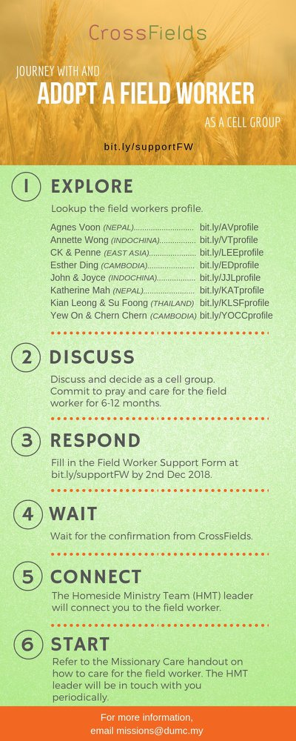
As a cell group explore this as a commitment to support missions through prayer and encouragement.

When we support them in this way, we join them in the work of the Lord in these nations to reach out to people groups whom the Lord loves and who have yet to hear & receive the Gospel into their lives.

- CMS: Steps to Fill in the Salvation Form
- Select “More”
- “Form”
- Select “Form Lit” box
- Look for “Salvation Form”
- Fill in form of new salvation by “Change Respondent”
- Must have “E-mail” and “Mobile Phone”

UPCOMING

PREACHING SCHEDULE

Nov 17/18 | Jesus according to the Unknown Woman | Pr Chris Kam
Nov 24/25 | Jesus according to Zaccheus | Pr Datuk Kee Sue Sing

EVENT HIGHLIGHTS

  - Church Prayer Altar
Every Saturday | 7.00 -9.00am | Room 101 & 102
Let us come and seek the face of God. Prayer precedes everything.

  - Crossfields November Events: Missions Training (MCPP1)
17-18 Nov | Empress Hotel Sepang
Register at bit.ly/MCPP2018 or contact: eunice.tan@dumc.my

EQUIP COURSES

Registration is open roughly 2-3 months prior to the course. Sign up with payment at Registration Counter. For information, visit dumc.my/equip

Bible 301
An advanced training course on bible study principles. Suitable for Word facilitators with experience. Taught by Lianne Lee.
Nov 24 | 8.30am - 1.00pm | RM10

