CONTENTS

Worship
Word
Works
Upcoming:
Preaching Schedule
Event Highlights
Equip courses

WORSHIP (Praise and Prayer)

- Prayer Focus

      - Malaysia: SPM Examinations (13 Nov – 13 Dec)
Pray:
- Wisdom for teachers and students alike and clarity of minds in preparing and sitting for the examinations.
- Minimal disruption of the examination schedule from rain or floods.

      - The Adopted Unreached People Group: Bamars, Myanmar
The Bamars. Ask the Lord to:
- Disarm the spiritual principalities and powers over the nation.
- Soften hearts to be more receptive towards the gospel.
- Raise up more Christian leaders and strong local churches and lead believers to be bold in sharing the gospel; He will send labourers into Myanmar.

Mission Team (23 – 30 Nov)
Pray for Jacky Lai (Leader), Cathy Siew (Asst.), Sanice Kam, Cindy Teo & Janice Toh:
- Safety and protection for them and their loved ones back home.
- Love and compassion, and boldness in sharing the gospel; the Spirit’s anointing to communicate effectively through testimonies and teachings; for signs and wonders and miraculous healing.
- Good partnership with the local pastors and churches to advance God’s kingdom in Myanmar.

WORD (60 minutes)

Jesus According to Zacchaeus
(Luke 19:1-10)
By Pastor Datuk Kee Sue Sing

Big Idea: There is no one so sinful, that God doesn’t love them.

- Read the scripture passage.
- Do a THREE-MINUTE SUMMARY of the sermon highlighting the KEY POINTS. Do not preach the whole sermon again, as majority of your members would have heard the sermon already. Allocate more time for sharing in the cell through the application questions below.
- Sermon Resource at: http://www.dumc.my/resources/sermons/

Reflection & Application Questions:

            - Zacchaeus was a notorious and despised man (v2) yet Jesus had compassion for him. Talk about how sometimes it is difficult for people to separate the sin from the sinner. How is it important for us to disapprove sin while trying to save those trapped in sin? Discuss how to approach people today whose lifestyles we cannot condone.

            - Zacchaeus was desperate to see Jesus (v. 3-4). His desperation says a lot about his awareness of his own need. On a scale of 1-10 (1 being the least, 10 being the most), rate how hungry and thirsty are you to seek after Christ? Also rate how deeply convicted are you of your need for Christ?

            - Jesus stopped to meet the need of one man. He was never too busy to save one man. (v.6-7) Talk about different actions we can take in order to prevent us from getting too busy to notice/remember the needs of others (example: restrict usage of handphone during lunch break, etc.)

            - There is no one beyond God’s redemption and God never stops seeking out to save the lost (v.9-10). Is there someone you’re concerned about who has yet to be saved? Share who that person is and pray together for boldness to continue displaying and offering the gospel. Consider whether this year’s Christmas would be a good opportunity to offer the gospel.

Note to Word leader:
As you are preparing for this session, this is a great time to pray that the Holy Spirit will guide you to use the questions efficaciously. You can select, modify or entirely create your own questions, according to the needs of your CG, especially if you feel that there are too many questions than required for the allocated time.

WORKS (Ministry and Bearing Witness)

Share your personal testimonies of God’s goodness and transformation to pre-believing family and friends this week.

- Christmas Party (renamed from Home-E)
We've got a fun line up for our Christmas Party programme! Cell groups have the option to invite friends to the CG Christmas Party or to participate in the Urban Food Sharing event. Cells to inform your pastors if you are interested in the Urban Food Sharing. For the CG Christmas Party, you may choose between Basic or Basic Plus. More information at dumc.my/christmas2018

- Share Your Story (Your Story, His Glory)
- Whether your story is about how you came to know Christ, of illness healed, an act of kindness in your times of need, or of how you served people or how people have served you, give glory to God. Share your story so that more people will be encouraged and God's love is known.
- If there are any good testimonies, ask your members to write out their testimonies and submit to the church: http://dumc.my/connect/individual-care/share-your-story/

- Personal: Bible Reading and Journaling
- Subscribe to the Bible Reading Plan from: YouVersion – OwnIt365 One Story Plan.
- Request one of your members to share a journal entry. Pair up members to share with, and pray for one another.

- Scripture Memory
Every cell meeting, do get your cell members to recite the following together:
- Ephesians 5:15-16 (Theme verse for 2018)
- Ephesians 4:1-2
¹As a prisoner for the Lord, then, I urge you to live a life worthy of the calling you have received. ² Be completely humble and gentle; be patient, bearing with one another in love.
- Matthew 6:9-13
9 “This, then, is how you should pray:
“‘Our Father in heaven,
hallowed be your name,
10 your kingdom come,
your will be done,
on earth as it is in heaven.
11 Give us today our daily bread.
12 And forgive us our debts,
as we also have forgiven our debtors.
13 And lead us not into temptation,[a]
but deliver us from the evil one.
(For Yours is the kingdom and the power and the glory forever. Amen)

- CrossFields

Short Term Mission Trips
*Crossing into the harvest field with the message of the Cross
Myanmar | 23-30 Nov 2018
Nepal | 6-16 Dec 2018
Sarawak Iban | 8-14 Dec 2018
For more info, contact Eunice Tan @ 03 7958 7388 or eunice.tan@dumc.my

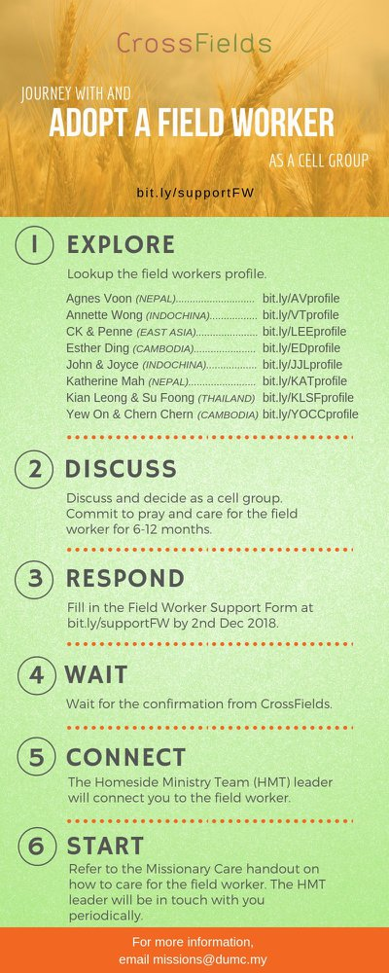
As a cell group explore this as a commitment to support missions through prayer and encouragement.

When we support them in this way, we join them in the work of the Lord in these nations to reach out to people groups whom the Lord loves and who have yet to hear & receive the Gospel into their lives.

- CMS: Steps to Fill in the Salvation Form
- Select “More”
- “Form”
- Select “Form Lit” box
- Look for “Salvation Form”
- Fill in form of new salvation by “Change Respondent”
- Must have “E-mail” and “Mobile Phone”

UPCOMING

PREACHING SCHEDULE

Nov 24/25 | Jesus according to Zaccheus | Pr Datuk Kee Sue Sing

Go to: http://www.dumc.my/resources/sermons/ for the latest info.

EVENT HIGHLIGHTS

  - Church Prayer Altar
Every Saturday | 7.00 -9.00am | Room 101 & 102
Let us come and seek the face of God. Prayer precedes everything.

  - Christmas is coming!

Light of the World, Christmas Day Celebration

25 Dec | 8.30am / 11.30am | Auditorium

Advent season is near. Join us at our weekly Christmas Celebrations beginning 1, 2 Dec. First Devotional available at Info Counter.

dumc.my/christmas2018 for more info.

EQUIP COURSES

Registration is open roughly 2-3 months prior to the course. Sign up with payment at Registration Counter. For information, visit dumc.my/equip

Bible 301
An advanced training course on bible study principles. Suitable for Word facilitators with experience. Taught by Lianne Lee.
Nov 24 | 8.30am - 1.00pm | RM10

