CONTENTS

Worship
Word
Works
Upcoming:
Preaching Schedule
Event Highlights
Equip courses

WORSHIP (Praise and Prayer)

- Prayer Focus

      - Malaysia: Bless the Nation with Gods’s Peace & Love
Pray:
- For those in authority, our Rulers, Prime Minister and his Cabinet members, and all members of our Parliament and State Assemblies. (1 Tim 2:1-2)
- That we allow the Holy Spirit to lead us to be obedient to Him so that He can use us to pray and intercede effectively for our nation.
- For ourselves, that we will learn to take heed of His Word and to be His “ambassadors” in the nation.

      - International:14,000 immigrant minors currently in US Custody
PRAY :
• Those in detention centres, especially minors – that they will be treated humanely, with compassion, and that their basic needs will provided for. Parents will be allowed to care for and protect their children and unaccompanied children will be handled in a sensitive manner while their asylum applications are being processed.
• For NGOs as they reach hurting immigrant families and children: ◊ Success in their efforts to reunite parents with children. ◊ God’s provision for them to carry their mission.
• Wisdom for the US government in handling this situation, and that the governments of Honduras, El Salvador, and Guatemala will seriously plan how to restore public safety in their communities.
Missions: Yew On & Chern Chern, Cambodia
- • Thank God for His enabling of Yew On in his deputation role. Pray for smooth transition as he hands over the Field Director role before 25 December.
- • For Yew On’s mother’s health and salvation. She is 96, and has been very weak since November.

WORD (60 minutes)

Advent II:God is Love
(1 John 2:3-11)
Rev. Irvin Rutherford
Big Idea: God Has Love, Is Love and His Love Changes Us

- Read the scripture passage.
- Do a THREE-MINUTE SUMMARY of the sermon highlighting the KEY POINTS. Do not preach the whole sermon again, as majority of your members would have heard the sermon already. Allocate more time for sharing in the cell through the application questions below.
- Sermon Resource at: http://www.dumc.my/resources/sermons/

Reflection & Application Questions:

- God Has Love for everyone . Is this true ? Share some testimonies of Gods Love in your daily life . Give some examples of that Love in action .

- The Young , The Free Thinker and The self –Satisfied are 3 segments of types of people that need God’s Love . How can we use 1 John 4:8 to relate God’s Love to them?

- God’s Love Changes Us. To what extent does God’s Love change us ? Are we transformed ?

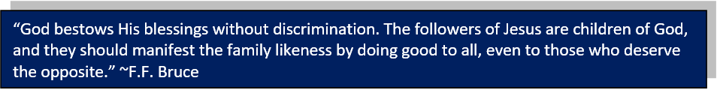

Note to Word leader:
As you are preparing for this session, this is a great time to pray that the Holy Spirit will guide you to use the questions efficaciously. You can select, modify or entirely create your own questions, according to the needs of your CG, especially if you feel that there are too many questions than required for the allocated time.

WORKS (Ministry and Bearing Witness)

Share your personal testimonies of God’s goodness and transformation to pre-believing family and friends this week.

- Christmas Party (renamed from Home-E)
We've got a fun line up for our Christmas Party programme! Cell groups have the option to invite friends to the CG Christmas Party or to participate in the Urban Food Sharing event. Cells to inform your pastors if you are interested in the Urban Food Sharing. For the CG Christmas Party, you may choose between Basic or Basic Plus. More information at dumc.my/christmas2018

- Share Your Story (Your Story, His Glory)
- Whether your story is about how you came to know Christ, of illness healed, an act of kindness in your times of need, or of how you served people or how people have served you, give glory to God. Share your story so that more people will be encouraged and God's love is known.
- If there are any good testimonies, ask your members to write out their testimonies and submit to the church: http://dumc.my/connect/individual-care/share-your-story/

- Personal: Bible Reading and Journaling
- Subscribe to the Bible Reading Plan from: YouVersion – OwnIt365 One Story Plan.
- Request one of your members to share a journal entry. Pair up members to share with, and pray for one another.

- Scripture Memory
Every cell meeting, do get your cell members to recite the following together:
- Ephesians 5:15-16 (Theme verse for 2018)
- Ephesians 4:1-2
¹As a prisoner for the Lord, then, I urge you to live a life worthy of the calling you have received. ² Be completely humble and gentle; be patient, bearing with one another in love.
- Matthew 6:9-13
9 “This, then, is how you should pray:
“‘Our Father in heaven,
hallowed be your name,
10 your kingdom come,
your will be done,
on earth as it is in heaven.
11 Give us today our daily bread.
12 And forgive us our debts,
as we also have forgiven our debtors.
13 And lead us not into temptation,[a]
but deliver us from the evil one.
(For Yours is the kingdom and the power and the glory forever. Amen)

- CrossFields

Short Term Mission Trips
*Crossing into the harvest field with the message of the Cross
Nepal | 6-16 Dec 2018
Sarawak Iban | 8-14 Dec 2018
For more info, contact Eunice Tan @ 03 7958 7388 or eunice.tan@dumc.my

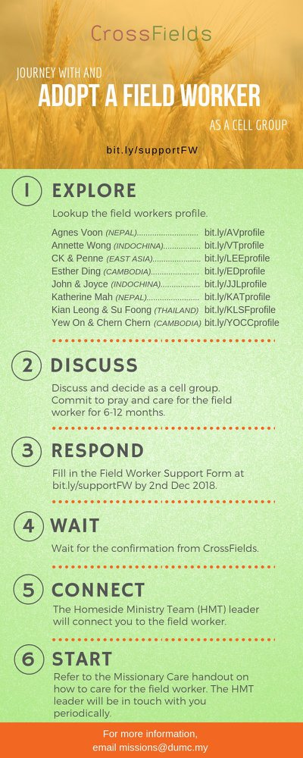
As a cell group explore this as a commitment to support missions through prayer and encouragement.

When we support them in this way, we join them in the work of the Lord in these nations to reach out to people groups whom the Lord loves and who have yet to hear & receive the Gospel into their lives.

- CMS: Steps to Fill in the Salvation Form
- Select “More”
- “Form”
- Select “Form Lit” box
- Look for “Salvation Form”
- Fill in form of new salvation by “Change Respondent”
- Must have “E-mail” and “Mobile Phone”

UPCOMING

PREACHING SCHEDULE

Dec 15&16 | Advent 3-God is Life | Pr Dato’ Dr Daniel Ho

Go to: http://www.dumc.my/resources/sermons/ for the latest info.

EVENT HIGHLIGHTS

  - Church Prayer Altar
Every Saturday | 7.00 -9.00am | Room 101 & 102
Let us come and seek the face of God. Prayer precedes everything.

  - Christmas is coming!

Light of the World, Christmas Day Celebration

25 Dec | 8.30am / 11.30am | Auditorium

Advent season is near. Join us at our weekly Christmas Celebrations beginning 1, 2 Dec. First Devotional available at Info Counter.

dumc.my/christmas2018 for more info.

  - DUMC CHRISTMAS CELEBRATIONS
Chinese | 25 Dec | 9.00am & 11.15am | Hall 1
BM | 23 Dec |10.00am | Hall 4
Myanmar | 25 Dec |11.30pm | Hall 1
Tamil | 23 Dec |7.30pm | Hall 1
Nepalese | 9 Dec | 2.00pm | Hall 4

EQUIP COURSES

Watch out for our exciting announcements for 2019!

