CONTENTS

Worship
Word
Works
Upcoming:
Preaching Schedule
Event Highlights
Equip courses

WORSHIP (Praise and Prayer)

- Prayer Focus

      - Malaysia & Singapore – Maritime & Airspace Spat
Pray:
• Amicable and equitable solutions to be found through negotiations.
• Wisdom for the relevant parties at the negotiation table.
• The good relations between the two countries will be guarded and upheld.

      - International(China):More than 100 Christians detained by Chinese Police
PRAY :
In coordinated raids across Chengdu, police snatched pastors and more than 100 worshippers from their homes. Some claimed abuse while in custody. (Source: South China Morning Post Facebook, 9 Dec) Pray:
• God to protect those who are in custody or are missing, and for them to be released soon.
• A new generation of fervent and passionate Chinese believers to reach out to their countrymen with the Good News.
• Perseverance for Chinese Christians to stand strong against tightening religious restrictions and persecution.
• Young believers will enter a deeper walk with Jesus, withstanding the challenge of their materialistic environment.
• Christ will reveal Himself to government officials who seek to control the church.

Missions: Yew On & Chern Chern, Cambodia
Pray:
• God’s protection and journey mercy as they commute between Siem Reap and Phnom Penh for ministry and meetings.
• God’s provision of a suitable place to rent, and guidance for ministry involvement for Yew On as they prepare to move to Siem Reap soon.
• God’s favour for the MOU renewal between OMF Cambodia and University of Health Sciences (expiring soon) and between OMF Cambodia and Ministry of Cults and Religion.

WORD (60 minutes)

Advent III:God is Life
(John1:4;6:35;10:10)
Dato’Dr Daniel Ho ,Founding Senior Pastor
Big Idea: God Has Love, Is Love and His Love Changes Us

- Read the scripture passage.
- Do a THREE-MINUTE SUMMARY of the sermon highlighting the KEY POINTS. Do not preach the whole sermon again, as majority of your members would have heard the sermon already. Allocate more time for sharing in the cell through the application questions below.
- Sermon Resource at: http://www.dumc.my/resources/sermons/

Reflection & Application Questions:

- The life the world has to offer is all about quantity but the Life that Christ give is all about quality . What qualities do you have that shows the impact that Christ has done in your life?

- Christ transforms lives and thus this produces a quality that the world cannot compete with. What have you done with your life for others ?

- When was the last time you shared CHRIST gift of salvation ? if you have share a testimony . If you have not what is holding you back?

Note to Word leader:
As you are preparing for this session, this is a great time to pray that the Holy Spirit will guide you to use the questions efficaciously. You can select, modify or entirely create your own questions, according to the needs of your CG, especially if you feel that there are too many questions than required for the allocated time.

WORKS (Ministry and Bearing Witness)

Share your personal testimonies of God’s goodness and transformation to pre-believing family and friends this week.

- Christmas Party (renamed from Home-E)
We've got a fun line up for our Christmas Party programme! Cell groups have the option to invite friends to the CG Christmas Party or to participate in the Urban Food Sharing event. Cells to inform your pastors if you are interested in the Urban Food Sharing. For the CG Christmas Party, you may choose between Basic or Basic Plus. More information at dumc.my/christmas2018

- Share Your Story (Your Story, His Glory)
- Whether your story is about how you came to know Christ, of illness healed, an act of kindness in your times of need, or of how you served people or how people have served you, give glory to God. Share your story so that more people will be encouraged and God's love is known.
- If there are any good testimonies, ask your members to write out their testimonies and submit to the church: http://dumc.my/connect/individual-care/share-your-story/

- Personal: Bible Reading and Journaling
- Subscribe to the Bible Reading Plan from: YouVersion – OwnIt365 One Story Plan.
- Request one of your members to share a journal entry. Pair up members to share with, and pray for one another.

- Scripture Memory
Every cell meeting, do get your cell members to recite the following together:
- Ephesians 5:15-16 (Theme verse for 2018)
- Ephesians 4:1-2
¹As a prisoner for the Lord, then, I urge you to live a life worthy of the calling you have received. ² Be completely humble and gentle; be patient, bearing with one another in love.
- Matthew 6:9-13
9 “This, then, is how you should pray:
“‘Our Father in heaven,
hallowed be your name,
10 your kingdom come,
your will be done,
on earth as it is in heaven.
11 Give us today our daily bread.
12 And forgive us our debts,
as we also have forgiven our debtors.
13 And lead us not into temptation,[a]
but deliver us from the evil one.
(For Yours is the kingdom and the power and the glory forever. Amen)

- CrossFields

Short Term Mission Trips
*Crossing into the harvest field with the message of the Cross
Nepal | 6-16 Dec 2018
Sarawak Iban | 8-14 Dec 2018
For more info, contact Eunice Tan @ 03 7958 7388 or eunice.tan@dumc.my

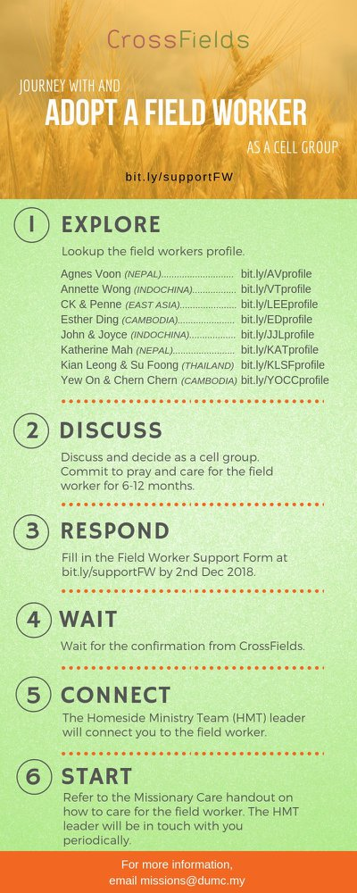
As a cell group explore this as a commitment to support missions through prayer and encouragement.

When we support them in this way, we join them in the work of the Lord in these nations to reach out to people groups whom the Lord loves and who have yet to hear & receive the Gospel into their lives.

- CMS: Steps to Fill in the Salvation Form
- Select “More”
- “Form”
- Select “Form Lit” box
- Look for “Salvation Form”
- Fill in form of new salvation by “Change Respondent”
- Must have “E-mail” and “Mobile Phone”

UPCOMING

PREACHING SCHEDULE

Dec 22&23 | Advent 4-God is Life | Pr Alex Tan

Go to: http://www.dumc.my/resources/sermons/ for the latest info.

EVENT HIGHLIGHTS

  - Church Prayer Altar
Every Saturday | 7.00 -9.00am | Room 101 & 102
Let us come and seek the face of God. Prayer precedes everything.

  - Christmas is coming!

Light of the World, Christmas Day Celebration

25 Dec | 8.30am / 11.30am | Auditorium

Advent season is near. Join us at our weekly Christmas Celebrations beginning 1, 2 Dec. First Devotional available at Info Counter.

dumc.my/christmas2018 for more info.

  - DUMC CHRISTMAS CELEBRATIONS
Chinese | 25 Dec | 9.00am & 11.15am | Hall 1
BM | 23 Dec |10.00am | Hall 4
Myanmar | 25 Dec |11.30pm | Hall 1
Tamil | 23 Dec |7.30pm | Hall 1
Nepalese | 9 Dec | 2.00pm | Hall 4

EQUIP COURSES

Watch out for our exciting announcements for 2019!

