CONTENTS

Worship
Word
Works
Upcoming:
Preaching Schedule
Event Highlights
Equip courses

WORSHIP (Praise and Prayer)

- Malaysia-Harmony Among The People
Pray for:
• Better understanding and communication among the communities.
• Engagement of young people to promote non-discrimination and protection for minority groups.
• Firm action by the Government against extremist groups who incite racial and religious tensions.
- IndonesiaTsunami
An eruption of the Anak Krakatoa volcano, which sits in the middle of the Sunda Strait between the Java and Sumatra islands, caused a section of the crater to collapse and slide into the ocean, triggering a killer tsunami on 22 December.
Pray:
• For God’s comfort and peace to those who lost loved ones and also for those who have lost their homes and property.
• For much-needed supplies of food, clean water and medicine.
• Wisdom and coordination in the rescue and relief efforts. Pray especially that they will be able to locate victims in the interior and isolated places.
• Ask God to enable Christian believers to share His love, compassion and the gospel of Jesus Christ with those who are suffering.
- DUMC Anniversary & Gift Weekend (12/13 January 2019) As DUMC celebrates 39 years of God’s faithfulness, let us thank Him for:
- His grace and favour bestowed upon us.
- His wonderful provision for us and our families and His church.
Pray for God’s people, and that the Holy Spirit will:
- Envision and enable us to give towards a vision in which many lives will be blessed and transformed through the work of individuals and organisations both locally and globally.
- Teach us to trust Him to release to us the resources which will enable us to give to this vision. • Prepare and stir our hearts to give willingly, sacrificially, cheerfully and generously

WORD (60 minutes)

Year End Reflection: He Must Become Greater,I Must Become Less
(John 3:22-30)
Chris Kam, Senior Pastor
Big Idea: “I must become less” is a process of dying to self, yielding and surrendering to Jesus more and more each day, so that people can see more of Him in me.
life.

- Read the scripture passage.
- Do a THREE-MINUTE SUMMARY of the sermon highlighting the KEY POINTS. Do not preach the whole sermon again, as majority of your members would have heard the sermon already. Allocate more time for sharing in the cell through the application questions below.
- Sermon Resource at: http://www.dumc.my/resources/sermons/

Reflection & Application Questions:

- Competition in the Mind- Being competitive is not wrong in itself but it must not be taken to extreme. It will lead us to become performance oriented and this can effect our ministry . How do we do a check on our motives?

- Concern of the soul- It is easy for God to take us out of the world but it is very hard for God to take the world out of us. We need to die daily to the world. This is what Paul says, “I die every day”. Discuss what it means to Die Every Day ?

- Clarity in the spirit- The joy becomes complete when I fade away and Jesus become greater. Jesus must increase and I must decrease. What steps must we take to achieve this ?

Note to Word leader:
As you are preparing for this session, this is a great time to pray that the Holy Spirit will guide you to use the questions efficaciously. You can select, modify or entirely create your own questions, according to the needs of your CG, especially if you feel that there are too many questions than required for the allocated time.

WORKS (Ministry and Bearing Witness)

Share your personal testimonies of God’s goodness and transformation to pre-believing family and friends this week.

- Share Your Story (Your Story, His Glory)
- Whether your story is about how you came to know Christ, of illness healed, an act of kindness in your times of need, or of how you served people or how people have served you, give glory to God. Share your story so that more people will be encouraged and God's love is known.
- If there are any good testimonies, ask your members to write out their testimonies and submit to the church: http://dumc.my/connect/individual-care/share-your-story/

- Personal: Bible Reading and Journaling
- Subscribe to the Bible Reading Plan from: YouVersion – OwnIt365 One Story Plan.
- Request one of your members to share a journal entry. Pair up members to share with, and pray for one another.

- Scripture Memory
Every cell meeting, do get your cell members to recite the following together:
- Ephesians 5:15-16 (Theme verse for 2018)
- Ephesians 4:1-2
¹As a prisoner for the Lord, then, I urge you to live a life worthy of the calling you have received. ² Be completely humble and gentle; be patient, bearing with one another in love.
- Matthew 6:9-13
9 “This, then, is how you should pray:
“‘Our Father in heaven,
hallowed be your name,
10 your kingdom come,
your will be done,
on earth as it is in heaven.
11 Give us today our daily bread.
12 And forgive us our debts,
as we also have forgiven our debtors.
13 And lead us not into temptation,[a]
but deliver us from the evil one.
(For Yours is the kingdom and the power and the glory forever. Amen)

- CrossFields

CROSSFIELDS 2019
“Crossing into the harvest field with the message of the Cross”
Myanmar | 8-15 Mar
Cambodia | 21-29 Mar
Sabah | 21-24 Mar
Sarawak Iban | 21-29 Mar
MCPP1 | 23-24 Mar | Empress Hotel Sepang Contact Eunice at 03 79587388 or eunice.tan@dumc.my
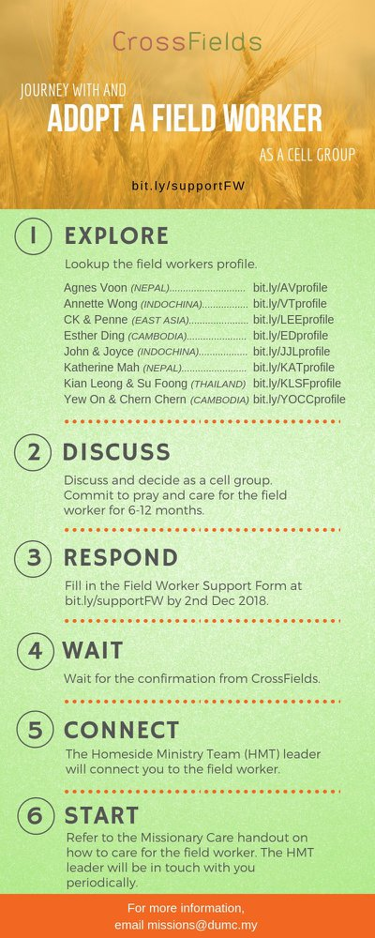
As a cell group explore this as a commitment to support missions through prayer and encouragement.

When we support them in this way, we join them in the work of the Lord in these nations to reach out to people groups whom the Lord loves and who have yet to hear & receive the Gospel into their lives.

- CMS: Steps to Fill in the Salvation Form
- Select “More”
- “Form”
- Select “Form Lit” box
- Look for “Salvation Form”
- Fill in form of new salvation by “Change Respondent”
- Must have “E-mail” and “Mobile Phone”

UPCOMING

PREACHING SCHEDULE

Jan 5&6 | Step Forward-Keep In Step With The Spirit | Sr Pr Chris Kam

Go to: http://www.dumc.my/resources/sermons/ for the latest info.

EVENT HIGHLIGHTS

  - Church Prayer Altar
Every Saturday | 7.00 -9.00am | Room 101 & 102
Let us come and seek the face of God. Prayer precedes everything.

  - PARENT SUPPORT PARENT (PSP)
Topic: Raising Kingdom Kids 12 & 26 Jan, 9 & 23 Feb, 9 & 23 Mar 2019
Time: 3.00pm-4.30pm
Venue: Cafe Function Room, Dream Centre
Sign up at bit.ly/psp_parenting

  - W2W MOMENTS BEGINS FEB 2019!
Moments are a platform for ladies from all walks of life to come together for a time of mutual encouragement and fellowship through Bible Study.
Every 3rd Sat | 8.30am-11.00am | Hall 3 Alternate Tues | 9.00am-11.30am | SS15, Rm109, DUMC@Puchong Alternate Wed | 9.00am-11.30am | Ara D’sara & BU4
Register at bit.ly/moments2019

  - ANNIVERSARY AND GIFT WEEKEND 2019
“Celebrating 39 years of God’s faithfulness to DUMC” 12 & 13 Jan 2019 | Dream Centre
Come prepared to sow into His Kingdom.

  - FORWARD 2019 COMBINED COMMUNION CELEBRATIONS
5 Jan 2019 | 11.45pm-2.00am | Auditorium
6 Jan 2019 | 9.00am-11.00am | Auditorium
6 Jan 2019 | 11.30am-1.30pm | Auditorium
  - WANT TO JOIN THE DUMC FAMILY?
Here are the steps:
> Join a Cell Group (You can get help at our CG Kiosk)
> Attend Basic Christianity 101 > Attend DUMC 101
> Join an Encounter Weekend
> Baptism & Membership Interview Sign up at the Info Counter or online at dumc.my/equip

EQUIP COURSES

a. BASIC CHRISTIANITY 101 (Basic Doctrine I) Saturdays • 12 & 19 Jan | 8.30am-1.00pm

b. DUMC 101 Saturday | 26 Jan | 8.30am-1.00pm

c. BAPTISM & MEMBERSHIP ENCOUNTER WEEKEND Saturday & Sunday (stay-in) • 16-17 Feb

d. CHRISTIAN LIVING 101 (My New Life) Sundays | 9 Feb-30 Mar | 8.00am-9.30am

e. BIBLE 101 (Understanding the Bible) Saturdays | 2 & 9 Feb | 8.30am-1.00pm

F. BE STILL AND KNOW THAT I AM GOD (A Spiritual Retreat) 22-24 Feb | Fraser’s Hill Register: bit.ly/DUMCRetreat_22Feb2018

g. EXPLICIT GOSPEL (W/ MATT CHANDLER) Sundays | 24 Feb-7 Apr | 8.00am-9.30am | Hall 3

h. HEBREWS PART 1 (REPEAT) Sundays | 24 Feb-14 Apr | 8.00am-9.30am | Hall 2

