CONTENTS

Worship
Word
Works
Upcoming:
Preaching Schedule
Event Highlights
Equip courses

WORSHIP (Praise and Prayer)

- Malaysia: Church
The restoration of the nation must first begin with restoration in ourselves.
Pray for Personal Holiness & a Return to Our First Love:
- For personal holiness and a conviction of sin in our personal lives. Let us pray not for our own preservation that we may live comfortable lives, but that God’s kingdom will come and His will be done.
- That we will remain strong in our faith so that we can withstand the pressures ahead. Pray that we may fully understand the call of our Lord Jesus Christ to take up our cross and follow Him.
- For holiness and reverence for God’s Word

- International: Democratic Republic of the Congo
The country is primarily Christian, at least by name. However, multiple languages and people groups mean they have to be intentional about which translations of Scripture are used.
Pray for:
- A pure Gospel to be proclaimed that is devoid of syncretism and heresy.
- Unity for the Church and for her to recapture the vision for evangelism of the entire country.
- An expansion of ministries that will equip the youth to decisively impact the nation for Christ.
- Swift production of 12 million booklets in French and Swahili by World Missionary Press. Ask God to bless each booklet and direct it into the hands of those who are seeking to know more of Him. For Vietnamese Christians in cities and in minority villages.

WORD (60 minutes)

FORWARD 3: Stepping Forward In Leadership
(Matthew 20: 17-28)
Chris Kam, Senior Pastor

Big Idea: To Lead is to Serve Like Jesus.

- Read the scripture passage.
- Do a THREE-MINUTE SUMMARY of the sermon highlighting the KEY POINTS. Do not preach the whole sermon again, as majority of your members would have heard the sermon already. Allocate more time for sharing in the cell through the application questions below.
- Sermon Resource at: http://www.dumc.my/resources/sermons/

Reflection & Application Questions:

      - What is the most significant thing the Holy Spirit spoke to you about through this sermon?

      - What examples do we see in the world today of what Jesus said in Matt 20:25? “Jesus called them together and said, “You know that the rulers of the Gentiles lord
it over them, and their high officials exercise authority over them.””

      - How are Christians to be different according to Matt 20:26-28? In what ways are we different from the world in terms of being servant leaders? In what ways are you or are you not like this in your leadership, whether at work, ministry or home?

      - Our tag line has this phrase: “Serve People”. How has your CG been making this a part of what you do? Give examples. Are you burdened for anything in particular that the Holy Spirit is showing you? Can the CG be involved in it?

Note to Word leader:
As you are preparing for this session, this is a great time to pray that the Holy Spirit will guide you to use the questions efficaciously. You can select, modify or entirely create your own questions, according to the needs of your CG, especially if you feel that there are too many questions than required for the allocated time.

Note to Cell Groups that have children during meeting:
We recognize several cell groups in DUMC may have 5 or more children joining them during Cell Group meetings. We would like to get them engaged as well during the session therefore we are suggesting for CGs to use Manna Pad and assign someone in rotation to facilitate them after worship. Here is the link to the Manna Pad materials http://dumc.my/resources/downloads/

WORKS (Ministry and Bearing Witness)

Cell leaders to ask these two important questions or share with one another during Works session in every CG meeting.

    - Who have I met, praying for and sharing Christ with?
    - What is the Holy Spirit saying about the community I am in?

- Share Your Story (Your Story, His Glory)
- Whether your story is about how you came to know Christ, of illness healed, an act of kindness in your times of need, or of how you served people or how people have served you, give glory to God. Share your story so that more people will be encouraged and God's love is known.
- If there are any good testimonies, ask your members to write out their testimonies and submit to the church: http://dumc.my/connect/individual-care/share-your-story/

- Personal: Bible Reading and Journaling
- Subscribe to the Bible Reading Plan from: YouVersion – OwnIt365 New Testament (NT)+ Plan.
- Request one of your members to share a journal entry. Pair up members to share with, and pray for one another.

- Scripture Memory

Every cell meeting, do get your cell members to recite the following together:

Galatians 5:22-26 (Theme verse for 2019)

²² But the fruit of the Spirit is love, joy, peace, forbearance, kindness, goodness, faithfulness, ²³ gentleness and self-control. Against such things there is no law. ²⁴ Those who belong to Christ Jesus have crucified the flesh with its passions and desires. ²⁵ Since we live by the Spirit, let us keep in step with the Spirit. ²⁶ Let us not become conceited, provoking and envying each other.

- CrossFields

“Crossing into the harvest field with the message of the Cross”
Myanmar | 8-15 Mar
Cambodia | 21-29 Mar
Sabah | 21-24 Mar
Sarawak Iban | 21-29 Mar

MCPP1 | 23-24 Mar | Empress Hotel Sepang Contact Eunice at 03 79587388 or eunice.tan@dumc.my

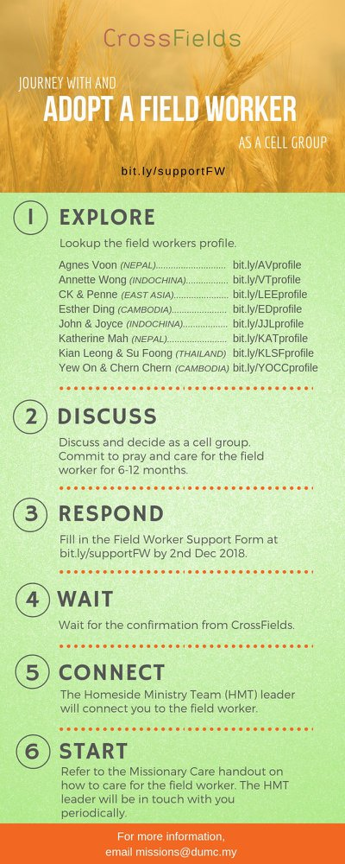
As a cell group explore this as a commitment to support missions through prayer and encouragement.

When we support them in this way, we join them in the work of the Lord in these nations to reach out to people groups whom the Lord loves and who have yet to hear & receive the Gospel into their lives.

- CMS: Steps to Fill in the Salvation Form
- Select “More”
- “Form”
- Select “Form Lit” box
- Look for “Salvation Form”
- Fill in form of new salvation by “Change Respondent”
- Must have “E-mail” and “Mobile Phone”

UPCOMING

PREACHING SCHEDULE

Jan 5&6 | Stepping Forward With The Spirit | Sr Pr Chris Kam
Jan 12&13 | Stepping Forward In Community | Sr Pr Chris Kam
Jan 19&20 | Stepping Forward In Leadership | Sr Pr Chris Kam
Jan 26&27 | Stepping Forward In Societal Transformation | Pr Dato’ Dr Daniel Ho

Go to: http://www.dumc.my/resources/sermons/ for the latest info.

EVENT HIGHLIGHTS

  - Church Prayer Altar
Every Saturday | 7.00 -9.00am | Room 101 & 102
Let us come and seek the face of God. Prayer precedes everything.

  - PARENT SUPPORT PARENT (PSP)
Topic: Raising Kingdom Kids 12 & 26 Jan, 9 & 23 Feb, 9 & 23 Mar 2019
Time: 3.00pm-4.30pm
Venue: Cafe Function Room, Dream Centre
Sign up at bit.ly/psp_parenting

  - W2W MOMENTS BEGINS FEB 2019!
Moments are a platform for ladies from all walks of life to come together for a time of mutual encouragement and fellowship through Bible Study.
Every 3rd Sat | 8.30am-11.00am | Hall 3, DC
Alternate Tues | 9.00am-11.30am | SS15 & Room 109, DC
Alternate Wed | 9.00am-11.30am | Ara D’sara & BU4
Register at bit.ly/moments2019

  - WANT TO JOIN THE DUMC FAMILY?
Here are the steps:
> Join a Cell Group (You can get help at our CG Kiosk)
> Attend Basic Christianity 101 > Attend DUMC 101
> Join an Encounter Weekend
> Baptism & Membership Interview Sign up at the Info Counter or online at dumc.my/equip

EQUIP COURSES

DUMC 101

Saturday | 26 Jan | 8.30am-1.00pm

BAPTISM & MEMBERSHIP ENCOUNTER WEEKEND

Saturday & Sunday (stay-in) • 16-17 Feb

CHRISTIAN LIVING 101 (My New Life)

Sundays | 9 Feb-30 Mar | 8.00am-9.30am

BIBLE 101 (Understanding the Bible)

Saturdays | 2 & 9 Feb | 8.30am-1.00pm

EXPLICIT GOSPEL (W/ MATT CHANDLER)

Sundays | 24 Feb-7 Apr | 8.00am-9.30am | Hall 3

HEBREWS PART 1 (REPEAT)

Sundays | 24 Feb-14 Apr | 8.00am-9.30am | Hall 2

