CONTENTS

Worship
Word
Works
Upcoming:
Preaching Schedule
Event Highlights
Equip courses

WORSHIP (Praise and Prayer)

- Malaysia: Justice for the Poor & Suffering

“This poor man cried out, and the Lord heard and delivered him from all of his distress.” (Psalm 34:6, International Standard Version)

“Loving God, You hear the cry of each of Your children, and especially those who are poor and suffering. We pray that we, too, might hear the cries of people in need: The family crying out for food …. The migrant child crying out for his mother …. The youth crying out for education …. The farmer crying out for rains for his harvest … The trafficked and abused, crying out for freedom … All of who are poor and vulnerable, crying out for help … Lord, open our hearts that we may hear the cries of the poor as You do and respond as Your hands and feet on earth. In Your Name we pray, Amen.” (Source: Catholic Relief Services)
- International: Venezuela

Despite having some of the world’s largest oil reserves, many people suffer in poverty. Over half of the urban population - over a million people - live in slums often controlled by gangs or drug barons. As a result of falling oil prices and restrictive policies, Venezuela has faced severe economic crises, leading to widespread critical shortages of food and medicine. Political corruption, divisions, revolutions, and coup attempts have plagued this troubled nation.
Pray for:
- Christ to reveal himself to those blinded by spiritism and other false religions.
- All 30 Amerindian tribes to be transformed by the Word of God despite government opposition.
- Solutions to economic instability and high crime rates.
- God to use the Venezuelan Church to bring the peace of Jesus Christ to a nation in much turmoil.

WORD (60 minutes)

Studies in the Book of Galatians 1
Paul & the Gospel
(Galatians 1:1-2:21)
Senior Pastor, Chris Kam

- Read the scripture passage.
- Do a THREE-MINUTE SUMMARY of the sermon highlighting the KEY POINTS. Do not preach the whole sermon again, as majority of your members would have heard the sermon already. Allocate more time for sharing in the cell through the application questions below.
- Sermon Resource at: http://www.dumc.my/resources/sermons/

Reflection & Application Questions:

      - What is the most significant thing the Holy Spirit spoke to you about through this sermon?
      - In your own words, answer this question in two to four lines: What is the Gospel?
      - What are the requirements for salvation? Based on your understanding, are you truly saved? How? (If you are not sure, get someone to pray with you.) Share how you became a Christian.
      - Have you ever been told or heard of additional requirements for salvation? Give some examples. How do you know what to believe or when to defend the Gospel against wrong teachings?
      - What does Galatians 2:20 mean to you? How does Christ living in you help you to live the Christian life?

Note to Word leader:
As you are preparing for this session, this is a great time to pray that the Holy Spirit will guide you to use the questions efficaciously. You can select, modify or entirely create your own questions, according to the needs of your CG, especially if you feel that there are too many questions than required for the allocated time.

Note to Cell Groups that have children during meeting:
We recognize several cell groups in DUMC may have 5 or more children joining them during Cell Group meetings. We would like to get them engaged as well during the session therefore we are suggesting for CGs to use Manna Pad and assign someone in rotation to facilitate them after worship. Here is the link to the Manna Pad materials http://dumc.my/resources/downloads/

WORKS (Ministry and Bearing Witness)

Cell leaders to ask these two important questions or share with one another during Works session in every CG meeting.

    - Who have I met, praying for and sharing Christ with?
    - What is the Holy Spirit saying about the community I am in?

- Share Your Story (Your Story, His Glory)
- Whether your story is about how you came to know Christ, of illness healed, an act of kindness in your times of need, or of how you served people or how people have served you, give glory to God. Share your story so that more people will be encouraged and God's love is known.
- If there are any good testimonies, ask your members to write out their testimonies and submit to the church: http://dumc.my/connect/individual-care/share-your-story/

- Personal: Bible Reading and Journaling
- Subscribe to the Bible Reading Plan from: YouVersion – OwnIt365 New Testament (NT)+ Plan.
- Request one of your members to share a journal entry. Pair up members to share with, and pray for one another.

- Scripture Memory

Every cell meeting, do get your cell members to recite the following together:

Galatians 5:22-26 (Theme verse for 2019)

²² But the fruit of the Spirit is love, joy, peace, forbearance, kindness, goodness, faithfulness, ²³ gentleness and self-control. Against such things there is no law. ²⁴ Those who belong to Christ Jesus have crucified the flesh with its passions and desires. ²⁵ Since we live by the Spirit, let us keep in step with the Spirit. ²⁶ Let us not become conceited, provoking and envying each other

- CrossFields

“Crossing into the harvest field with the message of the Cross”
Myanmar | 8-15 Mar
Cambodia | 21-29 Mar
Sabah | 21-24 Mar
Sarawak Iban | 21-29 Mar

MCPP1 | 23-24 Mar | Empress Hotel Sepang Contact Eunice at 03 79587388 or eunice.tan@dumc.my

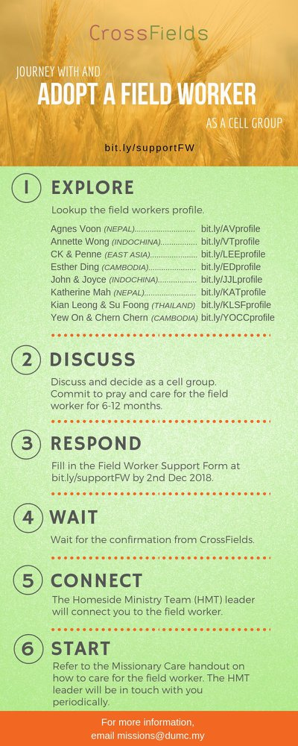

- CMS: Steps to Fill in the Salvation Form
- Select “More”
- “Form”
- Select “Form Lit” box
- Look for “Salvation Form”
- Fill in form of new salvation by “Change Respondent”
- Must have “E-mail” and “Mobile Phone”

UPCOMING

PREACHING SCHEDULE

Feb 23&24 | Studies in the Book of Galatians 2 | Pr Dato’ Kee Sue Sing
Mar 02&03 | Studies in the Book of Galatians 3 | Sr Pr. Chris Kam
Mar 09&10 | Studies in the Book of Galatians 4 | Pr. Mike Ngui
Mar 16&17 | Studies in the Book of Galatians 5 | Sr Pr. Chris Kam

Go to: http://www.dumc.my/resources/sermons/ for the latest info.

EVENT HIGHLIGHTS

  - Church Prayer Altar
Every Saturday | 7.00 -9.00am | Room 101 & 102
Let us come and seek the face of God. Prayer precedes everything.

  - PARENT SUPPORT PARENT (PSP)
Topic: Raising Kingdom Kids 9 & 23 Feb, 9 & 23 Mar 2019
Time: 3.00pm-4.30pm
Venue: Cafe Function Room, Dream Centre
Sign up at bit.ly/psp_parenting

  - WANT TO JOIN THE DUMC FAMILY?
Here are the steps:
> Join a Cell Group (You can get help at our CG Kiosk)
> Attend Basic Christianity 101 > Attend DUMC 101
> Join an Encounter Weekend
> Baptism & Membership Interview Sign up at the Info Counter or online at dumc.my/equip

EQUIP COURSES

EXPLICIT GOSPEL (W/ MATT CHANDLER)

Sundays | 24 Feb-7 Apr | 8.00am-9.30am | Hall 3

HEBREWS PART 1 (REPEAT)

Sundays | 24 Feb-14 Apr | 8.00am-9.30am | Hall 2

        - UNDERSTANDING THE BIBLE (101)

Saturdays | 2 Mar – 9 Mar | 8.30am-1.00pm | Room 108

ANNOUNCEMENT

