CONTENTS

Worship
Word
Works
Upcoming:
Preaching Schedule
Event Highlights
Equip courses

WORSHIP (Praise and Prayer)

- Malaysia: Justice for the Poor & Suffering

“The LORD is a refuge for the oppressed, a stronghold in times of trouble.” (Psalm 9:9)
Pray for the oppressed/weak/poor:
- That the disabled and ageing will be cared for.
- For “justice to flow like a river” for the least, the last, the lost and the little.
- Their Salvation (Luke 4:18)

Pray for workers among the people
- More workers to go to the urban poor.
- These workers will have endurance and grace from God to live in difficult circumstances alongside those they are there to reach.
- Christians to reach out in love to the marginalised, the vulnerable, the forgotten, and the neglected in society.

- International: Winter storms compound refugee miseries in Lebanon

Winter is always a difficult season for Syrian refugees in Lebanon. This year, it’s even worse. The mere act of daily survival is a struggle. Few tents could withstand two major winter storms in twelve days - Norma and Miriam - so refugee families are looking for shelter wherever they can find it. According to Heart for Lebanon, these families have few to no options. Physical help and the hope of Christ go far in times like these. Heart for Lebanon is bringing both to as many refugees as they can.
Pray for:
- Urgently-needed items like plastic sheeting, wooden poles, mattresses, blankets, winter clothes, and food.
- The hope of Christ’s resurrection to shine brightly in hearts darkened by despair.
- Reconciliation through spiritual discipleship - pray for the building of authentic relationships with families; for opportunities to hear the gospel and openness to attend Bible studies, women’s gatherings, and special events.

WORD (60 minutes)

Family Matters: Crazy Rich Christians
(Ephesians 1:3-10, 1 John 5:1-5)
Pastor Alex Tan

- Read the scripture passage.
- Do a THREE-MINUTE SUMMARY of the sermon highlighting the KEY POINTS. Do not preach the whole sermon again, as majority of your members would have heard the sermon already. Allocate more time for sharing in the cell through the application questions below.
- Sermon Resource at: http://www.dumc.my/resources/sermons/

Reflection & Application Questions:

      - How were your time spent with your family member or loved ones over the Chinese New Year Holidays? What are you grateful for your family for? How can you be more engaging and life giving to your family or loved ones?

Note to Word leader:
As you are preparing for this session, this is a great time to pray that the Holy Spirit will guide you to use the questions efficaciously. You can select, modify or entirely create your own questions, according to the needs of your CG, especially if you feel that there are too many questions than required for the allocated time.

Note to Cell Groups that have children during meeting:
We recognize several cell groups in DUMC may have 5 or more children joining them during Cell Group meetings. We would like to get them engaged as well during the session therefore we are suggesting for CGs to use Manna Pad and assign someone in rotation to facilitate them after worship. Here is the link to the Manna Pad materials http://dumc.my/resources/downloads/

WORKS (Ministry and Bearing Witness)

Cell leaders to ask these two important questions or share with one another during Works session in every CG meeting.

    - Who have I met, praying for and sharing Christ with?
    - What is the Holy Spirit saying about the community I am in?

- Share Your Story (Your Story, His Glory)
- Whether your story is about how you came to know Christ, of illness healed, an act of kindness in your times of need, or of how you served people or how people have served you, give glory to God. Share your story so that more people will be encouraged and God's love is known.
- If there are any good testimonies, ask your members to write out their testimonies and submit to the church: http://dumc.my/connect/individual-care/share-your-story/

- Personal: Bible Reading and Journaling
- Subscribe to the Bible Reading Plan from: YouVersion – OwnIt365 New Testament (NT)+ Plan.
- Request one of your members to share a journal entry. Pair up members to share with, and pray for one another.

- Scripture Memory

Every cell meeting, do get your cell members to recite the following together:

Galatians 5:22-26 (Theme verse for 2019)

²² But the fruit of the Spirit is love, joy, peace, forbearance, kindness, goodness, faithfulness, ²³ gentleness and self-control. Against such things there is no law. ²⁴ Those who belong to Christ Jesus have crucified the flesh with its passions and desires. ²⁵ Since we live by the Spirit, let us keep in step with the Spirit. ²⁶ Let us not become conceited, provoking and envying each other.

- CrossFields

“Crossing into the harvest field with the message of the Cross”
Myanmar | 8-15 Mar
Cambodia | 21-29 Mar
Sabah | 21-24 Mar
Sarawak Iban | 21-29 Mar

MCPP1 | 23-24 Mar | Empress Hotel Sepang Contact Eunice at 03 79587388 or eunice.tan@dumc.my

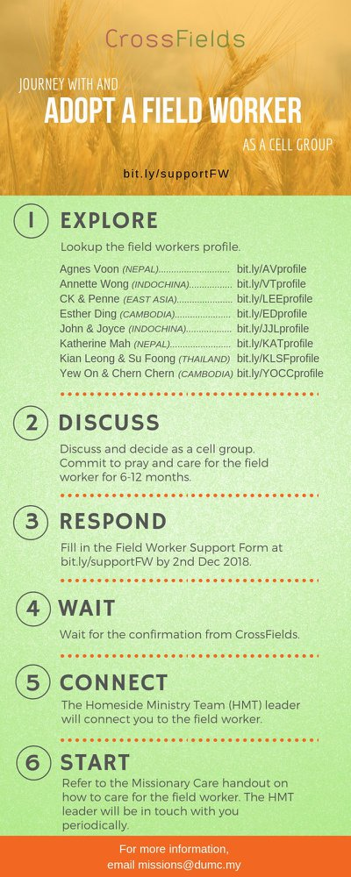

- CMS: Steps to Fill in the Salvation Form
- Select “More”
- “Form”
- Select “Form Lit” box
- Look for “Salvation Form”
- Fill in form of new salvation by “Change Respondent”
- Must have “E-mail” and “Mobile Phone”

UPCOMING

PREACHING SCHEDULE

Feb 16&17 | Studies in the Book of Galatians 1 | Sr Pr Chris Kam
Feb 23&24 | Studies in the Book of Galatians 2 | Pr Dato’ Kee Sue Sing
Mar 02&03 | Studies in the Book of Galatians 3 | Sr Pr. Chris Kam
Mar 09&10 | Studies in the Book of Galatians 4 | Pr Mike Ngui

Go to: http://www.dumc.my/resources/sermons/ for the latest info.

EVENT HIGHLIGHTS

  - Church Prayer Altar
Every Saturday | 7.00 -9.00am | Room 101 & 102
Let us come and seek the face of God. Prayer precedes everything.

  - PARENT SUPPORT PARENT (PSP)
Topic: Raising Kingdom Kids 9 & 23 Feb, 9 & 23 Mar 2019
Time: 3.00pm-4.30pm
Venue: Cafe Function Room, Dream Centre
Sign up at bit.ly/psp_parenting

  - W2W MOMENTS BEGINS FEB 2019!
Moments are a platform for ladies from all walks of life to come together for a time of mutual encouragement and fellowship through Bible Study.
Every 3rd Sat | 8.30am-11.00am | Hall 3, DC
Alternate Tues | 9.00am-11.30am | SS15 & Room 109, DC
Alternate Wed | 9.00am-11.30am | Ara D’sara & BU4
Register at bit.ly/moments2019

  - WANT TO JOIN THE DUMC FAMILY?
Here are the steps:
> Join a Cell Group (You can get help at our CG Kiosk)
> Attend Basic Christianity 101 > Attend DUMC 101
> Join an Encounter Weekend
> Baptism & Membership Interview Sign up at the Info Counter or online at dumc.my/equip

EQUIP COURSES

BAPTISM & MEMBERSHIP ENCOUNTER WEEKEND

Saturday & Sunday (stay-in) • 16-17 Feb

EXPLICIT GOSPEL (W/ MATT CHANDLER)

Sundays | 24 Feb-7 Apr | 8.00am-9.30am | Hall 3

HEBREWS PART 1 (REPEAT)

Sundays | 24 Feb-14 Apr | 8.00am-9.30am | Hall 2

ANNOUNCEMENT

Early bird price extended for one more week! Sign up & pay by 17 Feb 2019 to enjoy the conference for only RM150!

