CONTENTS

Worship
Word
Works
Upcoming:
Preaching Schedule
Event Highlights
Equip courses

WORSHIP (Praise and Prayer)

- Malaysia: Women & Girls

Pray:
- Enforcement of laws protecting young girls from being trafficked or abused

- International: North Korea
North Korea’s capital Pyongyang was once called the “Jerusalem of the East”, but now it can no longer claim that title, as many of its Christians have fled to South Korea during the Korean Way. Instead, the doctrine of Juche has become a religion, with the Kims as its deities. Information about the Christian church in North Korea today is limited, but it is known to survive in the face of intense persecution. It has become an underground church where meetings and worship must be held in secret and members know that if they are caught they could be thrown in prison or sent to a labour camp. Owing to strict government control of the media, most North Koreans have never heard the name of Jesus.

Pray for:
- Almighty God to deliver a nation long enslaved by a brutal regime
- The Church to persevere and multiply amid horrific persecution
- God’s truth to reign and liberate the nation from the regime’s indoctrination and lies

WORD (60 minutes)

Studies in the Book of Galatians IV
Set Free for Life!
(Galatians 5:1-13)
Pastor Mike Ngui

Big Idea: Christ set us free to truly live and live

- Read the scripture passage.
- Do a THREE-MINUTE SUMMARY of the sermon highlighting the KEY POINTS (Christ set us free for freedom; we must stand firm to live free; we are called to live right and free). Do not preach the whole sermon again, as majority of your members would have heard the sermon already. Allocate more time for sharing in the cell through the application questions below.
- Sermon Resource at: http://www.dumc.my/resources/sermons/

Reflection & Application Questions:

Option: Show this movie clip from the movie - Annie (1982) – as an intro:
https://www.youtube.com/watch?v=_nM_-CFRBS8

      - What is the most significant thing that the Holy Spirit spoke to you about through the sermon or this movie clip?

      - Why did Christ set us free and what does it mean to live a life of freedom? What does the abundant life truly mean (cf. John 10:10)? Illustrate this.

      - What are some of your challenges to stand firm to live free? Is your foundation based on the Gospel of Jesus Christ and in it alone? What evidences or examples in your life are there to support your stand?

      - How can we, as a cell group, visibly demonstrate ‘live right, expressing faith through love and in humble service’? (You may want to introduce the Easter Pack and plan for the Easter with your CG)

Note to Word leader:
As you are preparing for this session, this is a great time to pray that the Holy Spirit will guide you to use the questions efficaciously. You can select, modify or entirely create your own questions, according to the needs of your CG, especially if you feel that there are too many questions than required for the allocated time.

Note to Cell Groups that have children during meeting:
We recognize several cell groups in DUMC may have 5 or more children joining them during Cell Group meetings. We would like to get them engaged as well during the session therefore we are suggesting for CGs to use Manna Pad and assign someone in rotation to facilitate them after worship. Here is the link to the Manna Pad materials http://dumc.my/resources/downloads/

WORKS (Ministry and Bearing Witness)

Cell leaders to ask these two important questions or share with one another during Works session in every CG meeting.

    - Who have I met, praying for and sharing Christ with?
    - What is the Holy Spirit saying about the community I am in?

- Share Your Story (Your Story, His Glory)
- Whether your story is about how you came to know Christ, illness healed, an act of kindness in your times of need, or of how you served people or how people have served you, give glory to God. Share your story so that people will be encouraged and God's love is known.
- If there are any good testimonies, ask your members to write out their testimonies and submit to the church: http://dumc.my/connect/individual-care/share-your-story/

- Personal: Bible Reading and Journaling
- Subscribe to the Bible Reading Plan app: YouVersion – OwnIt365 New Testament (NT)+ Plan.
- Request one of your members to share a journal entry. Pair up members to share with, and pray for one another.

- Scripture Memory

Every cell meeting, do get your cell members to recite the following together:

Galatians 5:25 (Theme verse for 2019)
Since we live by the Spirit, let us keep in step with the Spirit.

Galatians 2:20 (added from March 2019)
I have been crucified with Christ and I no longer live, but Christ lives in me. The life I now live in the body, I live by faith in the Son of God, who loved me and gave himself for me.

- CrossFields
“Crossing into the harvest field with the message of the Cross”

Sarawak Iban | 19-22 Apr; 17-20 May
Nepal | 25 Apr-5 May
Sarawak Penan | 25-31 May
MCPP1 | 23-24 Mar | Empress Hotel Sepang

Website: dumc.my/missions Mission Trip dates: bit.ly/CF2019cal

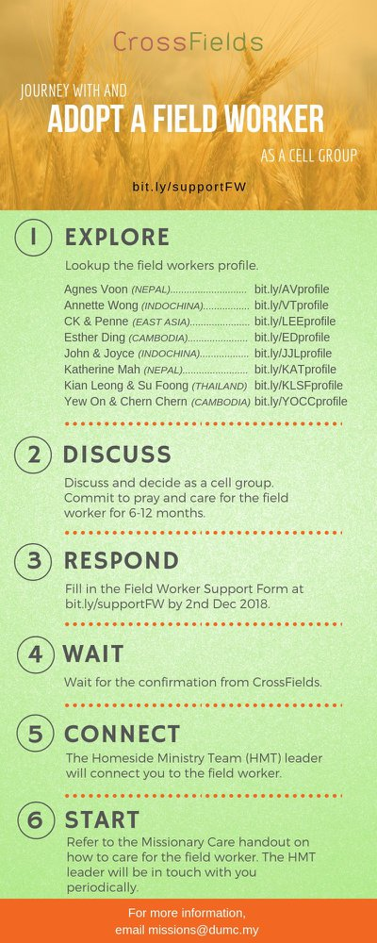

- CMS: Steps to Fill in the Salvation Form
- Select “More”
- “Form”
- Select “Form Lit” box
- Look for “Salvation Form”
- Fill in form of new salvation by “Change Respondent”
- Must have “E-mail” and “Mobile Phone”

UPCOMING

PREACHING SCHEDULE

Mar 16&17 | The Fruit of the Spirit | Sr Pr. Chris Kam
Mar 23&24 | Essential Women’s Conference Weekend | Stella Hoh
Mar 30&31 | The Christian’s Duty | Sr Pr Chris Kam
Apr 6&7 | Sowing and Reaping | Pr Mike Ngui

Go to: http://www.dumc.my/resources/sermons/ for the latest info.

EVENT HIGHLIGHTS

  - Church Prayer Altar
Every Saturday | 7.00 -9.00am | Room 101 & 102
Let us come and seek the face of God. Prayer precedes everything.

  - WANT TO JOIN THE DUMC FAMILY?
Here are the steps:
> Join a Cell Group (You can get help at our CG Kiosk)
> Attend Basic Christianity 101 > Attend DUMC 101
> Join an Encounter Weekend
> Baptism & Membership Interview Sign up at the Info Counter or online at dumc.my/equip

EQUIP COURSES 2019

EVANGELISM 101 (Simple Evangelism)

Saturday | 16 Mar | 8.30am-1.00pm

CHRISTIAN LEADERSHIP 201

Saturdays | 13 & 20 Apr | 8.30am-1.00pm

        - PRAYER 101 (The Lord’s Prayer)

Sundays | 14 Apr – 2 Jun | 8.00am-9.30am | (excluding 21 Apr & 19 May)

MINISTRY 201 (Finding Your Fit)

Saturday | 13 Apr | 8.30am-1.00pm

MINISTRY 202 (Moving in the Gifts of the Holy Spirit)

Saturdays | 27 Apr & 4 May | 8.30am-1.00pm

ANNOUNCEMENT

