CONTENTS

Worship (3rd week of the month, kindly organize the Lord’s Supper)
Word
Works
Upcoming:
Preaching Schedule
Event Highlights
Equip courses

WORSHIP (Praise and Prayer)

Reminder to conduct the Lord’s Supper this week.
Kindly refer to the guide sent to all Leaders on this topic via email previously.

WORD (60 minutes)

Studies in the Book of Galatians V
The Fruit of the Spirit
(Galatians 5:14-26)
Senior Pastor Chris Kam

Big Idea: Plugged in (i.e. plug into the Spirit of God)

- Read the scripture passage.
- Do a THREE-MINUTE SUMMARY of the sermon highlighting the KEY POINTS (Acts of the Flesh, Fruit of the Spirit, How do we do that?). Do not preach the whole sermon again, as majority of your members would have heard the sermon already. Allocate more time for sharing in the cell through the application questions below.
- Sermon Resource at: http://www.dumc.my/resources/sermons/

Reflection & Application Questions:

      - What is the most significant thing that the Holy Spirit spoke to you about through this sermon?

      - In Gal 5:17, what two things are in conflict? Can you describe them in the context of your everyday life? When we find ourselves frustrated by the desires of the flesh, how do we avoid discouragement?

      - What keeps us engaged in the fight against the flesh? In view of Galatians 5:19-21, what sinful acts are dead and buried in your life? What are still alive and well?

      - Which aspects of the spiritual fruit are blossoming in your life? Which are still in the bud?

      - How does being “plugged in” to the Holy Spirit help you crucify your sinful nature (v. 24) and allow the fruit of the Spirit to grow? Describe some “plugged in” initiatives in the context of the two points: “More of us surrendered” (v. 24) and “More of Him invited” (v. 25).

Note to Word leader:
As you are preparing for this session, this is a great time to pray that the Holy Spirit will guide you to use the questions efficaciously. You can select, modify or entirely create your own questions, according to the needs of your CG, especially if you feel that there are too many questions than required for the allocated time.

Note to Cell Groups that have children during meeting:
We recognise several cell groups in DUMC may have 5 or more children joining them during Cell Group meetings. We would like to get them engaged as well during the session therefore we are suggesting for CGs to use Manna Pad and assign someone in rotation to facilitate them after worship. Here is the link to the Manna Pad materials http://dumc.my/resources/downloads/

WORKS (Ministry and Bearing Witness)

Cell leaders to ask these two important questions or share with one another during Works session in every CG meeting.

    - Who have I met, praying for and sharing Christ with?
    - What is the Holy Spirit saying about the community I am in?

- Share Your Story (Your Story, His Glory)
- Whether your story is about how you came to know Christ, illness healed, an act of kindness in your times of need, or of how you served people or how people have served you, give glory to God. Share your story so that people will be encouraged and God's love is known.
- If there are any good testimonies, ask your members to write out their testimonies and submit to the church: http://dumc.my/connect/individual-care/share-your-story/

- Personal: Bible Reading and Journaling
- Subscribe to the Bible Reading Plan app: YouVersion – OwnIt365 New Testament (NT)+ Plan.
- Request one of your members to share a journal entry. Pair up members to share with, and pray for one another.

- Scripture Memory
Every cell meeting, do get your cell members to recite the following together:

Galatians 5:25 (Theme verse for 2019)
Since we live by the Spirit, let us keep in step with the Spirit.

Galatians 2:20 (added from March 2019)
I have been crucified with Christ and I no longer live, but Christ lives in me. The life I now live in the body, I live by faith in the Son of God, who loved me and gave himself for me.

- CrossFields
“Crossing into the harvest field with the message of the Cross”

Sarawak Iban | 19-22 Apr; 17-20 May
Nepal | 25 Apr-5 May
Sarawak Penan | 25-31 May
MCPP1 | 23-24 Mar | Empress Hotel Sepang

Website: dumc.my/missions Mission Trip dates: bit.ly/CF2019cal

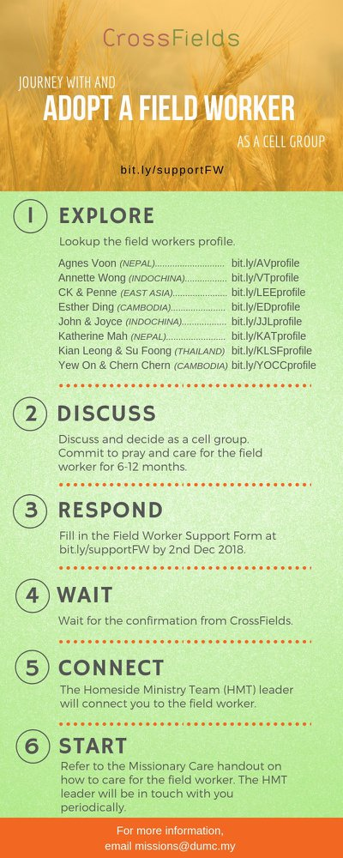

- CMS: Steps to Fill in the Salvation Form
- Select “More”
- “Form”
- Select “Form Lit” box
- Look for “Salvation Form”
- Fill in form of new salvation by “Change Respondent”
- Must have “E-mail” and “Mobile Phone”

UPCOMING

PREACHING SCHEDULE

Mar 23&24 | Essential Women’s Conference Weekend:  I have a Dream | Stella Hoh
Mar 30&31 | The Christian’s Duty | Sr Pr Chris Kam
Apr 6&7 | Sowing and Reaping | Pr Mike Ngui

Go to: http://www.dumc.my/resources/sermons/ for the latest info.

EVENT HIGHLIGHTS

  - Tuesday Night Encounters (NEW!)
Every 3rd Tuesday of every month | 8.30 -10.00pm | Auditorium
A night focusing on prayer, healing and deliverance
For more information, contact: forerunners@dumc.my

  - Church Prayer Altar
Every Saturday | 7.00 -9.00am | Room 101 & 102
Let us come and seek the face of God. Prayer precedes everything.

  - WANT TO JOIN THE DUMC FAMILY?
Here are the steps:
> Join a Cell Group (You can get help at our CG Kiosk)
> Attend Basic Christianity 101 > Attend DUMC 101
> Join an Encounter Weekend
> Baptism & Membership Interview Sign up at the Info Counter or online at dumc.my/equip

EQUIP COURSES 2019

CHRISTIAN LEADERSHIP 201

Saturdays | 13 & 20 Apr | 8.30am-1.00pm

        - PRAYER 101 (The Lord’s Prayer)

Sundays | 14 Apr – 2 Jun | 8.00am-9.30am | (excluding 21 Apr & 19 May)

MINISTRY 201 (Finding Your Fit)

Saturday | 13 Apr | 8.30am-1.00pm

MINISTRY 202 (Moving in the Gifts of the Holy Spirit)

Saturdays | 27 Apr & 4 May | 8.30am-1.00pm

DUMC 101 (Membership Requirement)

Saturday | 4 May | 8.30am-1.00pm

ANNOUNCEMENT

