CONTENTS

Worship
Word
Works
Upcoming:
Preaching Schedule
Event Highlights
Equip courses

WORSHIP (Praise and Prayer)

- Malaysia: Suhakam Inquiry into the disappearances of Pastor Raymond Koh & Amri Che Mat
At the close of the proceedings on 6 March, Suhakam Commissioner, Mah Weng Kwai, fixed 3 April for delivery of the Inquiry Panel decision, to be held at the Human Rights Commission offices.
Pray for:
- The appointment of a new impartial investigation team, with powers to prosecute and arrest, and which will get access even to documents classified under the Official Secrets Act (OSA).
- A positive response to the memorandum which Susanna Liew (wife of Pr Raymond Koh) and Pn Norhayati Ariffin (wife of Amri Che Mat) had submitted to Prime Minister Tun Dr Mahathir Mohamad.

- International: New Zealand
The nation of New Zealand faces growing secularism, which has infiltrated education and political policies. In 1951, only 1% of New Zealanders identified themselves as non-religious but by 2010, the number had grown to 41%! It is estimated that by 2020, Christianity will cease to be the majority religion and will be replaced by non-religious thought. The Church is in great need of unity amidst growing indifference. Pray that God’s Truth will show the way for a society increasingly lost in darkness.

Pray for:
- The Holy Spirit to humble an independent and secular people.
- Committed Christian leaders to rise up from among the Maori.
- Immigrant believers to be bold proclaimers of the faith.
- The nation is grieving over unexpected tragedy. Pray for God’s comfort and His healing grace for all affected.

WORD (60 minutes)

Studies in the book of Galatians VI:
The Christian’s Duty
(Galatians 6:2-5)
Senior Pastor Chris Kam

Big Idea: Carry Each Other’s Burden

- Read the scripture passage.
- Do a THREE-MINUTE SUMMARY of the sermon highlighting the KEY POINTS (The Task, The Test, The Trust). Do not preach the whole sermon, as majority of your members would have heard the sermon already. Allocate more time for sharing in the cell through the application questions below.
- Sermon Resource at: http://www.dumc.my/resources/sermons/

Illustrative reference options

Which of these pictures below remind you of the sermon shared from Gal. 6:1-5? Explain. If you identify with these pictures personally or know of someone who does, do share more.
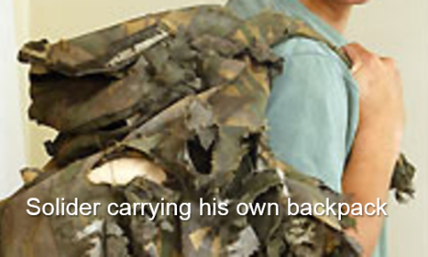
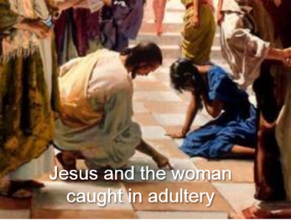

Reflection & Application Questions:

      - What is the most significant thing that the Holy Spirit spoke to you about through this sermon?

      - Have you ever been confronted by a Christian brother or sister about a wrong you had committed? What was that experience like and how did you feel? Were you built up or put off by that experience? What was done right, or what could have been done better?

      - What loving postures should we adopt from Gal 6:1 when we confront someone about their sins? How would you like to be treated if you were on the receiving end? Why did Apostle Paul warn them about this: “But watch yourselves, or you also may be tempted.”

      - Why is comparing ourselves with others so damaging at times? What does v4 mean?

      - As a CG, discuss this. Would you as members of this CG be loving enough to exercise Gal 6:1? Why? How do you think you can give permission to one another to do this lovingly?

Note to Word leader:
As you are preparing for this session, this is a great time to pray that the Holy Spirit will guide you to use the questions efficaciously. You can select, modify or entirely create your own questions, according to the needs of your CG, especially if you feel that there are too many questions than required for the allocated time.

Note to Cell Groups that have children during meeting:
We recognise several cell groups in DUMC may have 5 or more children joining them during Cell Group meetings. We would like to get them engaged as well during the session therefore we are suggesting for CGs to use Manna Pad and assign someone in rotation to facilitate them after worship. Here is the link to the Manna Pad materials http://dumc.my/resources/downloads/

WORKS (Ministry and Bearing Witness)

Cell leaders to ask these two important questions or share with one another during Works session in every CG meeting.

    - Who have I met, praying for and sharing Christ with?
    - What is the Holy Spirit saying about the community I am in?

- Share Your Story (Your Story, His Glory)
- Whether your story is about how you came to know Christ, illness healed, an act of kindness in your times of need, or of how you served people or how people have served you, give glory to God. Share your story so that people will be encouraged and God's love is known.
- If there are any good testimonies, ask your members to write out their testimonies and submit to the church: http://dumc.my/connect/individual-care/share-your-story/

- Personal: Bible Reading and Journaling
- Subscribe to the Bible Reading Plan app: YouVersion – OwnIt365 New Testament (NT)+ Plan.
- Request one of your members to share a journal entry. Pair up members to share with, and pray for one another.

- Scripture Memory
Every cell meeting, do get your cell members to recite the following together:

Galatians 5:25 (Theme verse for 2019)
Since we live by the Spirit, let us keep in step with the Spirit.

Galatians 2:20 (added from March 2019)
I have been crucified with Christ and I no longer live, but Christ lives in me. The life I now live in the body, I live by faith in the Son of God, who loved me and gave himself for me.

- CrossFields
“Crossing into the harvest field with the message of the Cross”

Sarawak Iban | 17-20 May
Sarawak Penan | 25-31 May
Thailand | 1-7 Jun
Vietnam | 14-18 Jun
MCPP1| 20-21 Jul | Empress Hotel (Sepang)

Website: dumc.my/missions Mission Trip dates: bit.ly/CF2019cal

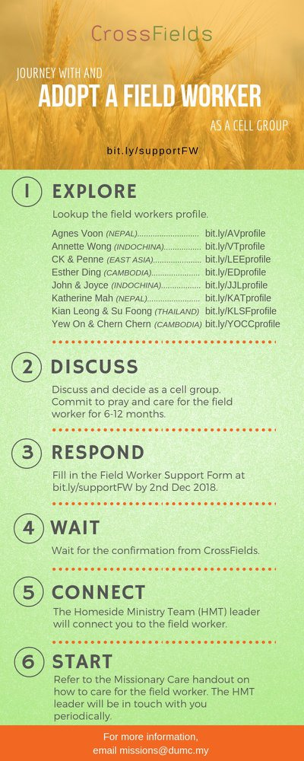

- CMS: Steps to Fill in the Salvation Form
- Select “More”
- “Form”
- Select “Form Lit” box
- Look for “Salvation Form”
- Fill in form of new salvation by “Change Respondent”
- Must have “E-mail” and “Mobile Phone”

UPCOMING

PREACHING SCHEDULE

Apr 6&7 | Sowing and Reaping | Pr Mike Ngui

Go to: http://www.dumc.my/resources/sermons/ for the latest info.

EVENT HIGHLIGHTS

  - AFTER7
6 Apr | 7.00 -10.00pm | Dream Centre
Food, fun, friendship made alive here again! See you then!

  - Tuesday Night Encounters (NEW!)
Every 3rd Tuesday of every month | 8.30 -10.00pm | Auditorium
A night focusing on prayer, healing and deliverance
For more information, contact: forerunners@dumc.my

  - Church Prayer Altar
Every Saturday | 7.00 -9.00am | Room 101 & 102
Let us come and seek the face of God. Prayer precedes everything.

  - WANT TO JOIN THE DUMC FAMILY?
Here are the steps:
> Join a Cell Group (You can get help at our CG Kiosk)
> Attend Basic Christianity 101
> Attend DUMC 101
> Join an Encounter Weekend
> Baptism & Membership Interview Sign up at the Info Counter or online at dumc.my/equip

EQUIP COURSES 2019

CHRISTIAN LEADERSHIP 201

Saturdays | 13 & 20 Apr | 8.30am-1.00pm

        - PRAYER 101 (The Lord’s Prayer)

Sundays | 14 Apr – 2 Jun | 8.00am-9.30am | (excluding 21 Apr & 19 May)

MINISTRY 201 (Finding Your Fit)

Saturday | 13 Apr | 8.30am-1.00pm

MINISTRY 202 (Moving in the Gifts of the Holy Spirit)

Saturdays | 27 Apr & 4 May | 8.30am-1.00pm

DUMC 101 (Membership Requirement)

Saturday | 4 May | 8.30am-1.00pm

ANNOUNCEMENT

Do plan your CG’s Easter outreach accordingly! Focus on the cross, focus on the lost!

