CONTENTS

Worship
Word
Works
Upcoming:
Preaching Schedule
Event Highlights
Equip courses

WORSHIP (Praise and Prayer)

- Malaysia: Justice for the Poor & Suffering

“The LORD is a refuge for the oppressed, a stronghold in times of trouble.” (Psalm 9:9)
Pray:
- For NGOs and the government to address the root causes of homelessness including unemployment, breakdown in families, poverty, the increasing cost of living, and ineffective social safety nets.
- For the gospel to be preached to the poor to bring relief and hope for their suffering.
- For the poor to be used by God to usher His Kingdom into their nations
- International: Growing Persecution in the Middle East
From state-sponsored backlash to familial pressures, faith in Christ is under attack. This is increasingly true in countries dominated by radical Islamic ideologies.

Pray for His Church in the Middle East that:
- They will stand strong in the midst of persecution.
- They will be faithful to the calling of Christ on their lives.
- They will proclaim the Gospel boldly
- God will use their persecution to make His name known, and through that persecution will grow His people in faith.

WORD (60 minutes)

Studies in the Book of Galatians 2
The Christian & The Old Testament Law
(Galatians 3)
Pastor Datuk Kee Sue Sing

- Read the scripture passage.
- Do a THREE-MINUTE SUMMARY of the sermon highlighting the KEY POINTS. Do not preach the whole sermon again, as majority of your members would have heard the sermon already. Allocate more time for sharing in the cell through the application questions below.
- Sermon Resource at: http://www.dumc.my/resources/sermons/

Reflection & Application Questions:

      - Suggest a list of the benefits and blessings that come to us through faith in Christ alone. (You can take a minute to share your personal experience in coming to Christ).

      - How can you be passionate (zealous) for Christ and add spiritual disciplines to your life (reading and memorizing the Bible, prayer, fasting, etc) without being legalistic?

      - If we are really free from the law and instead live by faith in Christ, what does this mean about how we live now? Is there a certain prescribed way to live?

Note to Word leader:
As you are preparing for this session, this is a great time to pray that the Holy Spirit will guide you to use the questions efficaciously. You can select, modify or entirely create your own questions, according to the needs of your CG, especially if you feel that there are too many questions than required for the allocated time.

Note to Cell Groups that have children during meeting:
We recognize several cell groups in DUMC may have 5 or more children joining them during Cell Group meetings. We would like to get them engaged as well during the session therefore we are suggesting for CGs to use Manna Pad and assign someone in rotation to facilitate them after worship. Here is the link to the Manna Pad materials http://dumc.my/resources/downloads/

WORKS (Ministry and Bearing Witness)

Cell leaders to ask these two important questions or share with one another during Works session in every CG meeting.

    - Who have I met, praying for and sharing Christ with?
    - What is the Holy Spirit saying about the community I am in?

- Share Your Story (Your Story, His Glory)
- Whether your story is about how you came to know Christ, of illness healed, an act of kindness in your times of need, or of how you served people or how people have served you, give glory to God. Share your story so that more people will be encouraged and God's love is known.
- If there are any good testimonies, ask your members to write out their testimonies and submit to the church: http://dumc.my/connect/individual-care/share-your-story/

- Personal: Bible Reading and Journaling
- Subscribe to the Bible Reading Plan from: YouVersion – OwnIt365 New Testament (NT)+ Plan.
- Request one of your members to share a journal entry. Pair up members to share with, and pray for one another.

- Scripture Memory

Every cell meeting, do get your cell members to recite the following together:

Galatians 5:22-26 (Theme verse for 2019)

²² But the fruit of the Spirit is love, joy, peace, forbearance, kindness, goodness, faithfulness, ²³ gentleness and self-control. Against such things there is no law. ²⁴ Those who belong to Christ Jesus have crucified the flesh with its passions and desires. ²⁵ Since we live by the Spirit, let us keep in step with the Spirit. ²⁶ Let us not become conceited, provoking and envying each other

- CrossFields

“Crossing into the harvest field with the message of the Cross”
Myanmar | 8-15 Mar
Cambodia | 21-29 Mar
Sabah | 21-24 Mar
Sarawak Iban | 21-29 Mar

MCPP1 | 23-24 Mar | Empress Hotel Sepang Contact Eunice at 03 79587388 or eunice.tan@dumc.my

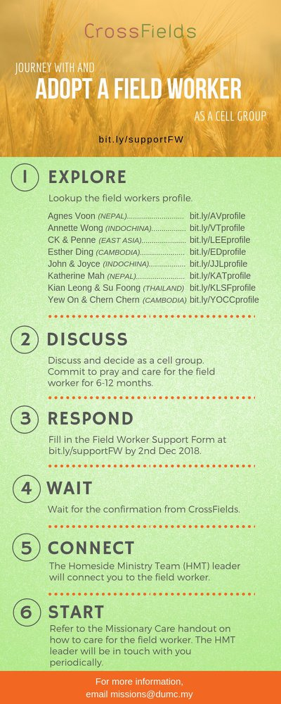

- CMS: Steps to Fill in the Salvation Form
- Select “More”
- “Form”
- Select “Form Lit” box
- Look for “Salvation Form”
- Fill in form of new salvation by “Change Respondent”
- Must have “E-mail” and “Mobile Phone”

UPCOMING

PREACHING SCHEDULE

Mar 02&03 | Studies in the Book of Galatians 3 | Sr Pr. Chris Kam
Mar 09&10 | Studies in the Book of Galatians 4 | Pr. Mike Ngui
Mar 16&17 | Studies in the Book of Galatians 5 | Sr Pr. Chris Kam
Mar 23&24 | Essential Women’s Conference Weekend | Stella Hoh

Go to: http://www.dumc.my/resources/sermons/ for the latest info.

EVENT HIGHLIGHTS

  - Church Prayer Altar
Every Saturday | 7.00 -9.00am | Room 101 & 102
Let us come and seek the face of God. Prayer precedes everything.

  - WANT TO JOIN THE DUMC FAMILY?
Here are the steps:
> Join a Cell Group (You can get help at our CG Kiosk)
> Attend Basic Christianity 101 > Attend DUMC 101
> Join an Encounter Weekend
> Baptism & Membership Interview Sign up at the Info Counter or online at dumc.my/equip

EQUIP COURSES

EXPLICIT GOSPEL (W/ MATT CHANDLER)

Sundays | 24 Feb-7 Apr | 8.00am-9.30am | Hall 3

HEBREWS PART 1 (REPEAT)

Sundays | 24 Feb-14 Apr | 8.00am-9.30am | Hall 2

        - UNDERSTANDING THE BIBLE (101)

Saturdays | 2 Mar – 9 Mar | 8.30am-1.00pm | Room 108

ANNOUNCEMENT

