CONTENTS

Worship
Word
Works
Upcoming:
Preaching Schedule
Event Highlights
Equip courses

WORSHIP (Praise and Prayer)

- Malaysia: The Judiciary
Pray for:
• The judiciary to uphold the Federal Constitution.
• Independence, impartiality and integrity of our Malaysian judiciary to apply and enforce the laws of the country on all citizens without bias.
• Independent and courageous judgments based on facts, the law and the constitution without considering whether the decision is popular or not, or whether the opposition or the government support their decisions.
• Judges:
- To deliver fair judgments in accordance to the law and evidence presented to them, which are fair and unaffected by politics or corruption.
- They will administer justice without partiality.
- For consistent judgements which reflect the integrity of the judicial system.

- International: Syria
Prayer of a Syrian Christian:

Thank You, Lord, For all that You have done and are still doing. I trust Your will is always good and finally You will turn evil to good. I know You are not silent, but patient... But how long will it take, Lord? I am looking forward to a new beginning amongst my people. My own desire is that evil will stop and that we see Your glory shine again in the darkness. I’m longing for healing, for restoration. I cry out to You, Lord. I’m longing for a new generation to take their place in Your Kingdom, To be the light and salt of this nation. Help me to see my role in this transformation. Protect me and be with me. Carry me, day by day. Amen.

WORD (60 minutes)

Repentance That Leads To Salvation
(Colossians 2:13-15,Luke 24:45-49)
Senior Pastor Chris Kam(Dream Centre)
Pastor Tan Moy How(DUMC@Puchong)

Big Idea: In seeking forgiveness, there must be repentance.

- Read the scripture passage.
- Do a THREE-MINUTE SUMMARY of the sermon highlighting the KEY POINTS (The Task, The Test, The Trust). Do not preach the whole sermon, as majority of your members would have heard the sermon already. Allocate more time for sharing in the cell through the application questions below.
- Sermon Resource at: http://www.dumc.my/resources/sermons/

Reflection & Application Questions:

      - What is the most significant thing that the Holy Spirit spoke to you about through this sermon?

      - Do you think you are a good person? How good will be good enough for GOD? What do Col 2:13, Rom 3:23 and Rom 6:23 speak about the true state of our soul? How do you see this in the light of Jer 17:9?

      - In what ways do you see yourself as a self-centred and narcissistic person? What evidence is there to suggest that?

      - What do you make of this statement: “People go to hell not because primarily they reject Jesus. They go to hell in the first place because of the wrath of God.” Discuss in the light of Rom 1:18; 2:5; 4:15; Eph 2:3.

Note to Word leader:
As you are preparing for this session, this is a great time to pray that the Holy Spirit will guide you to use the questions efficaciously. You can select, modify or entirely create your own questions, according to the needs of your CG, especially if you feel that there are too many questions than required for the allocated time.

Note to Cell Groups that have children during meeting:
We recognize several cell groups in DUMC may have 5 or more children joining them during Cell Group meetings. We would like to get them engaged as well during the session therefore we are suggesting for CGs to use Manna Pad and assign someone in rotation to facilitate them after worship. Here is the link to the Manna Pad materials http://dumc.my/resources/downloads/

WORKS (Ministry and Bearing Witness)

Cell leaders to ask these two important questions or share with one another during Works session in every CG meeting.

    - Who have I met, praying for and sharing Christ with?
    - What is the Holy Spirit saying about the community I am in?

- Share Your Story (Your Story, His Glory)
- Whether your story is about how you came to know Christ, illness healed, an act of kindness in your times of need, or of how you served people or how people have served you, give glory to God. Share your story so that people will be encouraged and God's love is known.
- If there are any good testimonies, ask your members to write out their testimonies and submit to the church: http://dumc.my/connect/individual-care/share-your-story/

- Personal: Bible Reading and Journaling
- Subscribe to the Bible Reading Plan app: YouVersion – OwnIt365 New Testament (NT)+ Plan.
- Request one of your members to share a journal entry. Pair up members to share with, and pray for one another.

- Scripture Memory
Every cell meeting, do get your cell members to recite the following together:

Galatians 5:25 (Theme verse for 2019)
Since we live by the Spirit, let us keep in step with the Spirit.

Galatians 2:20 (added from March 2019)
I have been crucified with Christ and I no longer live, but Christ lives in me. The life I now live in the body, I live by faith in the Son of God, who loved me and gave himself for me.

- CrossFields
“Crossing into the harvest field with the message of the Cross”

Sarawak Iban | 17-20 May
Sarawak Penan | 25-31 May
Thailand | 1-7 Jun
Vietnam | 14-18 Jun
MCPP1| 20-21 Jul | Empress Hotel (Sepang)

Website: dumc.my/missions Mission Trip dates: bit.ly/CF2019cal

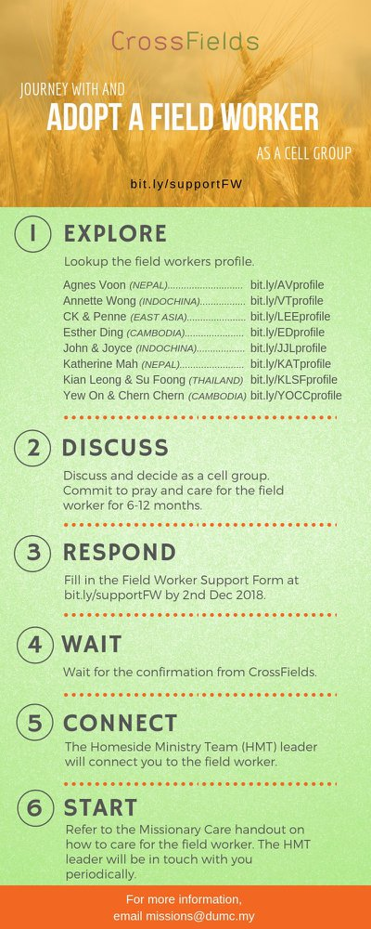

- CMS: Steps to Fill in the Salvation Form
- Select “More”
- “Form”
- Select “Form Lit” box
- Look for “Salvation Form”
- Fill in form of new salvation by “Change Respondent”
- Must have “E-mail” and “Mobile Phone”

UPCOMING

PREACHING SCHEDULE

Apr 27&28 | Called To The Marketplace | Pr Dato’Dr Daniel Ho

Go to: http://www.dumc.my/resources/sermons/ for the latest info.

EVENT HIGHLIGHTS

  - Join The Celebrations in DUMC@Puchong at 10am Every Sunday
Bring your friends and family members living around the Puchong area. Look for DUMC@Puchong on Waze or Google Maps. (Please park at IOI Business Park Level B2)

  - Tuesday Night Encounters (NEW!)
Every 3rd Tuesday of every month | 8.30 -10.00pm | Auditorium
A night focusing on prayer, healing and deliverance
For more information, contact: forerunners@dumc.my

  - Church Prayer Altar
Every Saturday | 7.00 -9.00am | Room 101 & 102
Let us come and seek the face of God. Prayer precedes everything.

  - WANT TO JOIN THE DUMC FAMILY?
Here are the steps:
> Join a Cell Group (You can get help at our CG Kiosk)
> Attend Basic Christianity 101
> Attend DUMC 101
> Join an Encounter Weekend
> Baptism & Membership Interview Sign up at the Info Counter or online at dumc.my/equip

  - SEMINAR ON THE KINGDOM OF GOD BY PASTOR NEAL PATTERSON
Come for an impactful and enlightening time.
Part 1 | 9 May (Thu) | 7.30pm-10.00pm | Hall 4
Part 2 | 11 May (Sat) | 8.30am-12.30pm | Hall 4
Register at bit.ly/DUMC2019KOG Enquiries to equip@dumc.my

- PARENTS SUPPORT PARENTS
Topic: Parenting Together (New Series)
Dates | 27/4, 11/5, 25/5, 15/6, 29/6
Time | 3.00pm-4.30pm
Venue | Café Function Room
Admission free!

EQUIP COURSES 2019

CHRISTIAN LEADERSHIP 201

Saturdays | 13 & 20 Apr | 8.30am-1.00pm

        - PRAYER 101 (The Lord’s Prayer)

Sundays | 14 Apr – 2 Jun | 8.00am-9.30am | (excluding 21 Apr & 19 May)

MINISTRY 201 (Finding Your Fit)

Saturday | 13 Apr | 8.30am-1.00pm

MINISTRY 202 (Moving in the Gifts of the Holy Spirit)

Saturdays | 27 Apr & 4 May | 8.30am-1.00pm

DUMC 101 (Membership Requirement)

Saturday | 4 May | 8.30am-1.00pm

ANNOUNCEMENT

