CONTENTS

Worship
Word
Works
Upcoming:
Preaching Schedule
Event Highlights
Equip courses

WORSHIP (Praise and Prayer)

- Malaysia: Media & Press Freedom
Pray for:
- Media practitioners to be ethical, responsible, balanced and objective, and conscientious of their power to shape the thoughts of society, as well as to be a voice to the voiceless.
- Media freedom in Malaysia to be nurtured, and its practitioners be bold in speaking out the truth.

- International: Albania
*Capital City: Tirana
∗Government: Emerging Democracy
∗Population: 3,047,987
∗Major People Groups: Albanian 82.6%, Greek 0.9%, Others 16.5%
∗Religions: Muslim 56.7%, Roman Catholic 10%, Orthodox 6.8%, Atheist 2.5%, Bektashi 2.1%, Others 5.7%, Unspecified 16.2
∗Language: Albanian
∗GDP per capita: $12,500
∗Literacy rate: 97.6%
Religious freedom granted by the government in 1998 has helped the infant Albanian church to mature. There are now organised, nationwide structures and a holistic vision for discipleship and evangelism. Almost 60% of Albanians are Muslim, while superstition and folk Islam prosper.
Pray for:
- Spiritual maturity for Albanian Christians who come from a long history of communism, atheism, or Islam.
- Christians to make use of opportunities made available by their religious freedom to minister to other non-believers including Muslims.
- More workers to train Albanian Christians to effectively proclaim the Gospel to their own countrymen.

WORD (60 minutes)

Calling In The Marketplace
(Colossians 3:22-4:1)
Eileen Wong

Big Idea: Anchor in the Word for Work.

- Read the scripture passage.
- Do a THREE-MINUTE SUMMARY of the sermon highlighting the KEY POINTS (The Task, The Test, The Trust). Do not preach the whole sermon, as majority of your members would have heard the sermon already. Allocate more time for sharing in the cell through the application questions below.
- Sermon Resource at: http://www.dumc.my/resources/sermons/

Reflection & Application Questions:

- What is the most significant thing that the Holy Spirit spoke to you about through this sermon?

- What is your view of work? What are some of the common values in your place of work/industry that you struggle with?

- Which biblical values do you find hardest to live out where you work? Why?

- Are you challenged to anchor yourself in the Word of God and the Gospel? If so, what will you do about it?

Note to Word leader:
As you are preparing for this session, this is a great time to pray that the Holy Spirit will guide you to use the questions efficaciously. You can select, modify or entirely create your own questions, according to the needs of your CG, especially if you feel that there are too many questions than required for the allocated time.

Note to Cell Groups that have children during meeting:
We recognize several cell groups in DUMC may have 5 or more children joining them during Cell Group meetings. We would like to get them engaged as well during the session therefore we are suggesting for CGs to use Manna Pad and assign someone in rotation to facilitate them after worship. Here is the link to the Manna Pad materials http://dumc.my/resources/downloads/

WORKS (Ministry and Bearing Witness)

Cell leaders to ask these two important questions or share with one another during Works session in every CG meeting.

    - Who have I met, praying for and sharing Christ with?
    - What is the Holy Spirit saying about the community I am in?

- Share Your Story (Your Story, His Glory)
- Whether your story is about how you came to know Christ, illness healed, an act of kindness in your times of need, or of how you served people or how people have served you, give glory to God. Share your story so that people will be encouraged and God's love is known.
- If there are any good testimonies, ask your members to write out their testimonies and submit to the church: http://dumc.my/connect/individual-care/share-your-story/

- Personal: Bible Reading and Journaling
- Subscribe to the Bible Reading Plan app: YouVersion – OwnIt365 New Testament (NT)+ Plan.
- Request one of your members to share a journal entry. Pair up members to share with, and pray for one another.

- Scripture Memory
Every cell meeting, do get your cell members to recite the following together:

Galatians 5:25 (Theme verse for 2019)
Since we live by the Spirit, let us keep in step with the Spirit.

Galatians 2:20 (added from March 2019)
I have been crucified with Christ and I no longer live, but Christ lives in me. The life I now live in the body, I live by faith in the Son of God, who loved me and gave himself for me.

- CrossFields
“Crossing into the harvest field with the message of the Cross”

Sarawak Iban | 17-20 May
Sarawak Penan | 25-31 May
Thailand | 1-7 Jun
Vietnam | 14-18 Jun
MCPP1| 20-21 Jul | Empress Hotel (Sepang)

Website: dumc.my/missions Mission Trip dates: bit.ly/CF2019cal

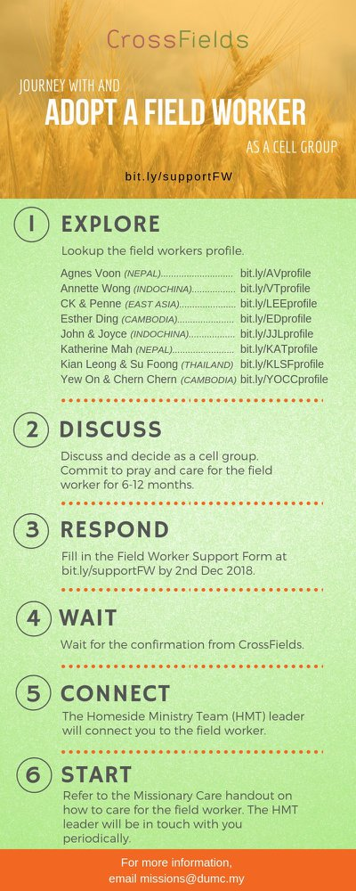

- CMS: Steps to Fill in the Salvation Form
- Select “More”
- “Form”
- Select “Form Lit” box
- Look for “Salvation Form”
- Fill in form of new salvation by “Change Respondent”
- Must have “E-mail” and “Mobile Phone”

UPCOMING

PREACHING SCHEDULE

11 & 12 May | Prayer – A Mother’s Prayer | Pr Sara Leong
18 & 19 May | Prayer – A Nation’s Prayer | Pr Dr Daniel Ho
25 & 26 May | Prayer – A Church’s Prayer | Pr Chris Manivanan

Go to: http://www.dumc.my/resources/sermons/ for the latest info.

EVENT HIGHLIGHTS

  - Join The Celebrations in DUMC@Puchong at 10am Every Sunday
Bring your friends and family members living around the Puchong area. Look for DUMC@Puchong on Waze or Google Maps. (Please park at IOI Business Park Level B2)

  - Tuesday Night Encounters (NEW!)
Every 3rd Tuesday of every month | 8.30 -10.00pm | Auditorium
A night focusing on prayer, healing and deliverance
For more information, contact: forerunners@dumc.my

  - Church Prayer Altar
Every Saturday | 7.00 -9.00am | Room 101 & 102
Let us come and seek the face of God. Prayer precedes everything.

  - WANT TO JOIN THE DUMC FAMILY?
Here are the steps:
> Join a Cell Group (You can get help at our CG Kiosk)
> Attend Basic Christianity 101
> Attend DUMC 101
> Join an Encounter Weekend
> Baptism & Membership Interview Sign up at the Info Counter or online at dumc.my/equip

  - SEMINAR ON THE KINGDOM OF GOD BY PASTOR NEAL PATTERSON
Come for an impactful and enlightening time.
Part 1 | 9 May (Thu) | 7.30pm-10.00pm | Hall 4
Part 2 | 11 May (Sat) | 8.30am-12.30pm | Hall 4
Register at bit.ly/DUMC2019KOG Enquiries to equip@dumc.my

  - PARENTS SUPPORT PARENTS
Topic: Parenting Together (New Series)
Dates | 27/4, 11/5, 25/5, 15/6, 29/6
Time | 3.00pm-4.30pm
Venue | Café Function Room
Admission free!

EQUIP COURSES 2019

BASIC CHRISTIANITY 201
Saturdays | 11 & 18 May | 8.30am-1.00pm

BMEW (Membership Requirement)
Weekend Away | 18 & 19 May

BIBLE 101
Saturdays | 25 May & 1 Jun | 8.30am-1.00pm

BIBLE STUDY – HEBREWS PT 2
Sundays | 12 May-21 Jul | 8.00am-9.45am (Exc 16 Jun)

