CONTENTS

Worship
Word
Works
Upcoming:
Preaching Schedule
Event Highlights
Equip courses

WORSHIP (Praise and Prayer)

- Malaysia: Government
Pray for:
• The rulers, cabinet ministers and civil servants to be men and women of integrity, justice, courage and compassion.
• The government and rulers - that they will show impartiality and remove those who are corrupt and insincere, or stirring dissension.
• God to place God-fearing men and women in strategic positions to influence for good.
- International: Mozambique –a nation in crisis, needing physical & spiritual rescue

Pray for:
• Lasting peace to overcome all threats to the nation's fragile stability.
• True freedom for those in bondage to poverty, disease, witchcraft, and animism.
• The Church and its leaders to grow in spiritual maturity and Biblical understanding
- Church : Lent Meditations 2019(TRAC)
Palm Sunday falls on 14 April, the last Sunday before Easter. The feast commemorates Jesus' triumphal entry into Jerusalem. Beginning 14 April, the theme is “This is the Gate of the Lord through which the righteous may enter.” For the week ahead, as we journey in this final week towards Good Friday & Easter Sunday, here are suggested Scripture passages and themes for your reading, meditation, contemplation and prayer.
- Behold, My Servant (Is. 42:1-9);
- The Paradox of Life (Is. 49:1-7);
- Deliverance & Remembrance (Ps. 70);
- Blood of the Passover Lamb (Ex. 12:1-14);
- The Suffering Servant (Is. 52:13-53:12);
- Finding Love in Pain (Lam. 3:1-9, 19-24);
- It is Finished (1 Corinthians 15:19-26)

WORD (60 minutes)

A Personal Relationship With God
(John 15:4)
Pr. Victor G

Big Idea: A 24/7 relationship with God : The desire for a Holy relationship which creates memories which are life’s testimonies, worshipping Him and
communing with Him

- Read the scripture passage.
- Do a THREE-MINUTE SUMMARY of the sermon highlighting the KEY POINTS (The Task, The Test, The Trust). Do not preach the whole sermon, as majority of your members would have heard the sermon already. Allocate more time for sharing in the cell through the application questions below.
- Sermon Resource at: http://www.dumc.my/resources/sermons/

Reflection & Application Questions:

      - What is the most significant thing that the Holy Spirit spoke to you about through this sermon?

      - What was one precious lesson you have learnt in your life experience about having a relationship with God?

      - Share one thought of the rewards and blessings of this relationship.?

Note to Word leader:
As you are preparing for this session, this is a great time to pray that the Holy Spirit will guide you to use the questions efficaciously. You can select, modify or entirely create your own questions, according to the needs of your CG, especially if you feel that there are too many questions than required for the allocated time.

Note to Cell Groups that have children during meeting:
We recognize several cell groups in DUMC may have 5 or more children joining them during Cell Group meetings. We would like to get them engaged as well during the session therefore we are suggesting for CGs to use Manna Pad and assign someone in rotation to facilitate them after worship. Here is the link to the Manna Pad materials http://dumc.my/resources/downloads/

WORKS (Ministry and Bearing Witness)

Cell leaders to ask these two important questions or share with one another during Works session in every CG meeting.

    - Who have I met, praying for and sharing Christ with?
    - What is the Holy Spirit saying about the community I am in?

- Share Your Story (Your Story, His Glory)
- Whether your story is about how you came to know Christ, illness healed, an act of kindness in your times of need, or of how you served people or how people have served you, give glory to God. Share your story so that people will be encouraged and God's love is known.
- If there are any good testimonies, ask your members to write out their testimonies and submit to the church: http://dumc.my/connect/individual-care/share-your-story/

- Personal: Bible Reading and Journaling
- Subscribe to the Bible Reading Plan app: YouVersion – OwnIt365 New Testament (NT)+ Plan.
- Request one of your members to share a journal entry. Pair up members to share with, and pray for one another.

- Scripture Memory
Every cell meeting, do get your cell members to recite the following together:

Galatians 5:25 (Theme verse for 2019)
Since we live by the Spirit, let us keep in step with the Spirit.

Galatians 2:20 (added from March 2019)
I have been crucified with Christ and I no longer live, but Christ lives in me. The life I now live in the body, I live by faith in the Son of God, who loved me and gave himself for me.

- CrossFields
“Crossing into the harvest field with the message of the Cross”

Sarawak Iban | 17-20 May
Sarawak Penan | 25-31 May
Thailand | 1-7 Jun
Vietnam | 14-18 Jun
MCPP1| 20-21 Jul | Empress Hotel (Sepang)

Website: dumc.my/missions Mission Trip dates: bit.ly/CF2019cal

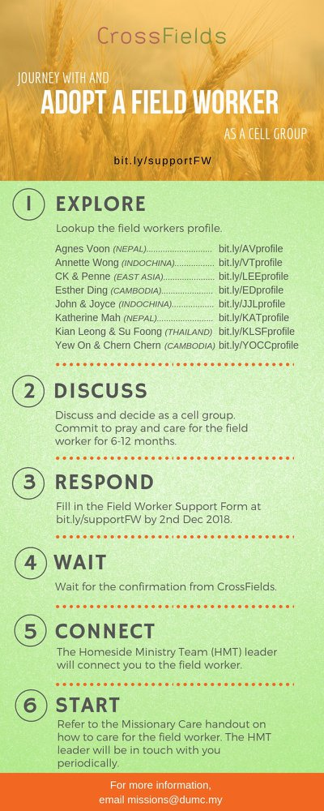

- CMS: Steps to Fill in the Salvation Form
- Select “More”
- “Form”
- Select “Form Lit” box
- Look for “Salvation Form”
- Fill in form of new salvation by “Change Respondent”
- Must have “E-mail” and “Mobile Phone”

UPCOMING

PREACHING SCHEDULE

Apr 20&21 | Easter Message | Pr Chris Kam

Go to: http://www.dumc.my/resources/sermons/ for the latest info.

EVENT HIGHLIGHTS

  - Join The Celebrations in DUMC@Puchong at 10am Every Sunday
Bring your friends and family members living around the Puchong area. Look for DUMC@Puchong on Waze or Google Maps. (Please park at IOI Business Park Level B2)

  - Tuesday Night Encounters (NEW!)
Every 3rd Tuesday of every month | 8.30 -10.00pm | Auditorium
A night focusing on prayer, healing and deliverance
For more information, contact: forerunners@dumc.my

  - Church Prayer Altar
Every Saturday | 7.00 -9.00am | Room 101 & 102
Let us come and seek the face of God. Prayer precedes everything.

  - WANT TO JOIN THE DUMC FAMILY?
Here are the steps:
> Join a Cell Group (You can get help at our CG Kiosk)
> Attend Basic Christianity 101
> Attend DUMC 101
> Join an Encounter Weekend
> Baptism & Membership Interview Sign up at the Info Counter or online at dumc.my/equip
e. EASTER 2019
GOOD FRIDAY SERVICE
19 Apr | 8.30pm | Auditorium
EASTER CELEBRATIONS
20 Apr | 5.00pm | Auditorium
21 Apr | 10.00am | Auditorium
21 Apr | 10.00am | DUMC@Puchong
f) “THEN CAME THE MORNING”
20 Apr | 6.30am-8.30am | Dream Centre
(Parking area between Blocks C & D)
A family Easter event for children and adults.
Registration & more info at
bit.ly/dumc2019eastersunrise
or contact Monica Lee 03-79587388

EQUIP COURSES 2019

CHRISTIAN LEADERSHIP 201

Saturdays | 13 & 20 Apr | 8.30am-1.00pm

        - PRAYER 101 (The Lord’s Prayer)

Sundays | 14 Apr – 2 Jun | 8.00am-9.30am | (excluding 21 Apr & 19 May)

MINISTRY 201 (Finding Your Fit)

Saturday | 13 Apr | 8.30am-1.00pm

MINISTRY 202 (Moving in the Gifts of the Holy Spirit)

Saturdays | 27 Apr & 4 May | 8.30am-1.00pm

DUMC 101 (Membership Requirement)

Saturday | 4 May | 8.30am-1.00pm

ANNOUNCEMENT

Do plan your CG’s Easter outreach accordingly! Focus on the cross, focus on the lost!

