CONTENTS

Worship
Word
Works
Upcoming:
Preaching Schedule
Event Highlights
Equip courses

WORSHIP (Praise and Prayer)

- Children Church: Holy Spirit Emphasis Weekend (25 May)
Pray:
- That the Holy Spirit’s Manifest Presence will be experienced by both children and adults.
- Ask the Holy Spirit to distribute His spiritual gifts as He determines to His people. (1 Corinthians 12:11)
- For the Spirit’s enabling and empowerment on His people to use the spiritual gifts they received in their daily lives.

- International: Sri Lanka
Sri Lanka has imposed a nationwide curfew for the second night in a row after a wave of anti-Muslim violence in the wake of the Easter bombings. A Muslim man was stabbed to death while rioters torched Muslim-owned shops and vandalised mosques during Monday's attacks. Police have arrested more than 70 people, including the leader of a far-right Buddhist group. The United Nations has called for calm and a "rejection of hate". (Source: BBC)
Pray:
- For peace and stability, and wisdom for officials to deal with the situation and maintain law and order.
- For all Sri Lankans to remain calm and act with restraint.
- That the people of Sri Lanka will find hope and healing in Christ; ask God to soften their hearts, preparing them to receive the Good News.
- For strength and comfort, and for the Lord’s healing hands upon all the injured, and for those grieving the loss of loved ones.

- Missions: Choo Yew On & Chern Chern, Cambodia
Pray for Chern Chern who will be training staff in Cleft Management at the Angkor Hospital for Children (21-22 May) and the National Paediatric Hospital (24 May).

WORD (60 minutes)

A Nation’s Prayer:
Lessons from Daniel’s Prayer
(Daniel 9:1-11, 17-19)
Founding Senior Pastor Dato’ Dr Daniel Ho

Big Idea: There is hope in Christ for the less than perfect.

- Read the scripture passage.
- Do a THREE-MINUTE SUMMARY of the sermon highlighting the KEY POINTS. Do not preach the whole sermon, as majority of your members would have heard the sermon already. Allocate more time for sharing in the cell through the application questions below.
- Sermon Resource at: http://www.dumc.my/resources/sermons/

Reflection & Application Questions:

- What is the most significant thing that the Holy Spirit spoke to you about through this sermon?

- What did you learn from Daniel’s prayer for his nation in the book of Daniel Chapter 9?

- What have your thoughts been about our nation and how has God burdened you to pray for our people and the land? What results have you seen and not seen and how will you continue to act and pray for the nation and mobilise others or join with others to do so too?

Note to Word leader:
As you are preparing for this session, this is a great time to pray that the Holy Spirit will guide you to use the questions efficaciously. You can select, modify or entirely create your own questions, according to the needs of your CG, especially if you feel that there are too many questions than required for the allocated time.

Note to Cell Groups that have children during meeting:
We recognize several cell groups in DUMC may have 5 or more children joining them during Cell Group meetings. We would like to get them engaged as well during the session therefore we are suggesting for CGs to use Manna Pad and assign someone in rotation to facilitate them after worship. Here is the link to the Manna Pad materials http://dumc.my/resources/downloads/

WORKS (Ministry and Bearing Witness)

Cell leaders to ask these two important questions or share with one another during Works session in every CG meeting.

    - Who have I met, praying for and sharing Christ with?
    - What is the Holy Spirit saying about the community I am in?

- Share Your Story (Your Story, His Glory)
- Whether your story is about how you came to know Christ, illness healed, an act of kindness in your times of need, or of how you served people or how people have served you, give glory to God. Share your story so that people will be encouraged and God's love is known.
- If there are any good testimonies, ask your members to write out their testimonies and submit to the church: http://dumc.my/connect/individual-care/share-your-story/

- Personal: Bible Reading and Journaling
- Subscribe to the Bible Reading Plan app: YouVersion – OwnIt365 New Testament (NT)+ Plan.
- Request one of your members to share a journal entry. Pair up members to share with, and pray for one another.

- Scripture Memory
Every cell meeting, do get your cell members to recite the following together:

Galatians 5:25 (Theme verse for 2019)
Since we live by the Spirit, let us keep in step with the Spirit.

Galatians 2:20 (added from March 2019)
I have been crucified with Christ and I no longer live, but Christ lives in me. The life I now live in the body, I live by faith in the Son of God, who loved me and gave himself for me.

- CrossFields
“Crossing into the harvest field with the message of the Cross”

Vietnam | 14 - 18 Jun
Myanmar | 9 -16 Aug
Sri Lanka | 14 - 20 Aug
MCPP1| 20-21 Jul | Empress Hotel (Sepang)

Website: dumc.my/missions
Mission Trip dates: bit.ly/CF2019cal

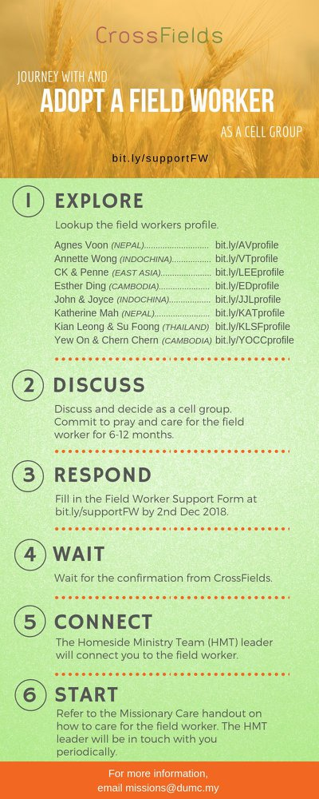

- CMS: Steps to Fill in the Salvation Form
- Select “More”
- “Form”
- Select “Form List” box
- Look for “Salvation Form”
- Fill in form of new salvation by “Change Respondent”
- Must have “E-mail” and “Mobile Phone”

UPCOMING

PREACHING SCHEDULE

11 & 12 May | Prayer – A Mother’s Prayer | Pr Sara Leong
18 & 19 May | Prayer – A Nation’s Prayer | Dato’ Dr Daniel Ho, Founding Senior Pastor
25 & 26 May | Credible Kingdom Hope – Prophetic Mission Of The Church | Dr Jayakumar Christian

Go to: http://www.dumc.my/resources/sermons/ for the latest info.

EVENT HIGHLIGHTS

  - Join The Celebrations in DUMC@Puchong at 10am Every Sunday
Bring your friends and family members living around the Puchong area. Look for DUMC@Puchong on Waze or Google Maps. (Please park at IOI Business Park Level B2)

  - TUESDAY NIGHT ENCOUNTERS
Every 3rd Tuesday of every month | 8.30 -10.00pm | Auditorium
Every 4th Tuesday of every month | 8.30 -10.00pm | DUMC@Puchong
A night focusing on prayer, healing and deliverance
For more information, contact: forerunners@dumc.my

  - CHURCH PRAYER ALTAR
Every Saturday | 7.00 -9.00am | Room 101 & 102
Let us come and seek the face of God. Prayer precedes everything.

  - WANT TO JOIN THE DUMC FAMILY?
Here are the steps:
> Join a Cell Group (You can get help at our CG Kiosk)
> Attend Basic Christianity 101
> Attend DUMC 101
> Join an Encounter Weekend
> Baptism & Membership Interview Sign up at the Info Counter or online at dumc.my/equip

  - DUMC CREATIVES RECRUITMENT
May 11-12 | 18-19 | 25-26 (30 mins before & after Celebration)
Calling all creatives - come and be part of our creative team!
Sign up at Concourse 2 over the weekend.

  - PARENTS SUPPORT PARENTS
Topic: Parenting Together (New Series)
Dates | 25/5, 15/6, 29/6
Time | 3.00pm-4.30pm
Venue | Café Function Room
Admission free!

  - HOLY SPIRIT EMPHASIS WEEKEND (FOR CHILDREN) Speaker: Pr David Abbott
Saturday | 25 May | 9.00am-4.30pm | Hall 1
Children will learn and experience how to have a special encounter with God.
Enquiries to monica.lee@dumc.my and sarah.kong@dumc.my or 03-7958 7388

  - ALPHA FOR SENIORS (NEW SEASON)
27 May-28 Oct | 10.00am-12.30pm | Hall 3 (Mondays)
Seniors too have questions about life, faith and God.
Visit our booth in Concourse 2 or contact Peck Har @ 016-612 0210

EQUIP COURSES 2019

BIBLE 101
Saturdays | 25 May & 1 Jun | 8.30am-1.00pm

BIBLE 301
Saturday | 25 May | 8.30am-1.00pm

EVANGELISM 101
Saturday | 15 Jun | 8.30am-1.00pm

PRAYER 201 (Sacred Rhythms)
Thursdays | 4 Jul – 8 Aug | 8.00pm-10.00pm

CHRISTIAN LIVING 101 (My New Life)
Sundays | 23 Jun-4 Aug | 8.00am-9.30am

CHRISTIAN LIVING 201 (The Beatitudes)
Saturdays | 6 & 13 Jul | 8.00am-1.00pm

Find out more about Equip courses at the Info Counter in Concourse 2, or online at dumc.my/equip

LIBRARY HOURS
Saturdays | 1.30pm-4.45pm
Sundays | 9.30am-1.30pm
Weekdays | CLOSED

