CONTENTS

Worship
Word
Works
Upcoming:
Preaching Schedule
Event Highlights
Equip courses

WORSHIP (Praise and Prayer)

- Ramadan: The Night of Power (31 May)
Laylat al-Qadr, known as the ‘Night of Power’, occurs around the 27th day of Ramadan. By the lunar calendar, this begins at sunset on the 26h day and may be celebrated at different times in different time zones. This night is also called the Night of Destiny because some Muslims also believe that God determines the fate of each believer on this night. Whatever will happen to you and your family in the coming year is decided on this night so that is also a motivation to make extra effort in worship and supplication.
Pray that:
- That God will reveal Himself through dreams and visions.
- That they may come to know the Father in heaven who gives good gifts to those who ask Him.
- God’s Kingdom will be established among them.

- Malaysia: Media
Pray:
- For Christians who are working in the media industry - pray for God’s blessings and wisdom upon them, and for Him to grant them perseverance and boldness to remain ethical and righteous in their profession.
- For Christians to be truthful and honest communicators so that they will help bring wholeness, well-being, life and a bright future to the nation and all those around us.
- That media tools will be used in a transparent way, to support fair and unbiased reporting and bring blessings to our nation.

- Malaysia: School Holidays
As the school holidays begin next weekend, pray:
- For meaningful and fruitful time spent together between parents and children, and for strengthening of family bonds.
- For churches, Christian organisations and NGOS to organise meaningful activities which promote harmony and wholesomeness among the children and youths.
- Children and youths will spend their holiday time wisely.

WORD (60 minutes)

Credible Kingdom Hope:
Prophetic Mission Of The Church
(Hab 1-3, 2 Ki 21-25, 2 Chron 33-36)
Dr Jayakumar Christian

Big Idea: Agent Of Hope

- Read the scripture passage.
- Do a THREE-MINUTE SUMMARY of the sermon highlighting the KEY POINTS. Do not preach the whole sermon, as majority of your members would have heard the sermon already. Allocate more time for sharing in the cell through the application questions below.
- Sermon Resource at: http://www.dumc.my/resources/sermons/

Reflection & Application Questions:

- What is the most significant thing that the Holy Spirit spoke to you about through this sermon?

- God is deeply aware and involved in our nation’s affairs. As ambassadors and agent of Christ, how do we bring hope to the hopeless?
Is our heart deeply disturbed by evil and burning for our righteousness? Do we bring that concerns to God in daily prayer and make it your mission to bring hope?
Encourage everyone to commit in praying for the Malaysia daily as a CG.

- God may use various agents to teach us righteousness similar to how he uses Babylon. Being secure is not about showing arrogance but by living in Christ’s faith that does not rely on evidences.
Discuss if we (as Christ followers) are truly secure and willing to collaborate with others to transform our nation in fulfilling God’s purpose. Think of ways during this Ramadan season for CG to collaborate and bless the community through God’s love.

- God has taken the first step into mission for all nations. He is inviting us to take the next step to join Him. Would you answer His call and accept His invitation to fulfil His purpose?
Make yourself available to partner with others in missions. One way is to sign up personally or as a CG for the next MCPP1 on 20-21 July. Mission trip dates are found in bit.ly/CF2019cal.

Note to Word leader:
As you are preparing for this session, this is a great time to pray that the Holy Spirit will guide you to use the questions efficaciously. You can select, modify or entirely create your own questions, according to the needs of your CG, especially if you feel that there are too many questions than required for the allocated time.
Note to Cell Groups that have children during meeting:
We recognize several cell groups in DUMC may have 5 or more children joining them during Cell Group meetings. We would like to get them engaged as well during the session therefore we are suggesting for CGs to use Manna Pad and assign someone in rotation to facilitate them after worship. Here is the link to the Manna Pad materials http://dumc.my/resources/downloads/

WORKS (Ministry and Bearing Witness)

Cell leaders to ask these two important questions or share with one another during Works session in every CG meeting.

    - Who have I met, praying for and sharing Christ with?
    - What is the Holy Spirit saying about the community I am in?

- Share Your Story (Your Story, His Glory)
- Whether your story is about how you came to know Christ, illness healed, an act of kindness in your times of need, or of how you served people or how people have served you, give glory to God. Share your story so that people will be encouraged and God's love is known.
- If there are any good testimonies, ask your members to write out their testimonies and submit to the church: http://dumc.my/connect/individual-care/share-your-story/

- Personal: Bible Reading and Journaling
- Subscribe to the Bible Reading Plan app: YouVersion – OwnIt365 New Testament (NT)+ Plan.
- Request one of your members to share a journal entry. Pair up members to share with, and pray for one another.

- Scripture Memory
Every cell meeting, do get your cell members to recite the following together:

Galatians 5:25 (Theme verse for 2019)
Since we live by the Spirit, let us keep in step with the Spirit.

Galatians 2:20 (added from March 2019)
I have been crucified with Christ and I no longer live, but Christ lives in me. The life I now live in the body, I live by faith in the Son of God, who loved me and gave himself for me.

- CrossFields
“Crossing into the harvest field with the message of the Cross”

Sarawak Penan | 10-16 Aug
Sarawak Iban | 10-17 Aug
Sabah Tenom | 9-12 Aug
Myanmar | 9-16 Aug
Sri Lanka | 14-20 Aug
Cambodia | 24 Oct-1 Nov
MCPP1| 20-21 Jul | Empress Hotel (Sepang)

Website: dumc.my/missions
Mission Trip dates: bit.ly/CF2019cal

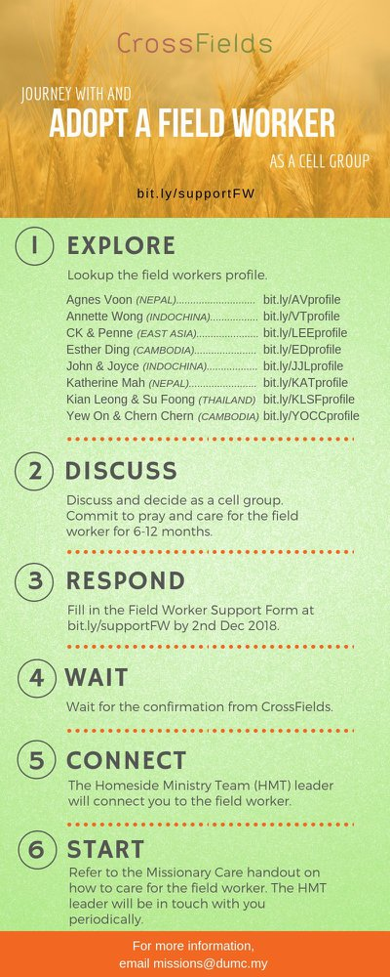

- CMS: Steps to Fill in the Salvation Form
- Select “More”
- “Form”
- Select “Form List” box
- Look for “Salvation Form”
- Fill in form of new salvation by “Change Respondent”
- Must have “E-mail” and “Mobile Phone”

UPCOMING

PREACHING SCHEDULE

1 & 2 June | Following Jesus | Pr Terry Yeow
8 & 9 June | Following Jesus (Mission Conference Weekend) | Pr Sam Dharam
15 & 16 June | Following Jesus (Father’s Day / Baby Dedication Weekend) | Senior Pr Chris Kam

Go to: http://www.dumc.my/resources/sermons/ for the latest info.

EVENT HIGHLIGHTS

  - Join The Celebrations in DUMC@Puchong at 10am Every Sunday
Bring your friends and family members living around the Puchong area. Look for DUMC@Puchong on Waze or Google Maps. (Please park at IOI Business Park Level B2)

  - TUESDAY ENCOUNTER NIGHT (TEN)
Every 3rd Tuesday of every month | 8.30 -10.00pm | Auditorium
Every 4th Tuesday of every month | 8.30 -10.00pm | DUMC@Puchong
A night focusing on prayer, healing and deliverance
For more information, contact: forerunners@dumc.my

  - CHURCH PRAYER ALTAR
Every Saturday | 7.00 -9.00am | Room 101 & 102
Let us come and seek the face of God. Prayer precedes everything.

  - WANT TO JOIN THE DUMC FAMILY?
Here are the steps:
> Join a Cell Group (You can get help at our CG Kiosk)
> Attend Basic Christianity 101
> Attend DUMC 101
> Join an Encounter Weekend
> Baptism & Membership Interview Sign up at the Info Counter or online at dumc.my/equip

  - PARENTS SUPPORT PARENTS
Topic: Parenting Together (New Series)
Dates | 25/5, 15/6, 29/6
Time | 3.00pm-4.30pm
Venue | Café Function Room
Admission free!

  - ALPHA FOR SENIORS (NEW SEASON)
27 May-28 Oct | 10.00am-12.30pm | Hall 3 (Mondays)
Seniors too have questions about life, faith and God.
Visit our booth in Concourse 2 or contact Peck Har @ 016-612 0210

EQUIP COURSES 2019

EVANGELISM 101
Saturday | 15 Jun | 8.30am-1.00pm

PRAYER 201 (Sacred Rhythms)
Thursdays | 4 Jul – 8 Aug | 8.00pm-10.00pm

CHRISTIAN LIVING 101 (My New Life)
Sundays | 23 Jun-4 Aug | 8.00am-9.30am

CHRISTIAN LIVING 201 (The Beatitudes)
Saturdays | 6 & 13 Jul | 8.00am-1.00pm

BASIC CHRISTIANITY 301
Saturdays | 6 &13 Jul | 8.30am-1.00pm

BASIC CHRISTIANITY 101 (Basic Doctrine I)
Saturdays | 13 & 20 Jul | 8.30am-1.00pm
Note: Membership requirement

Find out more about Equip courses at the Info Counter in Concourse 2, or online at dumc.my/equip

LIBRARY HOURS
Saturdays | 1.30pm-4.45pm
Sundays | 9.30am-1.30pm
Weekdays | CLOSED

