CONTENTS

Worship
Word
Works
Upcoming:
Preaching Schedule
Event Highlights
Equip courses

WORSHIP (Praise and Prayer)

- Malaysia: Media & Press Freedom
Pray for:
- For editorial integrity in media and news coverage.
- For courage to speak the truth, and that truth becomes an established standard and benchmark in our news media.
- That media bias be replaced by fair and factual reporting, and that journalists and editors will work hard to treat all parties fairly, and not allow themselves to be used to spread falsehood and misinformation.

- International: The Sahel Region of Africa
Pray that:
- The Good News will travel with the 35 million Fulani who are on the move across Africa.
- Fulani women left alone in their villages will experience God’s protection, provision and peace like the widow of Zarephath, who put God first in serving the prophet Elijah. (1 Kings 17:7-16)
- As Fulani families extend hospitality to others, they will experience the One who said, “Behold, I stand at the door and knock, and if anyone hears My voice, I will come in to him and eat with him and he with Me.” (Revelation 3:20)

WORD (60 minutes)

She Ain’t Perfect, She’s My Mother
(Ruth 1:16-22)
Pastor Sara Leong

Big Idea: There is hope in Christ for the less than perfect.

- Read the scripture passage.
- Do a THREE-MINUTE SUMMARY of the sermon highlighting the KEY POINTS. Do not preach the whole sermon, as majority of your members would have heard the sermon already. Allocate more time for sharing in the cell through the application questions below.
- Sermon Resource at: http://www.dumc.my/resources/sermons/

Reflection & Application Questions:

This week’s questions are catered for break-out sessions between ladies and men. If your CG gathers together, you may decide which questions to use for discussion.

For Men (provided by Men Alive team):

- What is the most significant thing that the Holy Spirit spoke to you about through this sermon?

- Naomi acted selflessly when she released her daughters-in-law and told them to return to their homes. Have you personally witnessed or experienced such self sacrificial love from the women in your life whether she was your mother/sister/wife/daughter? Share how that impacted you at the time and how it may have influenced the course of your life or that of the person who was being shown love.

- Share a time when you may have felt that God was making your life bitter. After the incident or the difficult season, did you change your mind about how God was actually dealing with you? What is something you learned about God or his character through that experience? (Facilitators - do be prepared lead the group in ministering to those you may share about a recent or ongoing situation or currently struggling with unresolved bitterness.)

- Do you personally know someone who could inspire others to say what Ruth said to Naomi in Ruth 1:16? ‘....Where you go I will go, and where you stay I will stay. Your people will be my people and your God my God?' What are the traits of the person that would such faith?

- What is one thing you can apply in own life from what has been shared in today's discussion/reflection?

For Ladies (provided by W2W team):

- Naomi demonstrated selfless love to Opah and Ruth by releasing them to return to their hometown, even though she had needs and would be alone. Share a specific situation where your mother had demonstrated her selfless love to you.

- CG Groups:

  - For singles/married groups with no children: As mothers seldom share/show their grief or problems with their children, invite a mother from another group (or one of their mothers) to join the CG and share some of the grieves and challenges of being a mother. Have a bit of a Q&A to understand better the role of a mother
  - For mixed groups/married groups: Share a past moment of grief or challenge of being a mother, how you felt and how did God help you to you overcome that.

- How has your mother inspired faith in God in you? If you are a mother/future mother/influencer of children, how can you intentionally inspire faith in your/the children? (Pray for one another)

Note to Word leader:
As you are preparing for this session, this is a great time to pray that the Holy Spirit will guide you to use the questions efficaciously. You can select, modify or entirely create your own questions, according to the needs of your CG, especially if you feel that there are too many questions than required for the allocated time.

Note to Cell Groups that have children during meeting:
We recognize several cell groups in DUMC may have 5 or more children joining them during Cell Group meetings. We would like to get them engaged as well during the session therefore we are suggesting for CGs to use Manna Pad and assign someone in rotation to facilitate them after worship. Here is the link to the Manna Pad materials http://dumc.my/resources/downloads/

(Snapshot below)

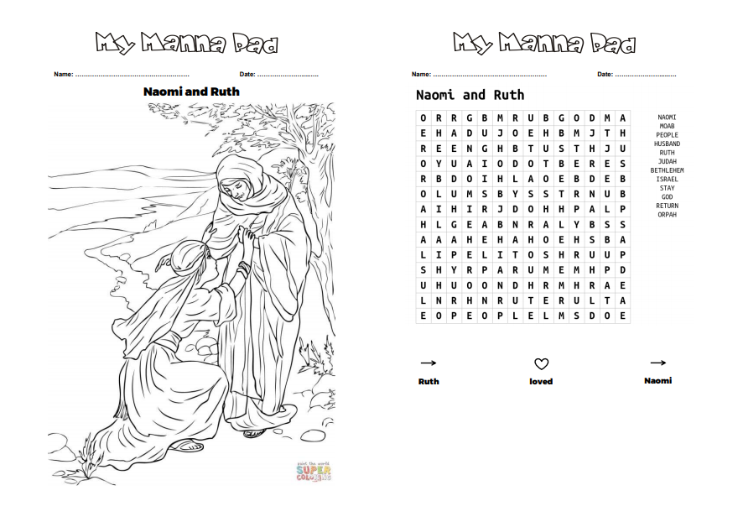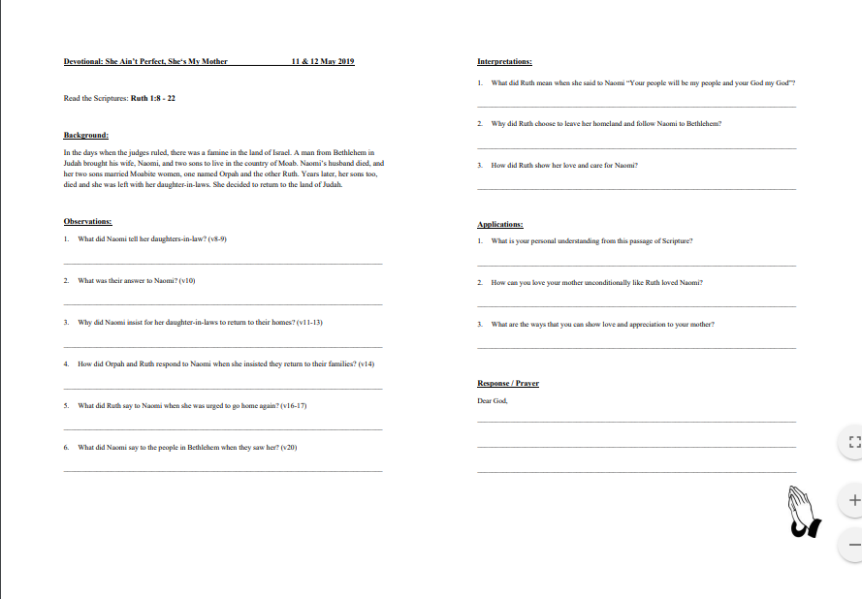

WORKS (Ministry and Bearing Witness)

Cell leaders to ask these two important questions or share with one another during Works session in every CG meeting.

    - Who have I met, praying for and sharing Christ with?
    - What is the Holy Spirit saying about the community I am in?

- Share Your Story (Your Story, His Glory)
- Whether your story is about how you came to know Christ, illness healed, an act of kindness in your times of need, or of how you served people or how people have served you, give glory to God. Share your story so that people will be encouraged and God's love is known.
- If there are any good testimonies, ask your members to write out their testimonies and submit to the church: http://dumc.my/connect/individual-care/share-your-story/

- Personal: Bible Reading and Journaling
- Subscribe to the Bible Reading Plan app: YouVersion – OwnIt365 New Testament (NT)+ Plan.
- Request one of your members to share a journal entry. Pair up members to share with, and pray for one another.

- Scripture Memory
Every cell meeting, do get your cell members to recite the following together:

Galatians 5:25 (Theme verse for 2019)
Since we live by the Spirit, let us keep in step with the Spirit.

Galatians 2:20 (added from March 2019)
I have been crucified with Christ and I no longer live, but Christ lives in me. The life I now live in the body, I live by faith in the Son of God, who loved me and gave himself for me.

- CrossFields
“Crossing into the harvest field with the message of the Cross”

Sarawak Iban | 17-20 May
Sarawak Penan | 25-31 May
Thailand | 1-7 Jun
Vietnam | 14-18 Jun
MCPP1| 20-21 Jul | Empress Hotel (Sepang)

Website: dumc.my/missions
Mission Trip dates: bit.ly/CF2019cal

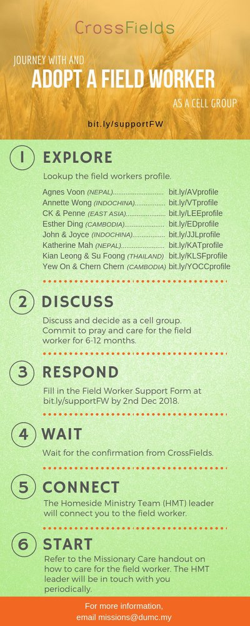

- CMS: Steps to Fill in the Salvation Form
- Select “More”
- “Form”
- Select “Form List” box
- Look for “Salvation Form”
- Fill in form of new salvation by “Change Respondent”
- Must have “E-mail” and “Mobile Phone”

UPCOMING

PREACHING SCHEDULE

11 & 12 May | Prayer – A Mother’s Prayer | Pr Sara Leong
18 & 19 May | Prayer – A Nation’s Prayer | Dato’ Dr Daniel Ho, Founding Senior Pastor
25 & 26 May | Prayer – A Church’s Prayer | Pr Chris Manivanan

Go to: http://www.dumc.my/resources/sermons/ for the latest info.

EVENT HIGHLIGHTS

  - Join The Celebrations in DUMC@Puchong at 10am Every Sunday
Bring your friends and family members living around the Puchong area. Look for DUMC@Puchong on Waze or Google Maps. (Please park at IOI Business Park Level B2)

  - Tuesday Night Encounters (NEW!)
Every 3rd Tuesday of every month | 8.30 -10.00pm | Auditorium
Every 4th Tuesday of every month | 8.30 -10.00pm | DUMC@Puchong
A night focusing on prayer, healing and deliverance
For more information, contact: forerunners@dumc.my

  - Church Prayer Altar
Every Saturday | 7.00 -9.00am | Room 101 & 102
Let us come and seek the face of God. Prayer precedes everything.

  - WANT TO JOIN THE DUMC FAMILY?
Here are the steps:
> Join a Cell Group (You can get help at our CG Kiosk)
> Attend Basic Christianity 101
> Attend DUMC 101
> Join an Encounter Weekend
> Baptism & Membership Interview Sign up at the Info Counter or online at dumc.my/equip

  - DUMC CREATIVES RECRUITMENT
May 11-12 | 18-19 | 25-26 (30 mins before & after Celebration)
Calling all creatives - come and be part of our creative team!
Sign up at Concourse 2 over the weekend.

  - PARENTS SUPPORT PARENTS
Topic: Parenting Together (New Series)
Dates | 25/5, 15/6, 29/6
Time | 3.00pm-4.30pm
Venue | Café Function Room
Admission free!

  - HOLY SPIRIT EMPHASIS WEEKEND (FOR CHILDREN) Speaker: Pr David Abbott
Saturday | 25 May | 9.00am-4.30pm | Hall 1
Children will learn and experience how to have a special encounter with God.
Enquiries to monica.lee@dumc.my and sarah.kong@dumc.my or 03-7958 7388

  - ALPHA FOR SENIORS (NEW SEASON)
27 May-28 Oct | 10.00am-12.30pm | Hall 3 (Mondays)
Seniors too have questions about life, faith and God.
Visit our booth in Concourse 2 or contact Peck Har @ 016-612 0210

EQUIP COURSES 2019

BMEW (Membership Requirement)
Weekend Away | 18 & 19 May

BIBLE 101
Saturdays | 25 May & 1 Jun | 8.30am-1.00pm

BIBLE 301
Saturday | 25 May | 8.30am-1.00pm

EVANGELISM 101
Saturday | 15 Jun | 8.30am-1.00pm

BIBLE STUDY – HEBREWS PT 2
Sundays | 12 May-21 Jul | 8.00am-9.45am (Exc 16 Jun)

CHRISTIAN LIVING 101 (My New Life)
Sundays | 23 Jun-4 Aug | 8.00am-9.30am

Find out more about Equip courses at the Info Counter in Concourse 2, or online at dumc.my/equip

LIBRARY HOURS
Saturdays | 1.30pm-4.45pm
Sundays | 9.30am-1.30pm
Weekdays | CLOSED

