CONTENTS

Worship
Word
Works
Upcoming:
Preaching Schedule
Event Highlights
Equip courses

WORSHIP (Praise and Prayer)

- International: Chile
In 1973, General Pinochet led the nation’s only bloody coup, leaving more than 3,000 people dead and missing; he reigned for 17 years until a president was freely elected.
Pray:
- The culture of division within the Chilean church to be overcome by the unity of the Holy Spirit.
- Those scarred by Pinochet’s reign to humbly forgive their abusers.
- Zeal within the Church to evangelise to the Mapuche people in the south.

- Malaysia: New Mindset for all Politicians and Lawmakers
Pray that:
- The Lord will show to them what is good; what the Lord requires of them – to act justly and to love kindness and mercy and to walk humbly. (Micah 6:8)
- They will govern fairly and do that which is right.
- They will be merciful, unselfish and sensitive to the people’s needs.
- They will be humble and realise that they will have to give an account to God because they were appointed by Him to lead.

WORD (60 minutes)

The Gospel: For Growth
(Colossians 3:1-5; 2 Corinthians 3:18)
Senior Pastor: Chris Kam (DC); Pastor: Tan Moy How (Puchong)

Big Idea: The Gospel Grows and Matures You to be more Christlike (Acts 4:13)

- Read the scripture passage.
- Do a THREE-MINUTE SUMMARY of the sermon highlighting the KEY POINTS. Do not preach the whole sermon, as majority of your members would have heard the sermon already. Allocate more time for sharing in the cell through the application questions below.
- Sermon Resource at: http://www.dumc.my/resources/sermons/

Reflection & Application Questions:

- What is the most significant thing the Holy Spirit spoke to you about through this sermon?

- Describe in your own words what the Gospel is, based on the first three sermons in the series, (1) The Gospel is for all of Life; (2) The Gospel is for Salvation; (3) The Gospel is for Growth. Was there any new understanding that you received about the Gospel in terms of justification and sanctification? What are they?

- In the 4-step “birthing” process described in Hebrews 6:1-2 of elementary teachings about Christ and moving on from there, do you think you have moved on from milk to solid food (Hebrews 5:11-14)? As a reminder, the 4-steps are (1) Repentance towards the Father; (2) Believe in the Lord Jesus Christ; (3) Water Baptism; (4) Receive the Baptism of the Holy Spirit. In which of these 4 steps do you need to walk in obedience to God?

- What is the difference between merely modifying our behaviour versus a heart transformation? Both relate to a change of behaviour. Share a story of your own heart transformation.

- In what ways have you become more Christ-like?

Note to Word facilitator:
As you are preparing for this session, this is a great time to pray that the Holy Spirit will guide you to use the questions efficaciously. You can select, modify or entirely create your own questions, according to the needs of your CG, especially if you feel that there are too many questions than required for the allocated time.

Note to Cell Groups that have children during meeting:
We recognize several cell groups in DUMC may have 5 or more children joining them during Cell Group meetings. We would like to get them engaged as well during the session therefore we are suggesting for CGs to use Manna Pad and assign someone in rotation to facilitate them after worship. Here is the link to the Manna Pad materials http://dumc.my/resources/downloads/

WORKS (Ministry and Bearing Witness)

Cell leaders to ask these two important questions or share with one another during Works session in every CG meeting.

    - Who have I met, praying for and sharing Christ with?
    - What is the Holy Spirit saying about the community I am in?

- Share Your Story (Your Story, His Glory)
- Whether your story is about how you came to know Christ, illness healed, an act of kindness in your times of need, or of how you served people or how people have served you, give glory to God. Share your story so that people will be encouraged and God's love is known.
- If there are any good testimonies, ask your members to write out their testimonies and submit to the church: http://dumc.my/connect/individual-care/share-your-story/

- Personal: Bible Reading and Journaling
- Subscribe to the Bible Reading Plan app: YouVersion – OwnIt365 New Testament (NT)+ Plan.
- Request one of your members to share a journal entry. Pair up members to share with, and pray for one another.

- Scripture Memory
Every cell meeting, do get your cell members to recite the following together:

Galatians 5:25 (Theme verse for 2019)
Since we live by the Spirit, let us keep in step with the Spirit.

Galatians 2:20 (added from March 2019)
I have been crucified with Christ and I no longer live, but Christ lives in me. The life I now live in the body, I live by faith in the Son of God, who loved me and gave himself for me.

- CrossFields
“Crossing into the harvest field with the message of the Cross”

Sarawak Penan | 10-16 Aug
Sarawak Iban | 10-17 Aug
Sabah Tenom | 9-12 Aug
Myanmar | 9-16 Aug
Sri Lanka | 14-20 Aug
Cambodia | 24 Oct-1 Nov
MCPP1| 20-21 Jul | Empress Hotel (Sepang)

Website: dumc.my/missions
Mission Trip dates: bit.ly/CF2019cal

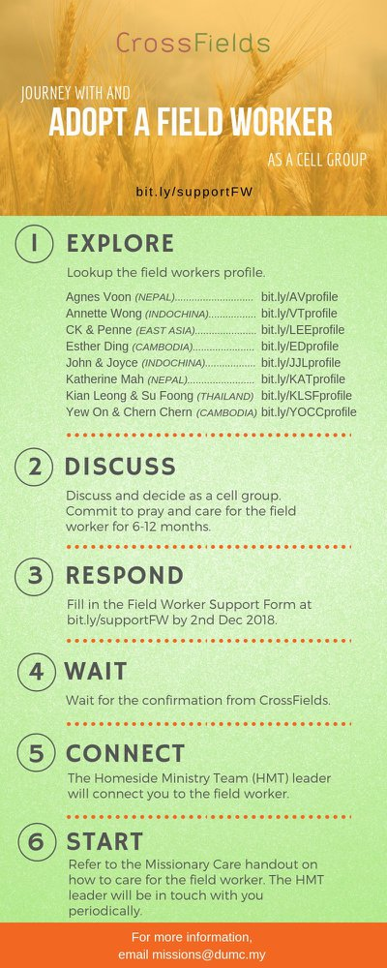

- CMS: Steps to Fill in the Salvation Form
- Select “More”
- “Form”
- Select “Form List” box
- Look for “Salvation Form”
- Fill in form of new salvation by “Change Respondent”
- Must have “E-mail” and “Mobile Phone”

UPCOMING

PREACHING SCHEDULE

13 & 14 July | What is the Gospel? 4. For Evangelism | Pr Mike Ngui
20 & 21 July | What is the Gospel? 5. For Accountability | SP, Chris Kam
27 & 28 July | What is the Gospel? 6. For Eternity | Pr Mike Ngui

Go to: http://www.dumc.my/resources/sermons/ for the latest info.

EVENT HIGHLIGHTS

  - Join The Celebrations in DUMC@Puchong at 10am Every Sunday
Bring your friends and family members living around the Puchong area. Look for DUMC@Puchong on Waze or Google Maps. (Please park at IOI Business Park Level B2)

  - TUESDAY ENCOUNTER NIGHT (TEN)
Every 3rd Tuesday of every month | 8.30 -10.00pm | Auditorium
Every 4th Tuesday of every month | 8.30 -10.00pm | DUMC@Puchong
A night focusing on prayer, healing and deliverance
For more information, contact: forerunners@dumc.my

  - CHURCH PRAYER ALTAR
Every Saturday | 7.00 -9.00am | Room 101 & 102
Let us come and seek the face of God. Prayer precedes everything.

  - 5-DAY FAST & PRAY
22-26 July | 8.30pm-10.00pm | Auditorium, Dream Centre
Repentance, Renewal, Restoration. “If my people… will humble themselves and pray…” (2 Chronicles 7:14)
For more information, contact: forerunners@dumc.my

  - WANT TO JOIN THE DUMC FAMILY?
Here are the steps:
> Join a Cell Group (You can get help at our CG Kiosk)
> Attend Basic Christianity 101
> Attend DUMC 101
> Join an Encounter Weekend
> Baptism & Membership Interview Sign up at the Info Counter or online at dumc.my/equip

EQUIP COURSES 2019

PRAYER 201 (Sacred Rhythms)
Thursdays | 4 Jul – 8 Aug | 8.00pm-10.00pm

CHRISTIAN LIVING 201 (The Beatitudes)
Saturdays | 6 & 13 Jul | 8.00am-1.00pm

BASIC CHRISTIANITY 301
Saturdays | 6 &13 Jul | 8.30am-1.00pm

BASIC CHRISTIANITY 101 (Basic Doctrine I)
Saturdays | 13 & 20 Jul | 8.30am-1.00pm
Note: Membership requirement

DUMC 101
Saturday | 3 Aug | 8.30am-1.00pm
(Note: Membership Requirement)

PAUSE & PONDER (Guided morning prayer & reflection)
Saturday | 10 Aug | 8.30am-11.30am
(Note: Register at bit.ly/PPAug2019)

LIBRARY HOURS
Saturdays | 1.30pm-4.45pm
Sundays | 9.30am-1.30pm
Weekdays | CLOSED
Find out more about Equip courses at the Info Counter in Concourse 2, or online at http://dumc.my/equip

