CONTENTS

Worship
Word
Works
Upcoming:
Preaching Schedule
Event Highlights
Equip courses

WORSHIP (Praise and Prayer)

- International: Turkey
Even though it was one of the earliest mission fields and home to many New Testament churches, hostility and persecution of Christians is strong in Turkey. Social pressure discourages many from coming to Christ and there is a deep national resentment towards Christianity, making evangelism more difficult. Even in the midst of persecution, God still stands, and He is calling out to His people of Turkey to accept the love and peace that only comes from Him.
Pray:
- The Turkish people to seek God and to feel hungry in their hearts. Ask the Lord to open their hearts, for they who seek Him with their whole heart will find Him.
- Wise leadership to peacefully navigate tensions between nationalists, radical Islamists, and Kurds.
- A radical change in deep-seated prejudices and biases against Christianity.
- The gospel to advance in power amid increased hostilities and persecution.

- Malaysia: National Unity
Pray:
- God to protect our nation from extremism, and to prevent those who use political means/institutions for their own agenda from gaining ground in support.
- For Malaysians to be engaged in public discourses and dialogues to build understanding involving Malaysians of all religious, ethnic, ideological, and socio-economic backgrounds.
- The government will continue to take a moderate stand and to seek to maintain a democratic and pluralistic society.

WORD (60 minutes)

The Gospel: For Others
(2 Corinthians 5:15-21)
Pastor: Michael Ngui

Big Idea: The Gospel inspires us towards others

- Read the scripture passage.
- Do a THREE-MINUTE SUMMARY of the sermon highlighting the KEY POINTS. Do not preach the whole sermon, as majority of your members would have heard the sermon already. Allocate more time for sharing in the cell through the application questions below.
- Sermon Resource at: http://www.dumc.my/resources/sermons/

Reflection & Application Questions:

- What is the most significant thing the Holy Spirit spoke to you about through this sermon?

- Proclaim the Good News (word of mouth)! What hinders you from sharing the Good News? What incremental small steps can you begin to take to share Christ (e.g. saying ‘hi’, sharing about what God has done for your life, attending Evangelism 101, etc.)?

- Portray the Good News (good works)! Share an instance that you have experienced in the cell group that inspired you. From the sharing, commit to do an act of kindness outside the cell group so that others can experience the love of Christ! (e.g. colleagues at work, a random stranger, etc.)

- “Prove” the Good News (walk with God)!
Like two wings, discovering more about God and living the Word, will help us soar (i.e. fly higher) in our walk with God.

  - How are you discovering the truth of God’s word for yourself? Share what you have done since the start of the year to equip yourself. (e.g. Attend SOL classes, OwnIt365, inductive bible studies, etc.).

  - Applying what we understand from the word of God is what matures us. How are you training yourself to be godly in your walk with God by serving others?

Note to Word facilitator:
As you are preparing for this session, this is a great time to pray that the Holy Spirit will guide you to use the questions efficaciously. You can select, modify or entirely create your own questions, according to the needs of your CG, especially if you feel that there are too many questions than required for the allocated time.

Note to Cell Groups that have children during meeting:
We recognize several cell groups in DUMC may have 5 or more children joining them during Cell Group meetings. We would like to get them engaged as well during the session therefore we are suggesting for CGs to use Manna Pad and assign someone in rotation to facilitate them after worship. Here is the link to the Manna Pad materials http://dumc.my/resources/downloads/

WORKS (Ministry and Bearing Witness)

Cell leaders to ask these two important questions or share with one another during Works session in every CG meeting.

    - Who have I met, praying for and sharing Christ with?
    - What is the Holy Spirit saying about the community I am in?

- Share Your Story (Your Story, His Glory)
- Whether your story is about how you came to know Christ, illness healed, an act of kindness in your times of need, or of how you served people or how people have served you, give glory to God. Share your story so that people will be encouraged and God's love is known.
- If there are any good testimonies, ask your members to write out their testimonies and submit to the church: http://dumc.my/connect/individual-care/share-your-story/

- Personal: Bible Reading and Journaling
- Subscribe to the Bible Reading Plan app: YouVersion – OwnIt365 New Testament (NT)+ Plan.
- Request one of your members to share a journal entry. Pair up members to share with, and pray for one another.

- Scripture Memory
Every cell meeting, do get your cell members to recite the following together:

Galatians 5:25 (Theme verse for 2019)
Since we live by the Spirit, let us keep in step with the Spirit.

Galatians 2:20 (added from March 2019)
I have been crucified with Christ and I no longer live, but Christ lives in me. The life I now live in the body, I live by faith in the Son of God, who loved me and gave himself for me.

- CrossFields
“Crossing into the harvest field with the message of the Cross”

Sarawak Penan | 10-16 Aug
Sarawak Iban | 10-17 Aug
Sabah Tenom | 9-12 Aug
Myanmar | 9-16 Aug
Sri Lanka | 14-20 Aug
Cambodia | 24 Oct-1 Nov
MCPP1| 20-21 Jul | Empress Hotel (Sepang)

Website: dumc.my/missions
Mission Trip dates: bit.ly/CF2019cal

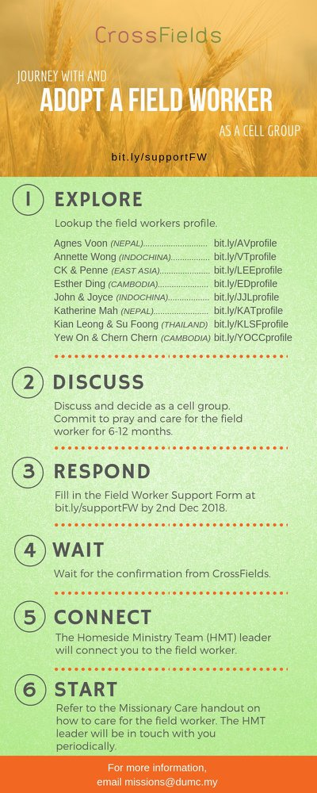

- CMS: Steps to Fill in the Salvation Form
- Select “More”
- “Form”
- Select “Form List” box
- Look for “Salvation Form”
- Fill in form of new salvation by “Change Respondent”
- Must have “E-mail” and “Mobile Phone”

UPCOMING

PREACHING SCHEDULE

20 & 21 July | What is the Gospel? 5. For Accountability | SP, Chris Kam
27 & 28 July | What is the Gospel? 6. For Eternity | Pr Mike Ngui

Go to: http://www.dumc.my/resources/sermons/ for the latest info.

EVENT HIGHLIGHTS

  - Join The Celebrations in DUMC@Puchong at 10am Every Sunday
Bring your friends and family members living around the Puchong area. Look for DUMC@Puchong on Waze or Google Maps. (Please park at IOI Business Park Level B2)

  - TUESDAY ENCOUNTER NIGHT (TEN)
Every 3rd Tuesday of every month | 8.30 -10.00pm | Auditorium
Every 4th Tuesday of every month | 8.30 -10.00pm | DUMC@Puchong
A night focusing on prayer, healing and deliverance
For more information, contact: forerunners@dumc.my

  - CHURCH PRAYER ALTAR
Every Saturday | 7.00 -9.00am | Room 101 & 102
Let us come and seek the face of God. Prayer precedes everything.

  - 5-DAY FAST & PRAY
22-26 July | 8.30pm-10.00pm | Auditorium, Dream Centre
Repentance, Renewal, Restoration. “If my people… will humble themselves and pray…” (2 Chronicles 7:14)
For more information, contact: forerunners@dumc.my

  - WANT TO JOIN THE DUMC FAMILY?
Here are the steps:
> Join a Cell Group (You can get help at our CG Kiosk)
> Attend Basic Christianity 101
> Attend DUMC 101
> Join an Encounter Weekend
> Baptism & Membership Interview Sign up at the Info Counter or online at dumc.my/equip

EQUIP COURSES 2019

PRAYER 201 (Sacred Rhythms)
Thursdays | 4 Jul – 8 Aug | 8.00pm-10.00pm

BASIC CHRISTIANITY 101 (Basic Doctrine I)
Saturdays | 6 & 20 Jul | 8.30am-1.00pm
Note: Membership requirement

DUMC 101
Saturday | 3 Aug | 8.30am-1.00pm
(Note: Membership Requirement)

PAUSE & PONDER (Guided morning prayer & reflection)
Saturday | 10 Aug | 8.30am-11.30am
(Note: Register at bit.ly/PPAug2019)

LIBRARY HOURS
Saturdays | 1.30pm-4.45pm
Sundays | 9.30am-1.30pm
Weekdays | CLOSED
Find out more about Equip courses at the Info Counter in Concourse 2, or online at http://dumc.my/equip

