NOTE For this week:
Cell groups should gather in church to observe the 5 Day Fast and Prayer, 8.30 – 10.00 p.m.

The following is for CGs that would still like to continue on the series of the Gospel as a basis of continuity (can be done over next week, if suitable).

CONTENTS

Worship (3rd week of the month, kindly organize the Lord’s Supper)
Word
Works
Upcoming:
Preaching Schedule
Event Highlights
Equip courses

WORSHIP (Praise and Prayer)

Reminder to conduct the Lord’s Supper this week.
Kindly refer to the guide sent to all Leaders on this topic via email previously.

WORD (60 minutes)

The Gospel: For Accountability
(Philippians 1:3-6, 2:12-13; Job 1:20-22)
Senior Pastor: Chris Kam

Big Idea: The Gospel holds you to the end

- Read the scripture passage.
- Do a THREE-MINUTE SUMMARY of the sermon highlighting the KEY POINTS. Do not preach the whole sermon, as majority of your members would have heard the sermon already. Allocate more time for sharing in the cell through the application questions below.
- Sermon Resource at: http://www.dumc.my/resources/sermons/

Reflection & Application Questions:

- Are there certain truths of the Gospel you are still unclear about? Please share what they are with the group and see if there is collective wisdom on the matter. Remember, it is not about what we think or opine on the matter, but we should always start with what the Bible has to say about it first.

- Define in your own words the meaning of the word “grace”. A good definition is: “unmerited or undeserving favour of God to those who are under condemnation.” What does this mean to you and how does it help you to walk in confidence in God’s love?

- What does it mean to “continue to work out your salvation with fear and trembling…” (Phil 2:12-13)? Why is it important that v.12 and v.13 are not stand-alone verses by themselves, but need to be held together and put into practice? Do you think you are living this out? Why or why not?

- Have pain and suffering drawn you closer to or further away from God? What are some of your experiences? How do you deal with unanswered prayer? How does the life of Job encourage you in building deeper faith in God (Job 1:20-22)?

Note to Word facilitator:
As you are preparing for this session, this is a great time to pray that the Holy Spirit will guide you to use the questions efficaciously. You can select, modify or entirely create your own questions, according to the needs of your CG, especially if you feel that there are too many questions than required for the allocated time.

Note to Cell Groups that have children during meeting:
We recognize several cell groups in DUMC may have 5 or more children joining them during Cell Group meetings. We would like to get them engaged as well during the session therefore we are suggesting for CGs to use Manna Pad and assign someone in rotation to facilitate them after worship. Here is the link to the Manna Pad materials http://dumc.my/resources/downloads/

WORKS (Ministry and Bearing Witness)

Cell leaders to ask these two important questions or share with one another during Works session in every CG meeting.

    - Who have I met, praying for and sharing Christ with?
    - What is the Holy Spirit saying about the community I am in?

- Share Your Story (Your Story, His Glory)
- Whether your story is about how you came to know Christ, illness healed, an act of kindness in your times of need, or of how you served people or how people have served you, give glory to God. Share your story so that people will be encouraged and God's love is known.
- If there are any good testimonies, ask your members to write out their testimonies and submit to the church: http://dumc.my/connect/individual-care/share-your-story/

- Personal: Bible Reading and Journaling
- Subscribe to the Bible Reading Plan app: YouVersion – OwnIt365 New Testament (NT)+ Plan.
- Request one of your members to share a journal entry. Pair up members to share with, and pray for one another.

- Scripture Memory
Every cell meeting, do get your cell members to recite the following together:

Galatians 5:25 (Theme verse for 2019)
Since we live by the Spirit, let us keep in step with the Spirit.

Galatians 2:20 (added from March 2019)
I have been crucified with Christ and I no longer live, but Christ lives in me. The life I now live in the body, I live by faith in the Son of God, who loved me and gave himself for me.

- CrossFields
“Crossing into the harvest field with the message of the Cross”

Sarawak Penan | 10-16 Aug
Sarawak Iban | 10-17 Aug
Sabah Tenom | 9-12 Aug
Myanmar | 9-16 Aug
Sri Lanka | 14-20 Aug
Cambodia | 24 Oct-1 Nov

Website: dumc.my/missions
Mission Trip dates: bit.ly/CF2019cal

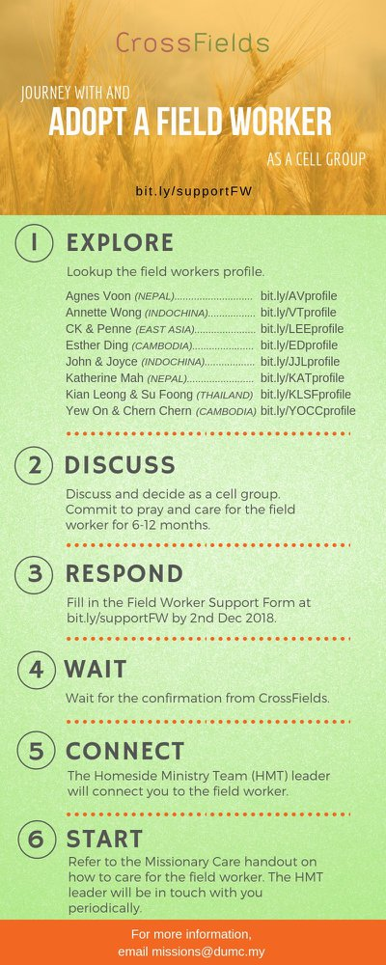

- CMS: Steps to Fill in the Salvation Form
- Select “More”
- “Form”
- Select “Form List” box
- Look for “Salvation Form”
- Fill in form of new salvation by “Change Respondent”
- Must have “E-mail” and “Mobile Phone”

UPCOMING

PREACHING SCHEDULE

27 & 28 July | What is the Gospel? 6. For Eternity | Pr Mike Ngui

Go to: http://www.dumc.my/resources/sermons/ for the latest info.

EVENT HIGHLIGHTS

  - Join The Celebrations in DUMC@Puchong at 10am Every Sunday
Bring your friends and family members living around the Puchong area. Look for DUMC@Puchong on Waze or Google Maps. (Please park at IOI Business Park Level B2)

  - TUESDAY ENCOUNTER NIGHT (TEN)
Every 3rd Tuesday of every month | 8.30 -10.00pm | Auditorium
Every 4th Tuesday of every month | 8.30 -10.00pm | DUMC@Puchong
A night focusing on prayer, healing and deliverance
For more information, contact: forerunners@dumc.my

  - CHURCH PRAYER ALTAR
Every Saturday | 7.00 -9.00am | Room 101 & 102
Let us come and seek the face of God. Prayer precedes everything.

  - 5-DAY FAST & PRAY
22-26 July | 8.30pm-10.00pm | Auditorium, Dream Centre
Repentance, Renewal, Restoration. “If my people… will humble themselves and pray…” (2 Chronicles 7:14)
For more information, contact: forerunners@dumc.my

  - WANT TO JOIN THE DUMC FAMILY?
Here are the steps:
> Join a Cell Group (You can get help at our CG Kiosk)
> Attend Basic Christianity 101
> Attend DUMC 101
> Join an Encounter Weekend
> Baptism & Membership Interview Sign up at the Info Counter or online at dumc.my/equip

EQUIP COURSES 2019

PRAYER 201 (Sacred Rhythms)
Thursdays | 4 Jul – 8 Aug | 8.00pm-10.00pm

DUMC 101
Saturday | 3 Aug | 8.30am-1.00pm
(Note: Membership Requirement)

PAUSE & PONDER (Guided morning prayer & reflection)
Saturday | 10 Aug | 8.30am-11.30am
(Note: Register at bit.ly/PPAug2019)

MINISTRY 201
Saturday | 24 Aug | 8.30am-1.00pm

THEMATIC STUDY – EPIC OF EDEN
Sundays | 25 Aug – 24 Nov | 8.00am-9.30am

BIBLE 101
Saturdays | 31 Aug & 7 Sep | 8.30am-1.00pm

EVANGELISM 101
Saturday | 7 Sep | 8.30am-1.00pm

LIBRARY HOURS
Saturdays | 1.30pm-4.45pm
Sundays | 9.30am-1.30pm
Weekdays | CLOSED
Find out more about Equip courses at the Info Counter in Concourse 2, or online at http://dumc.my/equip

