CONTENTS

Worship
Word
Works
Upcoming:
Preaching Schedule
Event Highlights
Equip courses

WORSHIP (Praise and Prayer)

- International: Mexico
A nation in desperate need; a people seeking hope & freedom.
Population: 110,645,154; Peoples: 317 (4%)

Pray:
- Love and forgiveness of Jesus demonstrated particularly through the church, to the communities may overpower the strongholds of crime, violence, and corruption.
- Leaders of government at every level - municipal, provincial and federal - to repent of corruption and to seek God's righteousness for their lives and their constituencies.
- Empty religious traditions of many self-professed “Christians” (95% of the population) may be supplanted by a radical discipleship in following Jesus.

- Malaysia: National Unity & Religious Freedom
“Over the decade from 2007 to 2017, government restrictions on religion— laws, policies and actions by state officials that restrict religious beliefs and practices—increased markedly around the world… And social hostilities involving religion—including violence and harassment by private individuals, organizations or groups—also have risen since 2007.” (Source: Pew Research)

Pray:
- All Malaysians to work together in love and humility to bring peace and unity to the nation, irrespective of ethnicity or faith.
- Church may play a significant role in this as we are called to “live in peace with everyone and to be holy.” (Heb 12:14)
- Grace granted to Christians in Malaysia facing persecution due to their faith in Christ to respond with love and wisdom, and to stand firm in their confession of Christ.
- Freedom of religion as guaranteed by the Federal Constitution of Malaysia may be genuinely extended to all and for each faith group to be allowed to manage their own religious affairs.

WORD (60 minutes)

The Gospel: For Eternity
(Romans 8:18-23; Revelation 21:1-4)
Pastor: Michael Ngui

Big Idea: God will make ALL things NEW

- Read the scripture passage.
- Do a THREE-MINUTE SUMMARY of the sermon highlighting the KEY POINTS. Do not preach the whole sermon, as majority of your members would have heard the sermon already. Allocate more time for sharing in the cell through the application questions below.
- Sermon Resource at: http://www.dumc.my/resources/sermons/

Reflection & Application Questions:

- Share how difficult a struggle it is for you to be committed to Christ (Rom. 7:21-25)? Then share how knowing that “God will make us NEW spiritually & morally” & “God will make our bodies NEW and glorious” (Rom. 8:21) gives you joy & endurance in the midst of your struggle to be committed to Christ today. Was it a struggle for Jesus himself to be committed to God (Heb. 12:3)? What gave Jesus joy & endurance in the midst of His struggle to be committed (Heb. 12:2)?

- God will make a NEW earth. On a scale of 1 (least) to 10 (most), rate how much is “your life in eternity” shaping the way you live “your life in the present moment”? Take some time to share with the group what do you understand from this statement “if we are not heavenly minded (2 Pet. 3:13), we will not be of earthly use to Christ (2 Cor. 5:9-10)”.

- Take turns to first share what do you look forward to the most in heaven & in life eternal (i.e. freedom from death/suffering/sickness/financial burden/toil of work, etc)? After that, share how does knowing that “the best part of Heaven is Jesus Christ himself” (Rev. 21:3)

  - increase your longing for eternity – where our relationship with God will be gloriously different & full; and

  - change the way you prioritise your investment either for this life or for your eternal future. What would you now change?

Note to Word facilitator:
As you are preparing for this session, this is a great time to pray that the Holy Spirit will guide you to use the questions efficaciously. You can select, modify or entirely create your own questions, according to the needs of your CG, especially if you feel that there are too many questions than required for the allocated time.

Note to Cell Groups that have children during meeting:
We recognise several cell groups in DUMC may have 5 or more children joining them during Cell Group meetings. We would like to get them engaged as well during the session therefore we are suggesting for CGs to use Manna Pad and assign someone in rotation to facilitate them after worship. Here is the link to the Manna Pad materials http://dumc.my/resources/downloads/

WORKS (Ministry and Bearing Witness)

Cell leaders to ask these two important questions or share with one another during Works session in every CG meeting.

    - Who have I met, praying for and sharing Christ with?
    - What is the Holy Spirit saying about the community I am in?

- Share Your Story (Your Story, His Glory)
- Whether your story is about how you came to know Christ, illness healed, an act of kindness in your times of need, or of how you served people or how people have served you, give glory to God. Share your story so that people will be encouraged and God's love is known.
- If there are any good testimonies, ask your members to write out their testimonies and submit to the church: http://dumc.my/connect/individual-care/share-your-story/

- Personal: Bible Reading and Journaling
- Subscribe to the Bible Reading Plan app: YouVersion – OwnIt365 New Testament (NT)+ Plan.
- Request one of your members to share a journal entry. Pair up members to share with, and pray for one another.

- Scripture Memory
Every cell meeting, do get your cell members to recite the following together:

Galatians 5:25 (Theme verse for 2019)
Since we live by the Spirit, let us keep in step with the Spirit.

Galatians 2:20 (added from March 2019)
I have been crucified with Christ and I no longer live, but Christ lives in me. The life I now live in the body, I live by faith in the Son of God, who loved me and gave himself for me.

- CrossFields
“Crossing into the harvest field with the message of the Cross”

Sarawak Penan | 10-16 Aug
Sarawak Iban | 10-17 Aug
Sabah Tenom | 9-12 Aug
Myanmar | 9-16 Aug
Sri Lanka | 14-20 Aug
Cambodia | 24 Oct-1 Nov

Website: dumc.my/missions
Mission Trip dates: bit.ly/CF2019cal

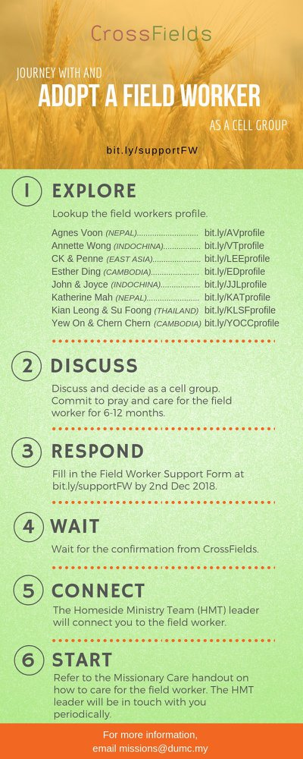

- CMS: Steps to Fill in the Salvation Form
- Select “More”
- “Form”
- Select “Form List” box
- Look for “Salvation Form”
- Fill in form of new salvation by “Change Respondent”
- Must have “E-mail” and “Mobile Phone”

UPCOMING

PREACHING SCHEDULE

Go to: http://www.dumc.my/resources/sermons/ for the latest info.

EVENT HIGHLIGHTS

  - Join The Celebrations in DUMC@Puchong at 10am Every Sunday
Bring your friends and family members living around the Puchong area. Look for DUMC@Puchong on Waze or Google Maps. (Please park at IOI Business Park Level B2)

  - TUESDAY ENCOUNTER NIGHT (TEN)
Every 3rd Tuesday of every month | 8.30 -10.00pm | Auditorium
Every 4th Tuesday of every month | 8.30 -10.00pm | DUMC@Puchong
A night focusing on prayer, healing and deliverance
For more information, contact: forerunners@dumc.my

  - CHURCH PRAYER ALTAR
Every Saturday | 7.00 -9.00am | Room 101 & 102
Let us come and seek the face of God. Prayer precedes everything.

  - WANT TO JOIN THE DUMC FAMILY?
Here are the steps:
> Join a Cell Group (You can get help at our CG Kiosk)
> Attend Basic Christianity 101
> Attend DUMC 101
> Join an Encounter Weekend
> Baptism & Membership Interview Sign up at the Info Counter or online at dumc.my/equip

EQUIP COURSES 2019

PRAYER 201 (Sacred Rhythms)
Thursdays | 4 Jul – 8 Aug | 8.00pm-10.00pm

DUMC 101
Saturday | 3 Aug | 8.30am-1.00pm
(Note: Membership Requirement)

PAUSE & PONDER (Guided morning prayer & reflection)
Saturday | 10 Aug | 8.30am-11.30am
(Note: Register at bit.ly/PPAug2019)

MINISTRY 201
Saturday | 24 Aug | 8.30am-1.00pm

THEMATIC STUDY – EPIC OF EDEN
Sundays | 25 Aug – 24 Nov | 8.00am-9.30am

BIBLE 101
Saturdays | 31 Aug & 7 Sep | 8.30am-1.00pm

EVANGELISM 101
Saturday | 7 Sep | 8.30am-1.00pm

LIBRARY HOURS
Saturdays | 1.30pm-4.45pm
Sundays | 9.30am-1.30pm
Weekdays | CLOSED
Find out more about Equip courses at the Info Counter in Concourse 2, or online at http://dumc.my/equip

