CONTENTS

Worship
Word
Works
Upcoming:
Preaching Schedule
Event Highlights
Equip courses

WORSHIP (Praise and Prayer)

- Libya
The head of Libya's UN-recognised government has proposed holding nationwide elections to end the war in the North African country, as forces of the rival military commander Khalifa Haftar continue their two-month-long battle to take the capital, Tripoli. Speaking at a news conference on 16 June, Prime Minister Fayez al-Sarraj said he was proposing a "Libyan congress" aimed at finding a peaceful solution to the conflict. Sarraj's Government of National Accord (GNA) holds the west, while Haftar's self-styled Libyan National Army (LNA) holds the east and much of the south of the country. (Source: Aljazeera)

Pray for:
- An end to tyranny and dictatorship, and restoration of peace and stability.
- A unified government that will rebuild the nation with justice.
- The tiny Libyan Church to be united and established despite intense persecution.
- Jesus to reveal Himself to the people of Libya.

- Malaysia: Government
Pray for:
- Stabilisation of the Federal and State governments and all political parties.
- God to curtail unhealthy ‘politicking’ in our government both Federal and State, and for them to focus on rebuilding the nation.
- Ask God for mercy and forgiveness for the past mistakes of previous and present governments; wisdom and guidance for the future for our present government.

- DUMC: PJN4 Leaders’ Refresh Encounter (29-30 June)
Pray:
- That the leaders will have a great time reflecting on the past, being refreshed in His presence and refocussing on His call.
- Good time of bonding and connecting on a personal and spiritual level with one another.
- Facilitators and organisers will serve wholeheartedly with the joy of the Lord.
- All personal matters will be taken care of as they participate in the Leaders’ Refresh Encounter.

- Missions: Choo Yew On & Chern Chern, Cambodia
Pray:
- For their team-mates who are ill, two of whom have been hospitalised for dengue and lupus.
- Comfort also for their team as they grieve over the sudden passing of their 37-year old team-mate last month.

WORD (60 minutes)

The Gospel:
For All of Life
(1 Corinthians 15: 1 – 4)
Pastor, Mike Ngui

Big Idea: The Gospel is the “A to Z” of the Christian Life

- Read the scripture passage.
- Do a THREE-MINUTE SUMMARY of the sermon highlighting the KEY POINTS. Do not preach the whole sermon, as majority of your members would have heard the sermon already. Allocate more time for sharing in the cell through the application questions below.
- Sermon Resource at: http://www.dumc.my/resources/sermons/

Reflection & Application Questions:

      - How important is it for you to understand the ‘Gospel’ (the work of Christ)?

      - When was the last time you thought you might not be worthy of coming to God’s presence? What is your usual/normal way of thinking at such a time?

      - Does what Jesus has done (in his life, death and resurrection) affect how you live each day? Share an example. If you cannot think of an example, why might it be so hard to do so?

      - What steps can you take to deepen your understanding of the work of Christ?

Note to Word leader:
As you are preparing for this session, this is a great time to pray that the Holy Spirit will guide you to use the questions efficaciously. You can select, modify or entirely create your own questions, according to the needs of your CG, especially if you feel that there are too many questions than required for the allocated time.

Note to Cell Groups that have children during meeting:
We recognize several cell groups in DUMC may have 5 or more children joining them during Cell Group meetings. We would like to get them engaged as well during the session therefore we are suggesting for CGs to use Manna Pad and assign someone in rotation to facilitate them after worship. Here is the link to the Manna Pad materials http://dumc.my/resources/downloads/

WORKS (Ministry and Bearing Witness)

Cell leaders to ask these two important questions or share with one another during Works session in every CG meeting.

    - Who have I met, praying for and sharing Christ with?
    - What is the Holy Spirit saying about the community I am in?

- Share Your Story (Your Story, His Glory)
- Whether your story is about how you came to know Christ, illness healed, an act of kindness in your times of need, or of how you served people or how people have served you, give glory to God. Share your story so that people will be encouraged and God's love is known.
- If there are any good testimonies, ask your members to write out their testimonies and submit to the church: http://dumc.my/connect/individual-care/share-your-story/

- Personal: Bible Reading and Journaling
- Subscribe to the Bible Reading Plan app: YouVersion – OwnIt365 New Testament (NT)+ Plan.
- Request one of your members to share a journal entry. Pair up members to share with, and pray for one another.

- Scripture Memory
Every cell meeting, do get your cell members to recite the following together:

Galatians 5:25 (Theme verse for 2019)
Since we live by the Spirit, let us keep in step with the Spirit.

Galatians 2:20 (added from March 2019)
I have been crucified with Christ and I no longer live, but Christ lives in me. The life I now live in the body, I live by faith in the Son of God, who loved me and gave himself for me.

- CrossFields
“Crossing into the harvest field with the message of the Cross”

Sarawak Penan | 10-16 Aug
Sarawak Iban | 10-17 Aug
Sabah Tenom | 9-12 Aug
Myanmar | 9-16 Aug
Sri Lanka | 14-20 Aug
Cambodia | 24 Oct-1 Nov
MCPP1| 20-21 Jul | Empress Hotel (Sepang)

Website: dumc.my/missions
Mission Trip dates: bit.ly/CF2019cal

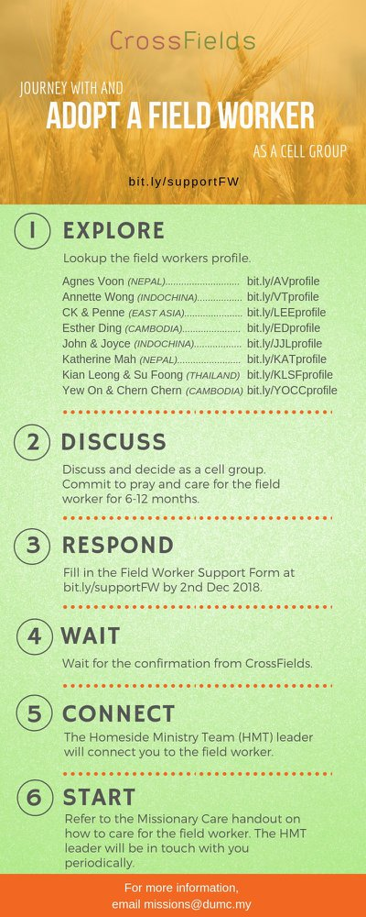

- CMS: Steps to Fill in the Salvation Form
- Select “More”
- “Form”
- Select “Form List” box
- Look for “Salvation Form”
- Fill in form of new salvation by “Change Respondent”
- Must have “E-mail” and “Mobile Phone”

UPCOMING

PREACHING SCHEDULE

29 & 30 June | What is the Gospel? 2. For Salvation | Pr Mike Ngui
6 & 7 July | What is the Gospel? 3. For Growth | SP, Chris Kam
13 & 14 July | What is the Gospel? 4. For Evangelism | Pr Mike Ngui

Go to: http://www.dumc.my/resources/sermons/ for the latest info.

EVENT HIGHLIGHTS

  - Join The Celebrations in DUMC@Puchong at 10am Every Sunday
Bring your friends and family members living around the Puchong area. Look for DUMC@Puchong on Waze or Google Maps. (Please park at IOI Business Park Level B2)

  - TUESDAY ENCOUNTER NIGHT (TEN)
Every 3rd Tuesday of every month | 8.30 -10.00pm | Auditorium
Every 4th Tuesday of every month | 8.30 -10.00pm | DUMC@Puchong
A night focusing on prayer, healing and deliverance
For more information, contact: forerunners@dumc.my

  - CHURCH PRAYER ALTAR
Every Saturday | 7.00 -9.00am | Room 101 & 102
Let us come and seek the face of God. Prayer precedes everything.

  - WANT TO JOIN THE DUMC FAMILY?
Here are the steps:
> Join a Cell Group (You can get help at our CG Kiosk)
> Attend Basic Christianity 101
> Attend DUMC 101
> Join an Encounter Weekend
> Baptism & Membership Interview Sign up at the Info Counter or online at dumc.my/equip

  - ALPHA FOR SENIORS (NEW SEASON)
27 May-28 Oct | 10.00am-12.30pm | Hall 3 (Mondays)
Seniors too have questions about life, faith and God.
Visit our booth in Concourse 2 or contact Peck Har @ 016-612 0210

EQUIP COURSES 2019

PRAYER 201 (Sacred Rhythms)
Thursdays | 4 Jul – 8 Aug | 8.00pm-10.00pm

CHRISTIAN LIVING 101 (My New Life)
Sundays | 23 Jun-4 Aug | 8.00am-9.30am

CHRISTIAN LIVING 201 (The Beatitudes)
Saturdays | 6 & 13 Jul | 8.00am-1.00pm

BASIC CHRISTIANITY 301
Saturdays | 6 &13 Jul | 8.30am-1.00pm

BASIC CHRISTIANITY 101 (Basic Doctrine I)
Saturdays | 13 & 20 Jul | 8.30am-1.00pm
Note: Membership requirement

Find out more about Equip courses at the Info Counter in Concourse 2, or online at dumc.my/equip

LIBRARY HOURS
Saturdays | 1.30pm-4.45pm
Sundays | 9.30am-1.30pm
Weekdays | CLOSED

