CONTENTS

Worship
Word
Works
Upcoming:
Preaching Schedule
Event Highlights
Equip courses

WORSHIP (Praise and Prayer)

- Hong Kong – Extradition Bill Protests
The ongoing anti-Hong Kong extradition bill protests are a series of demonstrations there and in other cities around the world against the Fugitive Offenders and Mutual Legal Assistance in Criminal Matters Legislation (Amendment) Bill 2019 proposed by the Hong Kong government. Concerns have been raised over the removal of the firewall protections between the legal systems of Hong Kong and Mainland China, where Hong Kong citizens and foreign nationals passing through the city could now fall victim to the Chinese legal system where the courts are reportedly under political control. On 16 June, according to claims by the organisers of the protest, a record number of nearly two million people turned out to demonstrate against the extradition bill as well as against police brutality, a day after Chief Executive Carrie Lam announced a pause in the passage of the extradition bill. (Source: Wikipedia)

Pray:
- For restoration of peace and stability, and for the Lord’s mercy and forgiveness on both sides for the animosity and violence That the Lord would heal those who have been wounded during the conflicts; pray against any further violence.
- That Jesus, the Prince of Peace, will reign and bring a miraculous turnaround, removing the anger and disagreements between the people and the authorities.
- For a wise response from the government, and that the police and judiciary will not be seen as political tools.
- That God will bring revival to Hong Kong through the witness of His Church in Hong Kong.

- Malaysia
Pray for:
- Renewed vision for Malaysia, and a clean and fair government.
- Restored confidence in our judicial system, rejuvenation of our economy, and increased freedom of religion in our country.
- The Church in Malaysia to be vigilant to watch and pray for our nation; she will bear faithful witness to the Lord Jesus Christ in word and deed.

WORD (60 minutes)

The Gospel:
For Salvation
(Romans 1:18-25; 3:20-26)
Pastor, Mike Ngui

Big Idea: God saves sinners through Christ

- Read the scripture passage.
- Do a THREE-MINUTE SUMMARY of the sermon highlighting the KEY POINTS. Do not preach the whole sermon, as majority of your members would have heard the sermon already. Allocate more time for sharing in the cell through the application questions below.
- Sermon Resource at: http://www.dumc.my/resources/sermons/

Reflection & Application Questions:

- What is the dominant picture you have of God? e.g. doting kind but weak grandfather, fearsome warrior ala Odin the father of Thor, distant cold stereotypical Asian father

- If sin is understood as a rebellion against God’s rightful authority over your life, then how do you see yourself repenting? What do you need to repent of? What’s hard about it?

- What are the areas of your life that you are anxious about? How can you cultivate a trust toward God for these areas?

Note to Word leader:
As you are preparing for this session, this is a great time to pray that the Holy Spirit will guide you to use the questions efficaciously. You can select, modify or entirely create your own questions, according to the needs of your CG, especially if you feel that there are too many questions than required for the allocated time.

Note to Cell Groups that have children during meeting:
We recognize several cell groups in DUMC may have 5 or more children joining them during Cell Group meetings. We would like to get them engaged as well during the session therefore we are suggesting for CGs to use Manna Pad and assign someone in rotation to facilitate them after worship. Here is the link to the Manna Pad materials http://dumc.my/resources/downloads/

WORKS (Ministry and Bearing Witness)

Cell leaders to ask these two important questions or share with one another during Works session in every CG meeting.

    - Who have I met, praying for and sharing Christ with?
    - What is the Holy Spirit saying about the community I am in?

- Share Your Story (Your Story, His Glory)
- Whether your story is about how you came to know Christ, illness healed, an act of kindness in your times of need, or of how you served people or how people have served you, give glory to God. Share your story so that people will be encouraged and God's love is known.
- If there are any good testimonies, ask your members to write out their testimonies and submit to the church: http://dumc.my/connect/individual-care/share-your-story/

- Personal: Bible Reading and Journaling
- Subscribe to the Bible Reading Plan app: YouVersion – OwnIt365 New Testament (NT)+ Plan.
- Request one of your members to share a journal entry. Pair up members to share with, and pray for one another.

- Scripture Memory
Every cell meeting, do get your cell members to recite the following together:

Galatians 5:25 (Theme verse for 2019)
Since we live by the Spirit, let us keep in step with the Spirit.

Galatians 2:20 (added from March 2019)
I have been crucified with Christ and I no longer live, but Christ lives in me. The life I now live in the body, I live by faith in the Son of God, who loved me and gave himself for me.

- CrossFields
“Crossing into the harvest field with the message of the Cross”

Sarawak Penan | 10-16 Aug
Sarawak Iban | 10-17 Aug
Sabah Tenom | 9-12 Aug
Myanmar | 9-16 Aug
Sri Lanka | 14-20 Aug
Cambodia | 24 Oct-1 Nov
MCPP1| 20-21 Jul | Empress Hotel (Sepang)

Website: dumc.my/missions
Mission Trip dates: bit.ly/CF2019cal

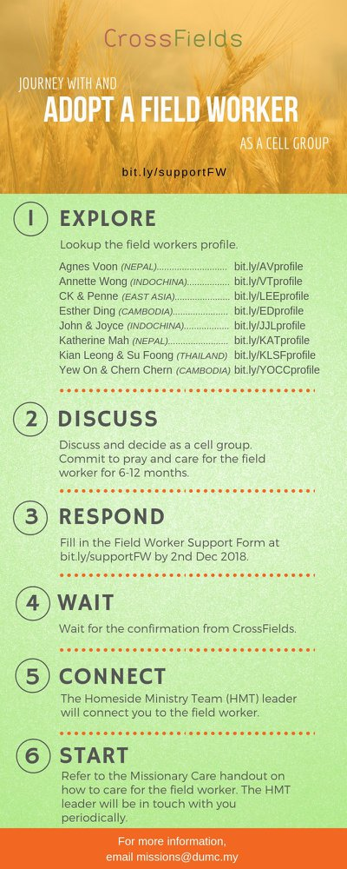

- CMS: Steps to Fill in the Salvation Form
- Select “More”
- “Form”
- Select “Form List” box
- Look for “Salvation Form”
- Fill in form of new salvation by “Change Respondent”
- Must have “E-mail” and “Mobile Phone”

UPCOMING

PREACHING SCHEDULE

6 & 7 July | What is the Gospel? 3. For Growth | SP, Chris Kam
13 & 14 July | What is the Gospel? 4. For Evangelism | Pr Mike Ngui
20 & 21 July | What is the Gospel? 5. For Accountability | SP, Chris Kam

Go to: http://www.dumc.my/resources/sermons/ for the latest info.

EVENT HIGHLIGHTS

  - Join The Celebrations in DUMC@Puchong at 10am Every Sunday
Bring your friends and family members living around the Puchong area. Look for DUMC@Puchong on Waze or Google Maps. (Please park at IOI Business Park Level B2)

  - TUESDAY ENCOUNTER NIGHT (TEN)
Every 3rd Tuesday of every month | 8.30 -10.00pm | Auditorium
Every 4th Tuesday of every month | 8.30 -10.00pm | DUMC@Puchong
A night focusing on prayer, healing and deliverance
For more information, contact: forerunners@dumc.my

  - CHURCH PRAYER ALTAR
Every Saturday | 7.00 -9.00am | Room 101 & 102
Let us come and seek the face of God. Prayer precedes everything.

  - WANT TO JOIN THE DUMC FAMILY?
Here are the steps:
> Join a Cell Group (You can get help at our CG Kiosk)
> Attend Basic Christianity 101
> Attend DUMC 101
> Join an Encounter Weekend
> Baptism & Membership Interview Sign up at the Info Counter or online at dumc.my/equip

  - AFTER 7
6 July | 7.00pm-10.30pm | Dream Centre
Food, Fun & Friendship made alive @ the Dream Centre! Stay as long as you can, leave as soon as you need to! See You July 6

EQUIP COURSES 2019

PRAYER 201 (Sacred Rhythms)
Thursdays | 4 Jul – 8 Aug | 8.00pm-10.00pm

CHRISTIAN LIVING 101 (My New Life)
Sundays | 23 Jun-4 Aug | 8.00am-9.30am

CHRISTIAN LIVING 201 (The Beatitudes)
Saturdays | 6 & 13 Jul | 8.00am-1.00pm

BASIC CHRISTIANITY 301
Saturdays | 6 &13 Jul | 8.30am-1.00pm

BASIC CHRISTIANITY 101 (Basic Doctrine I)
Saturdays | 13 & 20 Jul | 8.30am-1.00pm
Note: Membership requirement

Find out more about Equip courses at the Info Counter in Concourse 2, or online at dumc.my/equip

LIBRARY HOURS
Saturdays | 1.30pm-4.45pm
Sundays | 9.30am-1.30pm
Weekdays | CLOSED

