CONTENTS

Worship
Word
Works
Upcoming:
Preaching Schedule
Event Highlights
Equip courses

WORSHIP (Praise and Prayer)

- India
On 30 May 2019, Narendra Modi was sworn in for a second five-year term as India’s Prime Minister. In the recent Indian General Elections, his party, the Hindu nationalist Bharatiya Janata Party (or BJP) won 354 of 545 seats in the Lok Sabha, the lower house of India’s Parliament. During Modi’s first term, persecution against Christians in India severely increased. This year, Open Doors USA ranked India as the 10th worst country in the world for persecution of Christians who have faced violence and loss of rights.

Pray for:
- Indian pastors and leaders:
  - For grace to trust in God’s sovereignty, discernment on how God is going to move notwithstanding the persecution, and wisdom to carry out His work in spreading the gospel.
  - That God’s faithfulness will spur them to keep doing what they believe He is calling them to do.
- His people in India - that the global church will stand with them, both in prayer, and by empowering them with tools and training to continue to push the light of the Gospel against the spiritual darkness around them.
- Protection, wisdom, and open doors to the Gospel message.

- Malaysia: The Adopted Unreached People Group: Penans, Sarawak The Penans.
Pray for:
- God’s provision for the pastors serving the Penan people in the deep interior.
- God’s encouragement and support for the pre-school teachers who face challenging situations.
- God to raise up linguists who can document their language, history and culture.
- Their transition into modern society so that they can find more viable means of sustenance.

WORD (60 minutes)

Following Jesus:
Into Where He is unknown
(Luke 15: 8 - 10)
Sam Dharam

Big Idea: What is Your Story?

- Read the scripture passage.
- Do a THREE-MINUTE SUMMARY of the sermon highlighting the KEY POINTS. Do not preach the whole sermon, as majority of your members would have heard the sermon already. Allocate more time for sharing in the cell through the application questions below.
- Sermon Resource at: http://www.dumc.my/resources/sermons/

Reflection & Application Questions:

- What is the most significant thing that the Holy Spirit spoke to you about through this sermon?

- God’s heart is for the lost. He grieves at the evil of mankind. Yet His heart is for every soul on this earth. How do we react when we hear stories of injustices or evil either from the pulpit or from people/social media in our midst?

- Is there someone in your family or circle of friends whom you are praying for to know the Lord as his/her Saviour? Has the Lord open any opportunities for You to share the Gospel? Please share to your CG members what these opportunities are.

Note to Word leader:
As you are preparing for this session, this is a great time to pray that the Holy Spirit will guide you to use the questions efficaciously. You can select, modify or entirely create your own questions, according to the needs of your CG, especially if you feel that there are too many questions than required for the allocated time.

Note to Cell Groups that have children during meeting:
We recognize several cell groups in DUMC may have 5 or more children joining them during Cell Group meetings. We would like to get them engaged as well during the session therefore we are suggesting for CGs to use Manna Pad and assign someone in rotation to facilitate them after worship. Here is the link to the Manna Pad materials http://dumc.my/resources/downloads/

WORKS (Ministry and Bearing Witness)

Cell leaders to ask these two important questions or share with one another during Works session in every CG meeting.

    - Who have I met, praying for and sharing Christ with?
    - What is the Holy Spirit saying about the community I am in?

- Share Your Story (Your Story, His Glory)
- Whether your story is about how you came to know Christ, illness healed, an act of kindness in your times of need, or of how you served people or how people have served you, give glory to God. Share your story so that people will be encouraged and God's love is known.
- If there are any good testimonies, ask your members to write out their testimonies and submit to the church: http://dumc.my/connect/individual-care/share-your-story/

- Personal: Bible Reading and Journaling
- Subscribe to the Bible Reading Plan app: YouVersion – OwnIt365 New Testament (NT)+ Plan.
- Request one of your members to share a journal entry. Pair up members to share with, and pray for one another.

- Scripture Memory
Every cell meeting, do get your cell members to recite the following together:

Galatians 5:25 (Theme verse for 2019)
Since we live by the Spirit, let us keep in step with the Spirit.

Galatians 2:20 (added from March 2019)
I have been crucified with Christ and I no longer live, but Christ lives in me. The life I now live in the body, I live by faith in the Son of God, who loved me and gave himself for me.

- CrossFields
“Crossing into the harvest field with the message of the Cross”

Sarawak Penan | 10-16 Aug
Sarawak Iban | 10-17 Aug
Sabah Tenom | 9-12 Aug
Myanmar | 9-16 Aug
Sri Lanka | 14-20 Aug
Cambodia | 24 Oct-1 Nov
MCPP1| 20-21 Jul | Empress Hotel (Sepang)

Website: dumc.my/missions
Mission Trip dates: bit.ly/CF2019cal

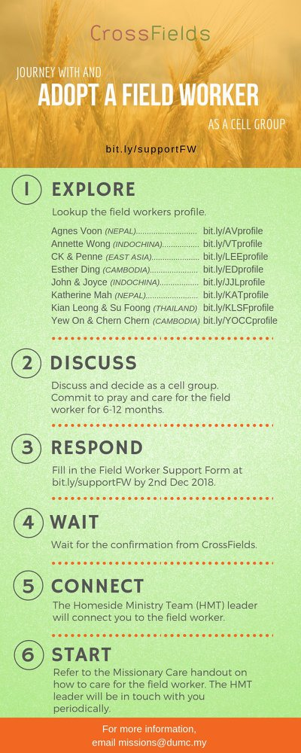

- CMS: Steps to Fill in the Salvation Form
- Select “More”
- “Form”
- Select “Form List” box
- Look for “Salvation Form”
- Fill in form of new salvation by “Change Respondent”
- Must have “E-mail” and “Mobile Phone”

UPCOMING

PREACHING SCHEDULE

15 & 16 June | Following Jesus (Father’s Day / Baby Dedication Weekend) | Senior Pr Chris Kam
22 & 23 June | What is the Gospel? 1. For All or Life | Pr Mike Ngui
29 & 30 June | What is the Gospel? 2. For Salvation | Pr Mike Ngui

Go to: http://www.dumc.my/resources/sermons/ for the latest info.

EVENT HIGHLIGHTS

  - Join The Celebrations in DUMC@Puchong at 10am Every Sunday
Bring your friends and family members living around the Puchong area. Look for DUMC@Puchong on Waze or Google Maps. (Please park at IOI Business Park Level B2)

  - TUESDAY ENCOUNTER NIGHT (TEN)
Every 3rd Tuesday of every month | 8.30 -10.00pm | Auditorium
Every 4th Tuesday of every month | 8.30 -10.00pm | DUMC@Puchong
A night focusing on prayer, healing and deliverance
For more information, contact: forerunners@dumc.my

  - CHURCH PRAYER ALTAR
Every Saturday | 7.00 -9.00am | Room 101 & 102
Let us come and seek the face of God. Prayer precedes everything.

  - WANT TO JOIN THE DUMC FAMILY?
Here are the steps:
> Join a Cell Group (You can get help at our CG Kiosk)
> Attend Basic Christianity 101
> Attend DUMC 101
> Join an Encounter Weekend
> Baptism & Membership Interview Sign up at the Info Counter or online at dumc.my/equip

  - PARENTS SUPPORT PARENTS
Topic: Parenting Together (New Series)
Dates | 25/5, 15/6, 29/6
Time | 3.00pm-4.30pm
Venue | Café Function Room
Admission free!

  - ALPHA FOR SENIORS (NEW SEASON)
27 May-28 Oct | 10.00am-12.30pm | Hall 3 (Mondays)
Seniors too have questions about life, faith and God.
Visit our booth in Concourse 2 or contact Peck Har @ 016-612 0210

EQUIP COURSES 2019

EVANGELISM 101
Saturday | 15 Jun | 8.30am-1.00pm

PRAYER 201 (Sacred Rhythms)
Thursdays | 4 Jul – 8 Aug | 8.00pm-10.00pm

CHRISTIAN LIVING 101 (My New Life)
Sundays | 23 Jun-4 Aug | 8.00am-9.30am

CHRISTIAN LIVING 201 (The Beatitudes)
Saturdays | 6 & 13 Jul | 8.00am-1.00pm

BASIC CHRISTIANITY 301
Saturdays | 6 &13 Jul | 8.30am-1.00pm

BASIC CHRISTIANITY 101 (Basic Doctrine I)
Saturdays | 13 & 20 Jul | 8.30am-1.00pm
Note: Membership requirement

Find out more about Equip courses at the Info Counter in Concourse 2, or online at dumc.my/equip

LIBRARY HOURS
Saturdays | 1.30pm-4.45pm
Sundays | 9.30am-1.30pm
Weekdays | CLOSED

