CONTENTS

Worship
Word
Works
Upcoming:
Preaching Schedule
Event Highlights
Equip courses

WORSHIP (Praise and Prayer)

- Sudan
Sudan’s capital Khartoum was occupied by citizens campaigning for a civilian government for seven weeks. The military crackdown against the prodemocracy protesters has proven deadly in a country already ravaged by war and deprivation. Among the many killed since violence broke out in the majority Sunni Muslim nation earlier this month have been at least 19 children. (Source: 9news.com.au)

Pray for:
- A return to peace and stability.
- Government leaders to rule with integrity and justice.
- God’s comfort and healing for the injured and for those who lost their loved ones.
- The church to grow spiritually strong despite suffering and persecution.

- Malaysia: Orang Asli & Orang Asal
It has been reported that 13 Bateq tribesmen have died from an illness that is yet to be conclusively determined in Kg Kuala Koh, which has been declared as a Red Zone. The Bateq villagers are said to have died under mysterious circumstances. (Source: www.thestar.com.my)

Pray for:
- Wisdom for the Health Ministry, the police and other relevant agencies investigating the incident to find the cause of death and take appropriate action.
- That those affected will receive the help they need.
- God’s comfort for the families who lost their loved ones. Pray against any more deaths.
- Wisdom and courage for our leaders as they seek to address poverty among our indigenous peoples in Malaysia.

WORD (60 minutes)

Following Jesus:
In the Face of Persecution
(Mark 8:34-38)
Senior Pastor, Chris Kam

Big Idea: Following Jesus is going to cost you!

- Read the scripture passage.
- Do a THREE-MINUTE SUMMARY of the sermon highlighting the KEY POINTS. Do not preach the whole sermon, as majority of your members would have heard the sermon already. Allocate more time for sharing in the cell through the application questions below.
- Sermon Resource at: http://www.dumc.my/resources/sermons/

Reflection & Application Questions:

- What is the most significant thing the Holy Spirit spoke to you about through this sermon?

- Read Luke 14:25-33. Please explain in your own words what this passage means. Were you aware that there are costs in following Jesus? What are some of these costs? Share with your group if you have experienced them. What emotions do the five “Are you willing ……” questions evoke in you? How would you answer the five questions?

- What does Mark 8:34 mean in the light of the sermon? What does it mean to “deny yourself”? What does it mean to “take up your cross”? Please give personal examples. Share also your personal struggles in this area. It may be a good time to spend some time to repent before God that you have taken your faith too lightly.

- In the light of what’s happening around the world with regard to the persecution of Christians, how does this help you live in liberty, and not in fear of such possibility? What has this revealed about your walk with Jesus?

Note to Word leader:
As you are preparing for this session, this is a great time to pray that the Holy Spirit will guide you to use the questions efficaciously. You can select, modify or entirely create your own questions, according to the needs of your CG, especially if you feel that there are too many questions than required for the allocated time.

Note to Cell Groups that have children during meeting:
We recognize several cell groups in DUMC may have 5 or more children joining them during Cell Group meetings. We would like to get them engaged as well during the session therefore we are suggesting for CGs to use Manna Pad and assign someone in rotation to facilitate them after worship. Here is the link to the Manna Pad materials http://dumc.my/resources/downloads/

WORKS (Ministry and Bearing Witness)

Cell leaders to ask these two important questions or share with one another during Works session in every CG meeting.

    - Who have I met, praying for and sharing Christ with?
    - What is the Holy Spirit saying about the community I am in?

- Share Your Story (Your Story, His Glory)
- Whether your story is about how you came to know Christ, illness healed, an act of kindness in your times of need, or of how you served people or how people have served you, give glory to God. Share your story so that people will be encouraged and God's love is known.
- If there are any good testimonies, ask your members to write out their testimonies and submit to the church: http://dumc.my/connect/individual-care/share-your-story/

- Personal: Bible Reading and Journaling
- Subscribe to the Bible Reading Plan app: YouVersion – OwnIt365 New Testament (NT)+ Plan.
- Request one of your members to share a journal entry. Pair up members to share with, and pray for one another.

- Scripture Memory
Every cell meeting, do get your cell members to recite the following together:

Galatians 5:25 (Theme verse for 2019)
Since we live by the Spirit, let us keep in step with the Spirit.

Galatians 2:20 (added from March 2019)
I have been crucified with Christ and I no longer live, but Christ lives in me. The life I now live in the body, I live by faith in the Son of God, who loved me and gave himself for me.

- CrossFields
“Crossing into the harvest field with the message of the Cross”

Sarawak Penan | 10-16 Aug
Sarawak Iban | 10-17 Aug
Sabah Tenom | 9-12 Aug
Myanmar | 9-16 Aug
Sri Lanka | 14-20 Aug
Cambodia | 24 Oct-1 Nov
MCPP1| 20-21 Jul | Empress Hotel (Sepang)

Website: dumc.my/missions
Mission Trip dates: bit.ly/CF2019cal

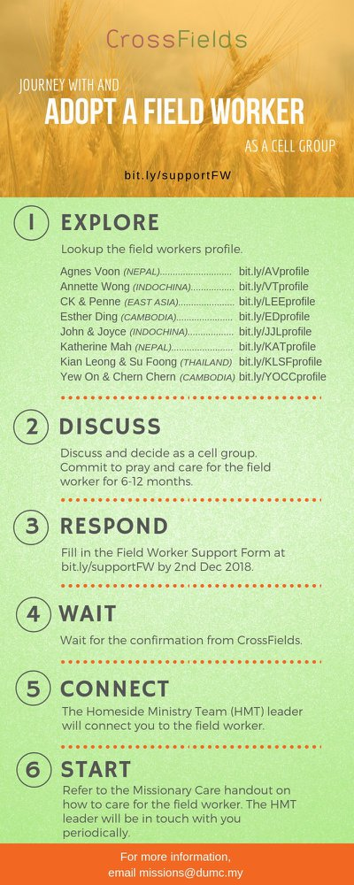

- CMS: Steps to Fill in the Salvation Form
- Select “More”
- “Form”
- Select “Form List” box
- Look for “Salvation Form”
- Fill in form of new salvation by “Change Respondent”
- Must have “E-mail” and “Mobile Phone”

UPCOMING

PREACHING SCHEDULE

22 & 23 June | What is the Gospel? 1. For All or Life | Pr Mike Ngui
29 & 30 June | What is the Gospel? 2. For Salvation | Pr Mike Ngui
6 & 7 July | What is the Gospel? 3. For Growth | SP, Chris Kam

Go to: http://www.dumc.my/resources/sermons/ for the latest info.

EVENT HIGHLIGHTS

  - Join The Celebrations in DUMC@Puchong at 10am Every Sunday
Bring your friends and family members living around the Puchong area. Look for DUMC@Puchong on Waze or Google Maps. (Please park at IOI Business Park Level B2)

  - TUESDAY ENCOUNTER NIGHT (TEN)
Every 3rd Tuesday of every month | 8.30 -10.00pm | Auditorium
Every 4th Tuesday of every month | 8.30 -10.00pm | DUMC@Puchong
A night focusing on prayer, healing and deliverance
For more information, contact: forerunners@dumc.my

  - CHURCH PRAYER ALTAR
Every Saturday | 7.00 -9.00am | Room 101 & 102
Let us come and seek the face of God. Prayer precedes everything.

  - WANT TO JOIN THE DUMC FAMILY?
Here are the steps:
> Join a Cell Group (You can get help at our CG Kiosk)
> Attend Basic Christianity 101
> Attend DUMC 101
> Join an Encounter Weekend
> Baptism & Membership Interview Sign up at the Info Counter or online at dumc.my/equip

  - ALPHA FOR SENIORS (NEW SEASON)
27 May-28 Oct | 10.00am-12.30pm | Hall 3 (Mondays)
Seniors too have questions about life, faith and God.
Visit our booth in Concourse 2 or contact Peck Har @ 016-612 0210

EQUIP COURSES 2019

PRAYER 201 (Sacred Rhythms)
Thursdays | 4 Jul – 8 Aug | 8.00pm-10.00pm

CHRISTIAN LIVING 101 (My New Life)
Sundays | 23 Jun-4 Aug | 8.00am-9.30am

CHRISTIAN LIVING 201 (The Beatitudes)
Saturdays | 6 & 13 Jul | 8.00am-1.00pm

BASIC CHRISTIANITY 301
Saturdays | 6 &13 Jul | 8.30am-1.00pm

BASIC CHRISTIANITY 101 (Basic Doctrine I)
Saturdays | 13 & 20 Jul | 8.30am-1.00pm
Note: Membership requirement

Find out more about Equip courses at the Info Counter in Concourse 2, or online at dumc.my/equip

LIBRARY HOURS
Saturdays | 1.30pm-4.45pm
Sundays | 9.30am-1.30pm
Weekdays | CLOSED

