CONTENTS

Worship
Word
Works
Upcoming:
Preaching Schedule
Event Highlights
Equip courses

WORSHIP (Praise and Prayer)

- The Unreached People Group: Khmers, Cambodia
Pray for:
• The Lord’s restoration of families to break free from poverty, injustice, ill health, and out from the strongholds of idolatry and addiction to alcohol.
• The Khmer children and youth:
◊ More opportunities for proper education.
◊ Protection from the harmful and evil intentions of others.
• The Church and believers:
◊ That they will stand strong in the Lord and in unity, acting wisely and continuing to be fervent in the Lord.
◊ That God will give them perseverance notwithstanding the opposition, and courage to share the Good News. ◊ They will be lighthouses to those who need hope, healing & salvation.
• Mission Team: Pray for Jacky Lai (Team Leader), Roger Chan, Melissa Ganason, John Ong, Amanda Soong, Cornelia Tay & Jennifer Yap
• That the Holy Spirit will go before them and unite them.
• For the Spirit’s compassion, boldness and love in their ministry to the children and adults, and for the preparation of their hearts.
• For God's grace, mercy, blessing, guidance and protection to be upon them and their loved ones back home.

- Malaysia: Youth
Youths today face many challenges, with some tending to push them towards sexual addiction (e.g. pornography or sexual promiscuity), digital addiction (e.g. electronic games or abuse of IT technology), or other forms of addiction.

Pray:
For the Holy Spirit to fill our youth with gospel values and to teach them to always make godly choices in loving obedience to the Lord.
• That they will be firmly grounded in the Word of God to help them handle life’s challenges.
• That God will lead them to develop strong relationships within godly communities to help one another journey together in growth, healing and restoration.

WORD (60 minutes)

The 3Ms of Sticky Marriages:
The Mission
(John 15:5-8; Philippians 4:11b-13; Ephesians 5:31-32)
Chris Kam, Senior Pastor

Big Idea: The Mission of Marriage is to grow disciples of Jesus.

- Read the scripture passage.
- Do a THREE-MINUTE SUMMARY of the sermon highlighting the KEY POINTS. Do not preach the whole sermon, as majority of your members would have heard the sermon already. Allocate more time for sharing in the cell through the application questions below.
- Sermon Resource at: http://www.dumc.my/resources/sermons/

Reflection & Application Questions:
1. Where did you get your idea of marriage from? Does what you see of the marriages around you give you greater or lesser hope? Please share your observations and conclusions.
2. Did this marriage series confirm, add to, change or correct any of your own preconceived ideas? Please share with the group what these are.
3. In what ways do you see a Christian marriage as a home of discipleship to the married couple and later to their children? What good family rituals or culture do you think you will want to see in your family? How would you have a conversation with your children about their future spouses? When will you start and what will you say?
4. For those who are single, discuss the merits of celibacy from 1 Cor 7:32-35. Will this affect the way you live your life now, even with the hope of marriage someday? What does it mean to be Mr or Miss Right first? If you choose to be single, what are some of the practical considerations you can have to be a disciple of Jesus in the area of contentment and purpose for your life?

Note to Word facilitator:
As you are preparing for this session, this is a great time to pray that the Holy Spirit will guide you to use the questions efficaciously. You can select, modify or entirely create your own questions, according to the needs of your CG, especially if you feel that there are too many questions than required for the allocated time.

Note to Cell Groups that have children during meeting:
We recognise several cell groups in DUMC may have 5 or more children joining them during Cell Group meetings. We would like to get them engaged as well during the session therefore we are suggesting for CGs to use Manna Pad and assign someone in rotation to facilitate them after worship. Here is the link to the Manna Pad materials http://dumc.my/resources/downloads/

WORKS (Ministry and Bearing Witness)

Cell leaders to ask these two important questions or share with one another during Works session in every CG meeting.

    - Who have I met, praying for and sharing Christ with?
    - What is the Holy Spirit saying about the community I am in?

- Share Your Story (Your Story, His Glory)
- Whether your story is about how you came to know Christ, illness healed, an act of kindness in your times of need, or of how you served people or how people have served you, give glory to God. Share your story so that people will be encouraged and God's love is known.
- If there are any good testimonies, ask your members to write out their testimonies and submit to the church: http://dumc.my/connect/individual-care/share-your-story/

- Personal: Bible Reading and Journaling
- Subscribe to the Bible Reading Plan app: YouVersion – OwnIt365 New Testament (NT)+ Plan.
- Request one of your members to share a journal entry. Pair up members to share with, and pray for one another.

- Scripture Memory
Every cell meeting, do get your cell members to recite the following together:

Galatians 5:25 (Theme verse for 2019)
Since we live by the Spirit, let us keep in step with the Spirit.

Galatians 2:20 (added from March 2019)
I have been crucified with Christ and I no longer live, but Christ lives in me. The life I now live in the body, I live by faith in the Son of God, who loved me and gave himself for me.

- CrossFields
“Crossing into the harvest field with the message of the Cross”

Sarawak Iban | 13-16 Sep
Sarawak Penan | 30 Nov-6 Dec
Thailand | 7-13 Sep
Myanmar | 15-22 Sep
Cambodia | 24 Oct-1 Nov
Vietnam | 5-10 Dec

Website: dumc.my/missions
Mission Trip dates: bit.ly/CF2019cal

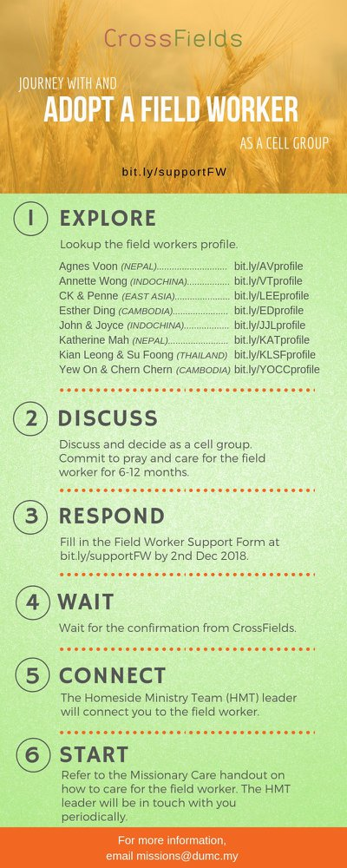

- CMS: Steps to Fill in the Salvation Form
- Select “More”
- “Form”
- Select “Form List” box
- Look for “Salvation Form”
- Fill in form of new salvation by “Change Respondent”
- Must have “E-mail” and “Mobile Phone”

UPCOMING

PREACHING SCHEDULE

24 & 25 Aug | Nation Series – Christian Citizenship  (Church and Politics/Religious Freedom & Persecution) | Pr Dr Daniel Ho
31 Aug & 1 Sep | Nation Series – Christian Citizenship  (Church and Justice) | Jim Yost
7 & 8 Sep | Nation Series – Christian Citizenship  (Church and Prophetic Voice to the Nation) | Rachel Hickson
14 & 15 Sep | Nation Series – Christian Citizenship  (Church and Nation Building/Constitution) | Denison Jayasooria

Go to: http://www.dumc.my/resources/sermons/ for the latest info.

EVENT HIGHLIGHTS

  - Join The Celebrations in DUMC@Puchong at 10am Every Sunday
Bring your friends and family members living around the Puchong area. Look for DUMC@Puchong on Waze or Google Maps. (Please park at IOI Business Park Level B2)

  - TUESDAY ENCOUNTER NIGHT (TEN)
Every 3rd Tuesday of every month | 8.30 -10.00pm | Auditorium
Every 4th Tuesday of every month | 8.30 -10.00pm | DUMC@Puchong
A night focusing on prayer, healing and deliverance
For more information, contact: forerunners@dumc.my

  - CHURCH PRAYER ALTAR
Every Saturday | 7.00 -9.00am | Room 101 & 102
Let us come and seek the face of God. Prayer precedes everything.

  - WANT TO JOIN THE DUMC FAMILY?
Here are the steps:
> Join a Cell Group (You can get help at our CG Kiosk)
> Attend Basic Christianity 101
> Attend DUMC 101
> Join an Encounter Weekend
> Baptism & Membership Interview Sign up at the Info Counter or online at dumc.my/equip

e. TALK@W2W with Rachel Hickson
7 Sep | 9:30am-11:30am | Hall 3
Topic: What Happens When Women Pray? (Specially for women) Come and be blessed.
Info? Email w2w@dumc.my

- THE MARRIAGE COURSE
1 Sep-27 Oct | 3.00pm-5.30pm | Hall 3
Building a healthy marriage that lasts a lifetime.
Sign up at bit.ly/marriage_course Info? Visit dumc.my/familylife

- IMPACT
2020·YOU·ME·theNATIONS
DUMC is turning 40 in 2020! It’s time to look outwards — beyond the four walls of our church. Info? Visit the IMPACT info booth or go to bit.ly/IMPACTleaflet

- NECF – MALAYSIA DAY PRAYER RALLY
15 Sep | 6.00pm | Full Gospel Tabernacle, USJ

- MALAYSIA DAY PRAYER
16 Sep | 10.00am-1.00pm Grace Convention Centre, Tmn Mayang PJ (organized by CCM/PrayerUnited/ Archdiocese of KL)

EQUIP COURSES 2019

CHRISTIAN LEADERSHIP 201
Saturday | 14 & 21 Sep | 8.30am-1.00pm

THEMATIC STUDY – EPIC OF EDEN
Sundays | 25 Aug – 24 Nov | 8.00am-9.30am

BIBLE 101
Saturdays | 31 Aug & 7 Sep | 8.30am-1.00pm

EVANGELISM 101
Saturday | 7 Sep | 8.30am-1.00pm

SPIRITUAL WARFARE 201
Saturdays | 21 & 28 Sep | 8.30am-1.00pm

BASIC CHRISTIANITY 101
Saturdays | 28 Sep & 5 Oct | 8.30am-1.00pm (Note: Membership Requirement)

LIBRARY HOURS
Saturdays | 1.30pm-4.45pm
Sundays | 9.30am-1.30pm
Weekdays | CLOSED
Find out more about Equip courses at the Info Counter in Concourse 2, or online at http://dumc.my/equip

