CONTENTS

Worship
Word
Works
Upcoming:
Preaching Schedule
Event Highlights
Equip courses

WORSHIP (Praise and Prayer)

- International: An end to Ebola-Disease and death do not have the final word. Jesus does.
The Ebola virus outbreak that began in December 2013 is by far the worst in history, claiming over 11,000 lives in West Africa. While we praise God that the rate of infection is abating, the disease is not eradicated, and its aftereffects are far-reaching. The three epicenter countries of Liberia, Guinea, and Sierra Leone are the hardest hit, but the entire region must cope with the effects of Ebola.
Pray for:
• Continued vigilance to prevent further outbreak.
• Readily available healthcare will be provided by governments of affected nations and assistance from richer nations.
• God’s mercy, power and authority to stop this disease and bring restoration to West Africa through His Church.

- Malaysia: Youth
Pray for:
• Equipping Parents – for a greater effectiveness of churches in equipping them for the work of raising a godly next generation as they are primarily entrusted with the work of teaching the fear of the Lord to the second and third generations.
• The Young People:
a) A passion for revival in them.
b) To grow in grace, wisdom and in the knowledge of our Lord Jesus.

The Unreached People Group
- The Murut People
Pray for:
• God to encounter the pre-believers and many nominal Christians with His Truth, and cause them to seek Him whole-heartedly
• The Christians that:
a) God will give them perseverance notwithstanding the opposition and courage to share the Good News.
b) God will empower them to live out His Word by their trust and obedience in Him.
c) For God’s grace and success in work and ministry.
B. Mission Team
Pray for Eunice Tan (Leader), Vicky Sylvester (Asst. Leader), Gawai & Toh Joon Sim:
• Team unity and good communication among them.
• Their sensitivity to the Holy Spirit’s whisper, leading and guidance.
• Safe journey, good health and good weather.

WORD (60 minutes)

The Myth
(Romans 3:9-12)
Chris Kam ,Senior Pastor

Big Idea: Be mindful of what marriage is not

- Read the scripture passage.
- Do a THREE-MINUTE SUMMARY of the sermon highlighting the KEY POINTS. Do not preach the whole sermon, as majority of your members would have heard the sermon already. Allocate more time for sharing in the cell through the application questions below.
- Sermon Resource at: http://www.dumc.my/resources/sermons/

Reflection & Application Questions:
1. Do you identify with any of the three myths mentioned? Which myth stands out to you most? Why?

2. Why is it difficult for two persons to live together based on Isaiah 53:6, Romans 3:10,11,23 and Genesis 3:16?

3. What does it mean to say we have to be disciples of Christ first before we can become husband and wife? Have you thought of this before and what is the implication therefore to how you are living the Christian life now and for the future?

4. What does it mean for both singles and marrieds to find their contentment in Christ first? If you are single, what good will this bring to your potential marriage someday, or even if you remain celibate? If you are married, what good will this bring to your marriage?

Note to Word facilitator:
As you are preparing for this session, this is a great time to pray that the Holy Spirit will guide you to use the questions efficaciously. You can select, modify or entirely create your own questions, according to the needs of your CG, especially if you feel that there are too many questions than required for the allocated time.

Note to Cell Groups that have children during meeting:
We recognise several cell groups in DUMC may have 5 or more children joining them during Cell Group meetings. We would like to get them engaged as well during the session therefore we are suggesting for CGs to use Manna Pad and assign someone in rotation to facilitate them after worship. Here is the link to the Manna Pad materials http://dumc.my/resources/downloads/

WORKS (Ministry and Bearing Witness)

Cell leaders to ask these two important questions or share with one another during Works session in every CG meeting.

    - Who have I met, praying for and sharing Christ with?
    - What is the Holy Spirit saying about the community I am in?

- Share Your Story (Your Story, His Glory)
- Whether your story is about how you came to know Christ, illness healed, an act of kindness in your times of need, or of how you served people or how people have served you, give glory to God. Share your story so that people will be encouraged and God's love is known.
- If there are any good testimonies, ask your members to write out their testimonies and submit to the church: http://dumc.my/connect/individual-care/share-your-story/

- Personal: Bible Reading and Journaling
- Subscribe to the Bible Reading Plan app: YouVersion – OwnIt365 New Testament (NT)+ Plan.
- Request one of your members to share a journal entry. Pair up members to share with, and pray for one another.

- Scripture Memory
Every cell meeting, do get your cell members to recite the following together:

Galatians 5:25 (Theme verse for 2019)
Since we live by the Spirit, let us keep in step with the Spirit.

Galatians 2:20 (added from March 2019)
I have been crucified with Christ and I no longer live, but Christ lives in me. The life I now live in the body, I live by faith in the Son of God, who loved me and gave himself for me.

- CrossFields
“Crossing into the harvest field with the message of the Cross”

Sarawak Penan | 10-16 Aug
Sarawak Iban | 10-17 Aug
Sabah Tenom | 9-12 Aug
Myanmar | 9-16 Aug
Sri Lanka | 14-20 Aug
Cambodia | 24 Oct-1 Nov

Website: dumc.my/missions
Mission Trip dates: bit.ly/CF2019cal

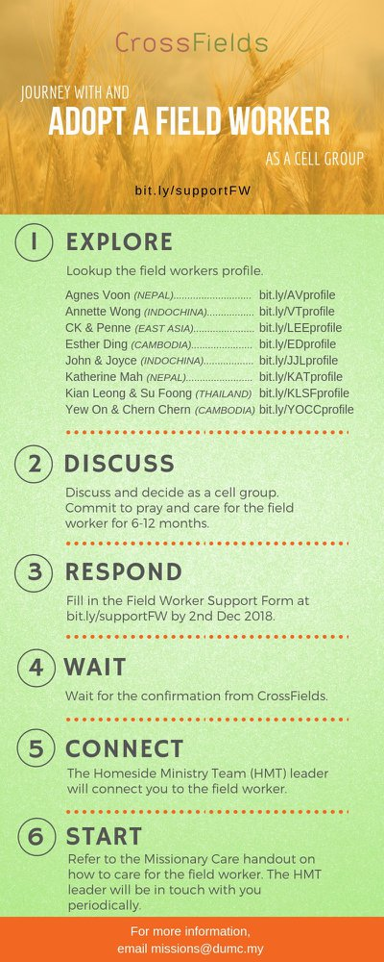

- CMS: Steps to Fill in the Salvation Form
- Select “More”
- “Form”
- Select “Form List” box
- Look for “Salvation Form”
- Fill in form of new salvation by “Change Respondent”
- Must have “E-mail” and “Mobile Phone”

UPCOMING

PREACHING SCHEDULE

Go to: http://www.dumc.my/resources/sermons/ for the latest info.

EVENT HIGHLIGHTS

  - Join The Celebrations in DUMC@Puchong at 10am Every Sunday
Bring your friends and family members living around the Puchong area. Look for DUMC@Puchong on Waze or Google Maps. (Please park at IOI Business Park Level B2)

  - TUESDAY ENCOUNTER NIGHT (TEN)
Every 3rd Tuesday of every month | 8.30 -10.00pm | Auditorium
Every 4th Tuesday of every month | 8.30 -10.00pm | DUMC@Puchong
A night focusing on prayer, healing and deliverance
For more information, contact: forerunners@dumc.my

  - CHURCH PRAYER ALTAR
Every Saturday | 7.00 -9.00am | Room 101 & 102
Let us come and seek the face of God. Prayer precedes everything.

  - WANT TO JOIN THE DUMC FAMILY?
Here are the steps:
> Join a Cell Group (You can get help at our CG Kiosk)
> Attend Basic Christianity 101
> Attend DUMC 101
> Join an Encounter Weekend
> Baptism & Membership Interview Sign up at the Info Counter or online at dumc.my/equip

EQUIP COURSES 2019

CHRISTIAN LEADERSHIP 201
Saturday | 14 & 21 Sep | 8.30am-1.00pm

PRAYER 201 (Sacred Rhythms)
Thursdays | 4 Jul – 8 Aug | 8.00pm-10.00pm

DUMC 101
Saturday | 3 Aug | 8.30am-1.00pm
(Note: Membership Requirement)

PAUSE & PONDER (Guided morning prayer & reflection)
Saturday | 10 Aug | 8.30am-11.30am
(Note: Register at bit.ly/PPAug2019)

MINISTRY 201
Saturday | 24 Aug | 8.30am-1.00pm

THEMATIC STUDY – EPIC OF EDEN
Sundays | 25 Aug – 24 Nov | 8.00am-9.30am

BIBLE 101
Saturdays | 31 Aug & 7 Sep | 8.30am-1.00pm

EVANGELISM 101
Saturday | 7 Sep | 8.30am-1.00pm

LIBRARY HOURS
Saturdays | 1.30pm-4.45pm
Sundays | 9.30am-1.30pm
Weekdays | CLOSED
Find out more about Equip courses at the Info Counter in Concourse 2, or online at http://dumc.my/equip

