CONTENTS

Worship
Word
Works
Upcoming:
Preaching Schedule
Event Highlights
Equip courses

WORSHIP (Praise and Prayer)

- International: Senegal
Population: 14,668,522.
GDP Per Capita: $2,700. Literacy Rate: 57.7%.
Languages: French, Wolof, Pular, Jola, Mandinka, Serer, Soninke. People Groups: Wolof 41.6%, Pular 28.1%, Serer 15.3%, Mandinka 5.4%, Jola 3.4%, Soninka 5.4%, others 5.4%.
Religions: Muslim 96.1%, Christian 3.6%, animist 0.3%. UNREACHED: 46.4%
Pray for:
• Spiritual breakthroughs among the diverse ethnic groups.
• The small body of believers to boldly live out their faith in a way that draws others to Christ.
• Indigenous churches to be planted among the many unreached people groups.
- Malaysia: Youth
Pray for:
• The Youth in our Nation - conviction upon them to walk in spirit and in truth bringing glory to their Master and Friend.
• Effective partnership between church and family to raise a generation of young people who can fulfil their God-given roles in modelling what it means to belong to the kingdom of heaven, as sons and daughters with prophetic voices to this generation, as the "little child" who will lead the lion and the lamb.
Children’s Church: Vacation Bible School (VBS) [11-13 August]
Pray:
• Purpose
◊ That the God of the Word will encounter children and adults alike.
◊ For their responsiveness and commitment to Jesus; for open hearts and sensitivity to the Holy Spirit.
• People
◊ The speakers - for the Spirit’s anointing and wisdom to speak the truth in love.
◊ The leaders and all the volunteer teams - for unity and love; for synergy and smooth operations and for service with joyful and willing hearts.
◊ The children, youth and adults - for good health.
• Place
◊ Safety and security of children, youths and adults.
◊ God’s glory will descend that all will see His beauty, majesty and power.
• Post-VBS
◊ For the children and Leaders to reflect on what they have received from God and live it out in faith.

WORD (60 minutes)

The Mystery
(Ephesians 5:21-33)
Chris Kam ,Senior Pastor

Big Idea: Marriage is not just about you. It is more about Christ and His Church, and you becoming more like Him

- Read the scripture passage.
- Do a THREE-MINUTE SUMMARY of the sermon highlighting the KEY POINTS. Do not preach the whole sermon, as majority of your members would have heard the sermon already. Allocate more time for sharing in the cell through the application questions below.
- Sermon Resource at: http://www.dumc.my/resources/sermons/

Reflection & Application Questions:
1. What is this profound mystery about Christ and the church in a marriage relationship?

2. Why is marriage a place of discipleship to be more Christ like? Please give examples and how you can apply this in your current or future family.

3. Discuss this statement: You have to be a disciple of Christ first before you can become a husband or wife.

4. What does it mean for husband and wife to “submit to one another out of reverence for Christ?” (Eph 5:21) What are the things that Christians are to do for one another which are exemplified in an even greater way in a marriage relationship?

5. What does it mean for husbands to love their wives (v25) and for wives to respect their husbands (v33b)? What are some practical examples of this? Why are husbands given the command to love and wives to respect? Why is it difficult for the husbands or wives to carry out their respective ,and you becoming more ccommands? Please give examples.

Note to Word facilitator:
As you are preparing for this session, this is a great time to pray that the Holy Spirit will guide you to use the questions efficaciously. You can select, modify or entirely create your own questions, according to the needs of your CG, especially if you feel that there are too many questions than required for the allocated time.

Note to Cell Groups that have children during meeting:
We recognise several cell groups in DUMC may have 5 or more children joining them during Cell Group meetings. We would like to get them engaged as well during the session therefore we are suggesting for CGs to use Manna Pad and assign someone in rotation to facilitate them after worship. Here is the link to the Manna Pad materials http://dumc.my/resources/downloads/

WORKS (Ministry and Bearing Witness)

Cell leaders to ask these two important questions or share with one another during Works session in every CG meeting.

    - Who have I met, praying for and sharing Christ with?
    - What is the Holy Spirit saying about the community I am in?

- Share Your Story (Your Story, His Glory)
- Whether your story is about how you came to know Christ, illness healed, an act of kindness in your times of need, or of how you served people or how people have served you, give glory to God. Share your story so that people will be encouraged and God's love is known.
- If there are any good testimonies, ask your members to write out their testimonies and submit to the church: http://dumc.my/connect/individual-care/share-your-story/

- Personal: Bible Reading and Journaling
- Subscribe to the Bible Reading Plan app: YouVersion – OwnIt365 New Testament (NT)+ Plan.
- Request one of your members to share a journal entry. Pair up members to share with, and pray for one another.

- Scripture Memory
Every cell meeting, do get your cell members to recite the following together:

Galatians 5:25 (Theme verse for 2019)
Since we live by the Spirit, let us keep in step with the Spirit.

Galatians 2:20 (added from March 2019)
I have been crucified with Christ and I no longer live, but Christ lives in me. The life I now live in the body, I live by faith in the Son of God, who loved me and gave himself for me.

- CrossFields
“Crossing into the harvest field with the message of the Cross”

Sarawak Penan | 10-16 Aug
Sarawak Iban | 10-17 Aug
Sabah Tenom | 9-12 Aug
Myanmar | 9-16 Aug
Sri Lanka | 14-20 Aug
Cambodia | 24 Oct-1 Nov

Website: dumc.my/missions
Mission Trip dates: bit.ly/CF2019cal

e.) DUA for W2W and Men alive Exercise Based on this weekend’s Sermon
1. Separate the Men and Woman.
In 5 minutes ,write down the common needs Men /Woman want from the Future/Current spouse. Rank the top 5 .Then spend 15 minutes having fun sharing with each other .
After that ,in separate gender discussions:

A.What does it mean to be a Miss/Mrs Right ?What does one have to do?
B. As my marriage (current/Future)is ment to reflect the relationship between Christ and the Church,what is one thing the Holy spirit is convicting you to change or grow in?
Referring to the list the men stated as their top5 needs ,how can you meet these needs in your marriage?

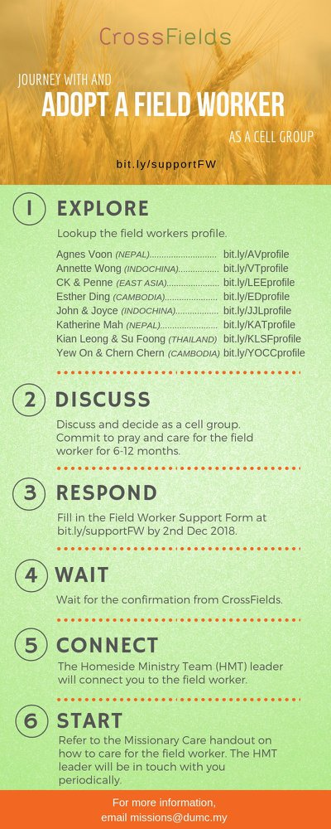

- CMS: Steps to Fill in the Salvation Form
- Select “More”
- “Form”
- Select “Form List” box
- Look for “Salvation Form”
- Fill in form of new salvation by “Change Respondent”
- Must have “E-mail” and “Mobile Phone”

UPCOMING

PREACHING SCHEDULE

Go to: http://www.dumc.my/resources/sermons/ for the latest info.

EVENT HIGHLIGHTS

  - Join The Celebrations in DUMC@Puchong at 10am Every Sunday
Bring your friends and family members living around the Puchong area. Look for DUMC@Puchong on Waze or Google Maps. (Please park at IOI Business Park Level B2)

  - TUESDAY ENCOUNTER NIGHT (TEN)
Every 3rd Tuesday of every month | 8.30 -10.00pm | Auditorium
Every 4th Tuesday of every month | 8.30 -10.00pm | DUMC@Puchong
A night focusing on prayer, healing and deliverance
For more information, contact: forerunners@dumc.my

  - CHURCH PRAYER ALTAR
Every Saturday | 7.00 -9.00am | Room 101 & 102
Let us come and seek the face of God. Prayer precedes everything.

  - WANT TO JOIN THE DUMC FAMILY?
Here are the steps:
> Join a Cell Group (You can get help at our CG Kiosk)
> Attend Basic Christianity 101
> Attend DUMC 101
> Join an Encounter Weekend
> Baptism & Membership Interview Sign up at the Info Counter or online at dumc.my/equip

e. TALK@W2W with Rachel Hickson
7 Sep | 9:30am-11:30am | Hall 3
Topic: What Happens When Women Pray? (Specially for women) Come and be blessed.
Info? Email w2w@dumc.my

- UNASHAMED2019
7-9 Sep | Grand Kampar Hotel
A combined NextGen camp for all youth aged between 12-23.
Register now at bit.ly/unashamed2019nxg Info? Head to the Info Counter.

- THE MARRIAGE COURSE
1 Sep-27 Oct | 3.00pm-5.30pm | Hall 3
Building a healthy marriage that lasts a lifetime.
Sign up at bit.ly/marriage_course Info? Visit dumc.my/familylif

EQUIP COURSES 2019

CHRISTIAN LEADERSHIP 201
Saturday | 14 & 21 Sep | 8.30am-1.00pm

PRAYER 201 (Sacred Rhythms)
Thursdays | 4 Jul – 8 Aug | 8.00pm-10.00pm

DUMC 101
Saturday | 3 Aug | 8.30am-1.00pm
(Note: Membership Requirement)

PAUSE & PONDER (Guided morning prayer & reflection)
Saturday | 10 Aug | 8.30am-11.30am
(Note: Register at bit.ly/PPAug2019)

MINISTRY 201
Saturday | 24 Aug | 8.30am-1.00pm

THEMATIC STUDY – EPIC OF EDEN
Sundays | 25 Aug – 24 Nov | 8.00am-9.30am

BIBLE 101
Saturdays | 31 Aug & 7 Sep | 8.30am-1.00pm

EVANGELISM 101
Saturday | 7 Sep | 8.30am-1.00pm

LIBRARY HOURS
Saturdays | 1.30pm-4.45pm
Sundays | 9.30am-1.30pm
Weekdays | CLOSED
Find out more about Equip courses at the Info Counter in Concourse 2, or online at http://dumc.my/equip

