CONTENTS

Worship
Word
Works
Upcoming:
Preaching Schedule
Event Highlights
Equip courses

WORSHIP (Praise and Prayer)

- The Unreached People Group: Tamang& Newari People, Nepal
Population: 28.5 million. Religions: Hinduism (84.0%), Christianity (1.3%), Islam (3.8%), Buddhism (7.9%), Others (3.0%). 275 people groups (267 unreached).
Pray:
Tamang/Newari People:
• Spiritual revival for them and an end to religious persecution; that the Lord will open the prebelievers’ spiritual eyes and hearts to the Good News.
• The Church & believers:
◊ God will unite the churches.
◊ Their passion for and intimacy with Jesus Christ will be reignited.
• The nation of Nepal - for justice and righteousness, political stability, economic growth, and the creation of jobs and thriving businesses.

- DUMC’s Mission Team (5-15 Sept)
Joanne Hee (Team Leader), David Wong (Asst. Leader), Therese Kung, Cecelia Lee & Ong Teck Jin: • God’s guidance and revelation, and His strength, wisdom, power and good health for them.
• The Spirit’s anointing upon them and Spirit-led partnerships with missionaries and local churches.
• Safety, journey mercies and God’s presence and protection over the team and their loved ones back home.

- The Marriage Course: Building a Healthy Marriage That Lasts A Lifetime (1 Sep – 27 Oct in Dream Centre) Pray:
• God will give the hosts & support team members wisdom to meet the needs of the participants.
• For the couples: ◊ They will participate actively and learn better husband wife communication. ◊ Their marital relationships will grow and deepen, leading to stronger marriages and stronger families. ◊ God will clear up their workloads during this time so that they can faithfully commit to the full course.
• Those with children will be able to arrange for them to be taken care of.
• God will touch the pre-believers at this course (one or both spouses) and bring forth in them an openness to His love and message, so that they will consequently come to trust in Him.

WORD (60 minutes)

Politics, Religious Freedom & Persecution
(Romans 13:1-7)
Dato’ Dr Daniel Ho, Founding Senior Pastor

- Read the scripture passage.
- Do a THREE-MINUTE SUMMARY of the sermon highlighting the KEY POINTS. Do not preach the whole sermon, as majority of your members would have heard the sermon already. Allocate more time for sharing in the cell through the application questions below.
- Sermon Resource at: http://www.dumc.my/resources/sermons/

Reflection & Application Questions:

1. What are the roles and responsibilities of the Church and Christians in the nation and how are you playing that role positively in Malaysia? Share your experience, both positive and negative.

2. When does the Christian position clash with the power-that-be or with other Christians? What should our attitude and response? What cost(s) have you paid in following Jesus?

Note to Word facilitator:
As you are preparing for this session, this is a great time to pray that the Holy Spirit will guide you to use the questions efficaciously. You can select, modify or entirely create your own questions, according to the needs of your CG, especially if you feel that there are too many questions than required for the allocated time.

Note to Cell Groups that have children during meeting:
We recognise several cell groups in DUMC may have 5 or more children joining them during Cell Group meetings. We would like to get them engaged as well during the session therefore we are suggesting for CGs to use Manna Pad and assign someone in rotation to facilitate them after worship. Here is the link to the Manna Pad materials http://dumc.my/resources/downloads/

WORKS (Ministry and Bearing Witness)

Cell leaders to ask these two important questions or share with one another during Works session in every CG meeting.

    - Who have I met, praying for and sharing Christ with?
    - What is the Holy Spirit saying about the community I am in?

- Share Your Story (Your Story, His Glory)
- Whether your story is about how you came to know Christ, illness healed, an act of kindness in your times of need, or of how you served people or how people have served you, give glory to God. Share your story so that people will be encouraged and God's love is known.
- If there are any good testimonies, ask your members to write out their testimonies and submit to the church: http://dumc.my/connect/individual-care/share-your-story/

- Personal: Bible Reading and Journaling
- Subscribe to the Bible Reading Plan app: YouVersion – OwnIt365 New Testament (NT)+ Plan.
- Request one of your members to share a journal entry. Pair up members to share with, and pray for one another.

- Scripture Memory
Every cell meeting, do get your cell members to recite the following together:

Galatians 5:25 (Theme verse for 2019)
Since we live by the Spirit, let us keep in step with the Spirit.

Galatians 2:20 (added from March 2019)
I have been crucified with Christ and I no longer live, but Christ lives in me. The life I now live in the body, I live by faith in the Son of God, who loved me and gave himself for me.

- CrossFields
“Crossing into the harvest field with the message of the Cross”

Sarawak Iban | 13-16 Sep
Sarawak Penan | 30 Nov-6 Dec
Thailand | 7-13 Sep
Myanmar | 15-22 Sep
Cambodia | 24 Oct-1 Nov
Vietnam | 5-10 Dec

Website: dumc.my/missions
Mission Trip dates: bit.ly/CF2019cal

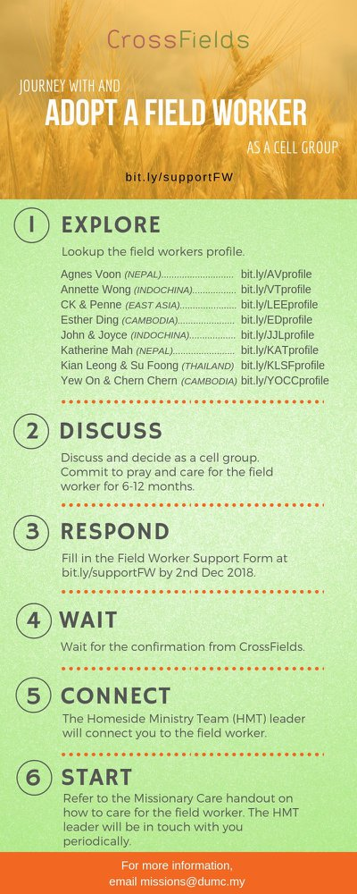

- CMS: Steps to Fill in the Salvation Form
- Select “More”
- “Form”
- Select “Form List” box
- Look for “Salvation Form”
- Fill in form of new salvation by “Change Respondent”
- Must have “E-mail” and “Mobile Phone”

UPCOMING

PREACHING SCHEDULE

31 Aug & 1 Sep | Nation Series – Christian Citizenship  (Church and Justice) | Jim Yost
7 & 8 Sep | Nation Series – Christian Citizenship  (Church and Prophetic Voice to the Nation) | Rachel Hickson
14 & 15 Sep | Nation Series – Christian Citizenship  (Church and Nation Building/Constitution) | Denison Jayasooria

Go to: http://www.dumc.my/resources/sermons/ for the latest info.

EVENT HIGHLIGHTS

  - Join The Celebrations in DUMC@Puchong at 10am Every Sunday
Bring your friends and family members living around the Puchong area. Look for DUMC@Puchong on Waze or Google Maps. (Please park at IOI Business Park Level B2)

  - TUESDAY ENCOUNTER NIGHT (TEN)
Every 3rd Tuesday of every month | 8.30 -10.00pm | Auditorium
Every 4th Tuesday of every month | 8.30 -10.00pm | DUMC@Puchong
A night focusing on prayer, healing and deliverance
For more information, contact: forerunners@dumc.my

  - CHURCH PRAYER ALTAR
Every Saturday | 7.00 -9.00am | Room 101 & 102
Let us come and seek the face of God. Prayer precedes everything.

  - WANT TO JOIN THE DUMC FAMILY?
Here are the steps:
> Join a Cell Group (You can get help at our CG Kiosk)
> Attend Basic Christianity 101
> Attend DUMC 101
> Join an Encounter Weekend
> Baptism & Membership Interview Sign up at the Info Counter or online at dumc.my/equip

e. TALK@W2W with Rachel Hickson
7 Sep | 9:30am-11:30am | Hall 3
Topic: What Happens When Women Pray? (Specially for women) Come and be blessed.
Info? Email w2w@dumc.my

- THE MARRIAGE COURSE
1 Sep-27 Oct | 3.00pm-5.30pm | Hall 3
Building a healthy marriage that lasts a lifetime.
Sign up at bit.ly/marriage_course Info? Visit dumc.my/familylife

- IMPACT
2020·YOU·ME·theNATIONS
DUMC is turning 40 in 2020! It’s time to look outwards — beyond the four walls of our church. Info? Visit the IMPACT info booth or go to bit.ly/IMPACTleaflet

- NECF – MALAYSIA DAY PRAYER RALLY
15 Sep | 6.00pm | Full Gospel Tabernacle, USJ

- MALAYSIA DAY PRAYER
16 Sep | 10.00am-1.00pm Grace Convention Centre, Tmn Mayang PJ (organized by CCM/PrayerUnited/ Archdiocese of KL)

- AN EVENING WITH RACHEL HICKSON - LIVING IN VICTORY
6 Sep | 8.30pm-10.00pm | Auditorium
CHURCH PRAYER ALTAR
(With Rachel Hickson)
7 Sep | 7.00am-9.00am | Room 101/102
Info? Contact forerunners@dumc.my

EQUIP COURSES 2019

CHRISTIAN LEADERSHIP 201
Saturday | 14 & 21 Sep | 8.30am-1.00pm

THEMATIC STUDY – EPIC OF EDEN
Sundays | 25 Aug – 24 Nov | 8.00am-9.30am

BIBLE 101
Saturdays | 31 Aug & 7 Sep | 8.30am-1.00pm

EVANGELISM 101
Saturday | 7 Sep | 8.30am-1.00pm

SPIRITUAL WARFARE 201
Saturdays | 21 & 28 Sep | 8.30am-1.00pm

BASIC CHRISTIANITY 101
Saturdays | 28 Sep & 5 Oct | 8.30am-1.00pm (Note: Membership Requirement)

LIBRARY HOURS
Saturdays | 1.30pm-4.45pm
Sundays | 9.30am-1.30pm
Weekdays | CLOSED
Find out more about Equip courses at the Info Counter in Concourse 2, or online at http://dumc.my/equip

