CONTENTS

Worship
Word
Works
Upcoming:
Preaching Schedule
Event Highlights
Equip courses

WORSHIP (Praise and Prayer)

- Malaysia – 62nd Merdeka Day (31 Aug)
Pray for:
- The government – good and efficient cabinet; govern the nation with integrity, justice and compassion.
- Religious freedoms to be upheld and racial acceptance to be embraced by all segments of society. Pray against those who incite or stoke animosity using race and religion.
- Truth, justice and righteousness to be upheld in our land.
- The Church to be salt and light to the nation; for a return to the Great Commandment and the Great Commission.

- Hong Kong
Pray for:
- Wisdom for the government and strength for citizens.
- Heal the distrust between citizens and government, restore harmony in the society.
- Give hope to the whole community after experiencing this massive conflict.
- Lead Christians and the Church to be effective witnesses in a society that is torn apart and fractured. (Source: Hong Kong Christian Council)

- Malaysia – Christian Youth
Pray for:
The Holy Spirit to stir in their hearts a love for the Word of God and enable them to encounter the God of the Word in their daily living.
• God to help them find godly peer communities and at least 5 significant relationships with godly adults for healthy development.

- NextGen Camp: UNASHAMED2019 (7-9 Sep)
Pray for:
- The Campers:
  - God’s preparation of their hearts to seek and obey Him wholeheartedly; their encounter with the God of the Word.
  - The Lord will draw the prebelievers to faith in Jesus Christ.
  - The Lord will bless the committee members with unity and the spirit of servanthood.
  - Participants to prepare themselves to seek God and His plans for them.
- The Speakers: For the Spirit’s anointing and authority upon them.
- Journey mercies and safety for all concerned.

WORD (60 minutes)

Justice begins with me!
(Luke 10: 30-37)
Pastor Jim Yost

BIG IDEA: Be the new Samaritan

- Read the scripture passage.
- Do a THREE-MINUTE SUMMARY of the sermon highlighting the KEY POINTS. Do not preach the whole sermon, as majority of your members would have heard the sermon already. Allocate more time for sharing in the cell through the application questions below.
- Sermon Resource at: http://www.dumc.my/resources/sermons/

Reflection & Application Questions:

- Pr Jim shared that justice (just acts) is doing the right thing at the right time in the guidance of God’s spirit. However, sometimes we can become cold in our love and compassion for needy people when it seems to be a routine or a norm. In what ways can we continue to fan that flame in being the "first responders to pain" like the Samaritan?

- Have you ever find yourself protecting your reputation or guarding your religious profile when associated to sinners or unbelievers? How does this message change or strengthen your views about being among them?

- Discuss with your group the statements below and how we can respond to it as a disciple of Christ.
  - Pain is normal. We should thrive in the midst of chaos.
  - Safety is more important than helping hurting people.

- Mission is a lifestyle. How much of your life resemble Jesus in the community around you?
How can being in a CG help you to be more Christlike?

Note to Word facilitator:
As you are preparing for this session, this is a great time to pray that the Holy Spirit will guide you to use the questions efficaciously. You can select, modify or entirely create your own questions, according to the needs of your CG, especially if you feel that there are too many questions than required for the allocated time.

Note to Cell Groups that have children during meeting:
We recognise several cell groups in DUMC may have 5 or more children joining them during Cell Group meetings. We would like to get them engaged as well during the session therefore we are suggesting for CGs to use Manna Pad and assign someone in rotation to facilitate them after worship. Here is the link to the Manna Pad materials http://dumc.my/resources/downloads/

WORKS (Ministry and Bearing Witness)

Cell leaders to ask these two important questions or share with one another during Works session in every CG meeting.

    - Who have I met, praying for and sharing Christ with?
    - What is the Holy Spirit saying about the community I am in?

- Share Your Story (Your Story, His Glory)
- Whether your story is about how you came to know Christ, illness healed, an act of kindness in your times of need, or of how you served people or how people have served you, give glory to God. Share your story so that people will be encouraged and God's love is known.
- If there are any good testimonies, ask your members to write out their testimonies and submit to the church: http://dumc.my/connect/individual-care/share-your-story/

- Personal: Bible Reading and Journaling
- Subscribe to the Bible Reading Plan app: YouVersion – OwnIt365 New Testament (NT)+ Plan.
- Request one of your members to share a journal entry. Pair up members to share with, and pray for one another.

- Scripture Memory
Every cell meeting, do get your cell members to recite the following together:

Galatians 5:25 (Theme verse for 2019)
Since we live by the Spirit, let us keep in step with the Spirit.

Galatians 2:20 (added from March 2019)
I have been crucified with Christ and I no longer live, but Christ lives in me. The life I now live in the body, I live by faith in the Son of God, who loved me and gave himself for me.

- CrossFields
“Crossing into the harvest field with the message of the Cross”

Sarawak Iban | 13-16 Sep
Sarawak Penan | 30 Nov-6 Dec
Myanmar | 15-22 Nov
Cambodia | 24 Oct-1 Nov
Vietnam | 5-10 Dec

Website: dumc.my/missions
Mission Trip dates: bit.ly/CF2019cal

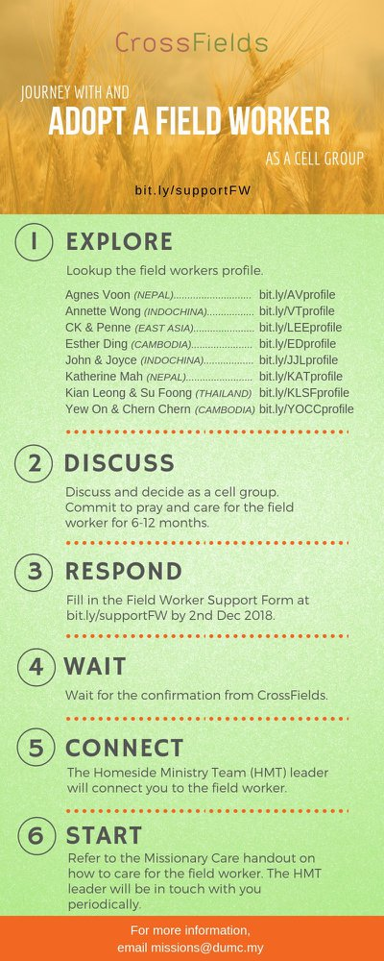

- CMS: Steps to Fill in the Salvation Form
- Select “More”
- “Form”
- Select “Form List” box
- Look for “Salvation Form”
- Fill in form of new salvation by “Change Respondent”
- Must have “E-mail” and “Mobile Phone”

UPCOMING

PREACHING SCHEDULE

7 & 8 Sep | Nation Series – Christian Citizenship  (Church and Prophetic Voice to the Nation) | Rachel Hickson
14 & 15 Sep | Nation Series – Christian Citizenship  (Church and Nation Building/Constitution) | Prof Datuk Dr Denison Jayasooria

Go to: http://www.dumc.my/resources/sermons/ for the latest info.

EVENT HIGHLIGHTS

  - Join The Celebrations in DUMC@Puchong at 10am Every Sunday
Bring your friends and family members living around the Puchong area. Look for DUMC@Puchong on Waze or Google Maps. (Please park at IOI Business Park Level B2)

  - MORNING WITH RACHEL HICKSON
5 - 6 Sep | 9.30am-12.30pm | Hall 3, DC

  - EVENING WITH RACHEL HICKSON
6 Sep | 8.30pm-10.00pm | Auditorium, DC

  - CHURCH PRAYER ALTAR (With Rachel Hickson)
7 Sep | 7.00am-9.00am | Room 101, DC

  - TALK@W2W (With Rachel Hickson)
7 Sep | 9:30am-11:30am | Hall 3
Topic: What Happens When Women Pray? (Specially for women) Come and be blessed
Info? Email w2w@dumc.my

  - MENALIVE HUDDLE
14 Sep | 8:30am-11:00am | Hall 3, DC
We are on the Stepping Up series. Next topic? 'Having a Vision for Your World’. Exclusively for
men. Info? Visit fb.com/MenAliveDUMC

  - CHURCH PRAYER ALTAR
Every Saturday | 7.00 -9.00am | Room 101 & 102
Let us come and seek the face of God. Prayer precedes everything.

  - WANT TO JOIN THE DUMC FAMILY?
Here are the steps:
> Join a Cell Group (You can get help at our CG Kiosk)
> Attend Basic Christianity 101
> Attend DUMC 101
> Join an Encounter Weekend
> Baptism & Membership Interview Sign up at the Info Counter or online at dumc.my/equip

  - THE MARRIAGE COURSE
1 Sep-27 Oct | 3.00pm-5.30pm | Hall 3
Building a healthy marriage that lasts a lifetime.
Sign up at bit.ly/marriage_course Info? Visit dumc.my/familylife

  - IMPACT
2020·YOU·ME·theNATIONS
DUMC is turning 40 in 2020! It’s time to look outwards — beyond the four walls of our church. Info? Visit the IMPACT info booth or go to bit.ly/IMPACTleaflet

  - NECF – MALAYSIA DAY PRAYER RALLY
- Sep | 6.00pm | Full Gospel Tabernacle, USJ

  - MALAYSIA DAY PRAYER
16 Sep | 10.00am-1.00pm Grace Convention Centre, Tmn Mayang PJ (organized by CCM/PrayerUnited/ Archdiocese of KL)

EQUIP COURSES 2019

CHRISTIAN LEADERSHIP 201
Saturday | 14 & 21 Sep | 8.30am-1.00pm

CHRISTIAN LEADERSHIP 301
Saturdays | 21 & 28 Sep | 8.30am-1.00pm

EVANGELISM 101
Saturday | 7 Sep | 8.30am-1.00pm

SPIRITUAL WARFARE 201
Saturdays | 21 & 28 Sep | 8.30am-1.00pm

PRAYER 101 Sundays | 22 Sep-17 Nov | 8.00am-9.45am

BASIC CHRISTIANITY 101
Saturdays | 28 Sep & 5 Oct | 8.30am-1.00pm (Note: Membership Requirement)

LIBRARY HOURS
Saturdays | 1.30pm-4.45pm
Sundays | 9.30am-1.30pm
Weekdays | CLOSED
Find out more about Equip courses at the Info Counter in Concourse 2, or online at http://dumc.my/equip

