CONTENTS

Worship
Word
Works
Upcoming:
Preaching Schedule
Event Highlights
Equip courses

WORSHIP (Praise and Prayer)

- Malaysia – Indigenous
Pray:
- For our indigenous peoples – the Orang Asli in Semenanjung and the Orang Asal from Sabah and Sarawak.
- That many may be lifted up from poverty and their welfare will be taken care of indiscriminately.
- That God will reveal Himself to them and His light will penetrate their hearts so that they will know the true, living God.

- Papua, Indonesia – Violent Riots
What has led to the violent riots in Indonesia’s Papua? - Riots broke out on 19 August in the restive Papua region, where a separatist movement has simmered since the 1960s. - While President Joko Widodo has sought to improve outcomes for the region, Indonesia’s long-standing racism against Papuans risks undermining his infrastructure plans, says Human Rights Watch. (Source: scmp.com)
Pray for:
- For cessation of violence, racism to be addressed, and reconciliation between Indonesians and Papuans.
- For the translation work and literacy programmes. (Forty percent of the population is illiterate, which hinders the working of God's word in their lives)
- May God establish a true peace and a new identity that rises above tribal and ethnic ties so that the people are brought together in a way that will only be accomplished through Christ as He provides creative solutions to meet the people's needs.

- Missions – Choo Yew On & Chern Chern, Cambodia
Pray:
- University of Health Sciences
  - For the renewal of MoU.
  - That the postgraduate Orthodontic students will be diligent in their research work.
- Intentional Discipleship-Making Conference in Singapore (5-7 Sep)
  - Pray that they will learn much and apply what they learn in their lives and in the mission field.
- The Cleft Clinics in Siem Reap and Phnom Penh
  - Pray that the Lord will increase the staff’s competence

WORD (60 minutes)

The Journey Of The Prophetic In A Nation
(1 Samuel 3:1-7)
Rachel Hickson

BIG IDEA: His Word never fails!

- Read the scripture passage.
- Do a THREE-MINUTE SUMMARY of the sermon highlighting the KEY POINTS. Do not preach the whole sermon, as majority of your members would have heard the sermon already. Allocate more time for sharing in the cell through the application questions below.
- Sermon Resource at: http://www.dumc.my/resources/sermons/

Reflection & Application Questions:
- A prophetic voice will release and reveal the voice of God for the season, time and place. It starts with prayerful and intercessional lifestyle. Upgrade your prayer lifestyle and take your intimacy with God to another level. What is preventing or distracting you from spending personal time and intimacy with Jesus consistently?

- Prophetic word professes and proclaims the dream of God and it could last for generations. Discuss what does that dream looks like for our current generation? As we are called to be helpers rather than judges, how can we then be the voice and act practically to bring upon this dream to our community?

- The ‘lamp of God’ (cf. 1 Samuel 3:3) has not gone out in Malaysia. We need to rise up to be the prophetic voice that connects the Church, Community and Commerce in partnership together for the kingdom of the Lord. Get into groups of 3 and pray to hear from the Lord how we can be the voice, the light and the change agents for our generation.

Note to Word facilitator:
As you are preparing for this session, this is a great time to pray that the Holy Spirit will guide you to use the questions efficaciously. You can select, modify or entirely create your own questions, according to the needs of your CG, especially if you feel that there are too many questions than required for the allocated time.

Note to Cell Groups that have children during meeting:
We recognise several cell groups in DUMC may have 5 or more children joining them during Cell Group meetings. We would like to get them engaged as well during the session therefore we are suggesting for CGs to use Manna Pad and assign someone in rotation to facilitate them after worship. Here is the link to the Manna Pad materials http://dumc.my/resources/downloads/

WORKS (Ministry and Bearing Witness)

Cell leaders to ask these two important questions or share with one another during Works session in every CG meeting.

    - Who have I met, praying for and sharing Christ with?
    - What is the Holy Spirit saying about the community I am in?

- Share Your Story (Your Story, His Glory)
- Whether your story is about how you came to know Christ, illness healed, an act of kindness in your times of need, or of how you served people or how people have served you, give glory to God. Share your story so that people will be encouraged and God's love is known.
- If there are any good testimonies, ask your members to write out their testimonies and submit to the church: http://dumc.my/connect/individual-care/share-your-story/

- Personal: Bible Reading and Journaling
- Subscribe to the Bible Reading Plan app: YouVersion – OwnIt365 New Testament (NT)+ Plan.
- Request one of your members to share a journal entry. Pair up members to share with, and pray for one another.

- Scripture Memory
Every cell meeting, do get your cell members to recite the following together:

Galatians 5:25 (Theme verse for 2019)
Since we live by the Spirit, let us keep in step with the Spirit.

Galatians 2:20 (added from March 2019)
I have been crucified with Christ and I no longer live, but Christ lives in me. The life I now live in the body, I live by faith in the Son of God, who loved me and gave himself for me.

- CrossFields
“Crossing into the harvest field with the message of the Cross”

Sarawak Iban | 13-16 Sep
Sarawak Penan | 30 Nov-6 Dec
Myanmar | 15-22 Nov
Cambodia | 24 Oct-1 Nov
Vietnam | 5-10 Dec
MCPP1 | 19 - 20 Oct | Empress Hotel (Sepang)

Website: dumc.my/missions
Mission Trip dates: bit.ly/CF2019cal

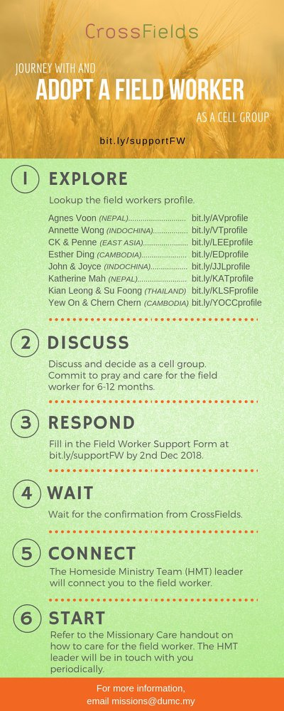

- CMS: Steps to Fill in the Salvation Form
- Select “More”
- “Form”
- Select “Form List” box
- Look for “Salvation Form”
- Fill in form of new salvation by “Change Respondent”
- Must have “E-mail” and “Mobile Phone”

UPCOMING

PREACHING SCHEDULE

14 & 15 Sep | Nation Series – Christian Citizenship  (Church and Nation Building/Constitution) | Prof Datuk Dr Denison Jayasooria
21 & 22 Sep | Studies in the Psalms: Our Ups and Downs in Life | Senior Pr Chris Kam

Go to: http://www.dumc.my/resources/sermons/ for the latest info.

EVENT HIGHLIGHTS

  - Join The Celebrations in DUMC@Puchong at 10am Every Sunday
Bring your friends and family members living around the Puchong area. Look for DUMC@Puchong on Waze or Google Maps. (Please park at IOI Business Park Level B2)

  - DUMC CHRISTMAS CHOIR AUDITIONS
Calling all singers! Sign up at dumc.my/Christmas2019

  - LET’S TALK ABOUT SEX
21 Sep | 1.30pm-4.30pm | Hall 1, DC
Open for parents to attend together with their children aged 10 to 12.
Sign up at bit.ly/DUMCLTAS19

  - PARENTAL GUIDANCE
22 Sep | 1.00pm-5.00pm | Hall 4, DC
A workshop to equip parents to address sexuality and relationship in a holistic & open way. Sign up at bit.ly/DUMCPG19

  - TALK@W2W (With Rachel Hickson)
7 Sep | 9:30am-11:30am | Hall 3
Topic: What Happens When Women Pray? (Specially for women) Come and be blessed
Info? Email w2w@dumc.my

  - MENALIVE HUDDLE
14 Sep | 8:30am-11:00am | Hall 3, DC
We are on the Stepping Up series. Next topic? 'Having a Vision for Your World’. Exclusively for
men. Info? Visit fb.com/MenAliveDUMC

  - CHURCH PRAYER ALTAR
Every Saturday | 7.00 -9.00am | Room 101 & 102
Let us come and seek the face of God. Prayer precedes everything.

  - WANT TO JOIN THE DUMC FAMILY?
Here are the steps:
> Join a Cell Group (You can get help at our CG Kiosk)
> Attend Basic Christianity 101
> Attend DUMC 101
> Join an Encounter Weekend
> Baptism & Membership Interview Sign up at the Info Counter or online at dumc.my/equip

  - TUESDAY ENCOUNTER NIGHT
17 Sep | 8.30pm-10.00pm | Auditorium, DC
24 Sep | 8.30pm-10.00pm | DUMC@Puchong
(3rd & 4th Tuesdays of every month)
Come together and be refreshed by His presence. Info? Contact forerunners@dumc.my

  - IMPACT
2020·YOU·ME·theNATIONS
DUMC is turning 40 in 2020! It’s time to look outwards — beyond the four walls of our church. Info? Visit the IMPACT info booth or go to bit.ly/IMPACTleaflet

  - NECF – MALAYSIA DAY PRAYER RALLY
- Sep | 6.00pm | Full Gospel Tabernacle, USJ
Info? Visit necf.org.my

  - MALAYSIA DAY PRAYER
16 Sep | 10.00am-1.00pm Grace Convention Centre, Tmn Mayang PJ (organized by CCM/PrayerUnited/ Archdiocese of KL)

EQUIP COURSES 2019

CHRISTIAN LEADERSHIP 201
Saturday | 14 & 21 Sep | 8.30am-1.00pm

CHRISTIAN LEADERSHIP 301
Saturdays | 21 & 28 Sep | 8.30am-1.00pm

EVANGELISM 101
Saturday | 7 Sep | 8.30am-1.00pm

SPIRITUAL WARFARE 201
Saturdays | 21 & 28 Sep | 8.30am-1.00pm

PRAYER 101 Sundays | 22 Sep-17 Nov | 8.00am-9.45am

SPIRITUAL RETREAT: RHYTHM OF GRACE
Thursday to Sunday | 31 Oct-3 Nov Register via: bit.ly/SROct2019

LIBRARY HOURS
Saturdays | 1.30pm-4.45pm
Sundays | 9.30am-1.30pm
Weekdays | CLOSED
Find out more about Equip courses at the Info Counter in Concourse 2, or online at http://dumc.my/equip

