CONTENTS

Worship
Word
Works
Upcoming:
Preaching Schedule
Event Highlights
Equip courses

WORSHIP (Praise and Prayer)

- Malaysia – Indigenous
Pray for the Orang Asli in Semanjung, the Orang Asal from Sabah and Sarawak:
- That the people will be independent and have the desire to be educated so that they will become self-reliant.
- That they be empowered to play a productive and leadership role in the affairs of the nation.
- For the indigenous church to be strong and courageous.

- Brazil
Pray for:
- Spiritual maturity throughout the rapidly-growing evangelical church.
- The Spirit of God to transform lives within sprawling urban slums. Pray for the hundreds of thousands of street children trapped in drug addiction, prostitution, and violence, and many suffer from AIDS.
- The indigenous Amerindians, who in 1500 A.D. numbered over 6 million but today number less than 250,000. These tribes' physical existence is threatened within the rain forest.
- Missionaries to be sent to areas and roughly 130 tribes unreached by the Gospel.

- China – Chinese youth cannot convert to Christianity until they are 18
It’s no secret that Chinese Christians have seen tightening restrictions and increased pressure against the Church. Some of these restrictions focus on young people and their interaction with the Church. It is reported that one of the rules that have always been in their law is that you cannot proselytise or you cannot convert somebody under the age of 18. Although the law already existed, it has now been more intensively enforced.
Pray for:
- Peace and wisdom for the Chinese Church and that God would touch the hearts of young people even if the local Church can’t reach out to them.
- That God will give wisdom to the Chinese Church with creative solutions to a very real problem.
- That Christian parents will teach, nurture and instruct their children in the Word of God and His ways.

- Missions – Choo Yew On & Chern Chern, Cambodia
Pray:
- Christian Dentists’ Fellowship – pray that the Christian dentists will be challenged and intentional in bearing witnesses.
- Mission Consultation – pray that God’s name will be glorified through this consultation as they go forth as one body to be His faithful witness among the East Asian peoples.

WORD (60 minutes)

Citizens & Nation Building
(Joshua 24:11, Acts 16:37, Ephesians 2:19, Philippians 3:20)
Professor Datuk Dr Denison Jayasooria

BIG IDEA: Being a good neighbour to all & a responsible citizen

- Read the scripture passage.
- Do a THREE-MINUTE SUMMARY of the sermon highlighting the KEY POINTS. Do not preach the whole sermon, as majority of your members would have heard the sermon already. Allocate more time for sharing in the cell through the application questions below.
- Sermon Resource at: http://www.dumc.my/resources/sermons/

Reflection & Application Questions:

1. What are some of your reflections on the biblical idea of being citizens?

2. What are the most pressing challenges being faced by citizens of Malaysia?

3. How can we overcome them?

4. What are the roles for Christians in nation building?

Note to Word facilitator:
As you are preparing for this session, this is a great time to pray that the Holy Spirit will guide you to use the questions efficaciously. You can select, modify or entirely create your own questions, according to the needs of your CG, especially if you feel that there are too many questions than required for the allocated time.

Note to Cell Groups that have children during meeting:
We recognise several cell groups in DUMC may have 5 or more children joining them during Cell Group meetings. We would like to get them engaged as well during the session therefore we are suggesting for CGs to use Manna Pad and assign someone in rotation to facilitate them after worship. Here is the link to the Manna Pad materials http://dumc.my/resources/downloads/

WORKS (Ministry and Bearing Witness)

Cell leaders to ask these two important questions or share with one another during Works session in every CG meeting.

    - Who have I met, praying for and sharing Christ with?
    - What is the Holy Spirit saying about the community I am in?

- Share Your Story (Your Story, His Glory)
- Whether your story is about how you came to know Christ, illness healed, an act of kindness in your times of need, or of how you served people or how people have served you, give glory to God. Share your story so that people will be encouraged and God's love is known.
- If there are any good testimonies, ask your members to write out their testimonies and submit to the church: http://dumc.my/connect/individual-care/share-your-story/

- Personal: Bible Reading and Journaling
- Subscribe to the Bible Reading Plan app: YouVersion – OwnIt365 New Testament (NT)+ Plan.
- Request one of your members to share a journal entry. Pair up members to share with, and pray for one another.

- Scripture Memory
Every cell meeting, do get your cell members to recite the following together:

Galatians 5:25 (Theme verse for 2019)
Since we live by the Spirit, let us keep in step with the Spirit.

Galatians 2:20 (added from March 2019)
I have been crucified with Christ and I no longer live, but Christ lives in me. The life I now live in the body, I live by faith in the Son of God, who loved me and gave himself for me.

- CrossFields
“Crossing into the harvest field with the message of the Cross”

Sarawak Iban | 13-16 Sep
Sarawak Penan | 30 Nov-6 Dec
Myanmar | 15-22 Nov
Cambodia | 24 Oct-1 Nov
Vietnam | 5-10 Dec

MCPP1 | 19 - 20 Oct | Empress Hotel (Sepang)

Website: dumc.my/missions
Mission Trip dates: bit.ly/CF2019cal

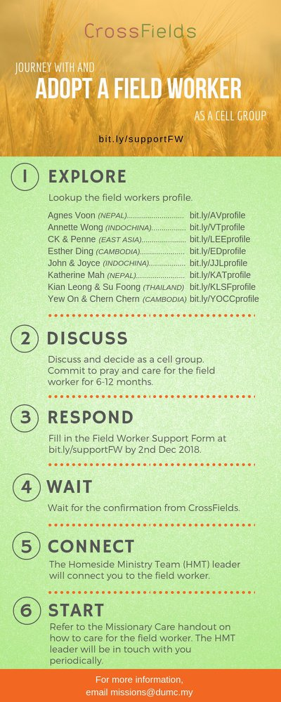

- CMS: Steps to Fill in the Salvation Form
- Select “More”
- “Form”
- Select “Form List” box
- Look for “Salvation Form”
- Fill in form of new salvation by “Change Respondent”
- Must have “E-mail” and “Mobile Phone”

UPCOMING

PREACHING SCHEDULE

21 & 22 Sep | Stepping Forward: God can use me | Senior Pr Chris Kam
28 & 29 Sep | Are you the One? | Jose Philips
5 & 6 Oct | Stepping Forward | Senior Pr Chris Kam
12 & 13 Oct | Studies in the Psalms: Our Ups and Downs in Life | Rev Philip Deas

Go to: http://www.dumc.my/resources/sermons/ for the latest info.

EVENT HIGHLIGHTS

  - Join The Celebrations in DUMC@Puchong at 10am Every Sunday
Bring your friends and family members living around the Puchong area. Look for DUMC@Puchong on Waze or Google Maps. (Please park at IOI Business Park Level B2)

  - DUMC CHRISTMAS CHOIR AUDITIONS
Calling all singers! Sign up at dumc.my/Christmas2019

  - LET’S TALK ABOUT SEX
21 Sep | 1.30pm-4.30pm | Hall 1, DC
Open for parents to attend together with their children aged 10 to 12.
Sign up at bit.ly/DUMCLTAS19

  - PARENTAL GUIDANCE
22 Sep | 1.00pm-5.00pm | Hall 4, DC
A workshop to equip parents to address sexuality and relationship in a holistic & open way. Sign up at bit.ly/DUMCPG19

  - CHURCH PRAYER ALTAR
Every Saturday | 7.00 -9.00am | Room 101 & 102
Let us come and seek the face of God. Prayer precedes everything.

  - WANT TO JOIN THE DUMC FAMILY?
Here are the steps:
> Join a Cell Group (You can get help at our CG Kiosk)
> Attend Basic Christianity 101
> Attend DUMC 101
> Join an Encounter Weekend
> Baptism & Membership Interview Sign up at the Info Counter or online at dumc.my/equip

  - TUESDAY ENCOUNTER NIGHT
24 Sep | 8.30pm-10.00pm | DUMC@Puchong
(4th Tuesdays of every month)
Come together and be refreshed by His presence. Info? Contact forerunners@dumc.my

  - IMPACT
2020·YOU·ME·theNATIONS
DUMC is turning 40 in 2020! It’s time to look outwards — beyond the four walls of our church. Info? Visit the IMPACT info booth or go to bit.ly/IMPACTleaflet

EQUIP COURSES 2019

DUMC 101 (Note: Membership Requirement)
Saturday | 12 Oct | 8.30am-1.00pm

CHRISTIAN LEADERSHIP 301
Saturdays | 21 & 28 Sep | 8.30am-1.00pm

EVANGELISM 101
Saturday | 7 Sep | 8.30am-1.00pm

SPIRITUAL WARFARE 201
Saturdays | 21 & 28 Sep | 8.30am-1.00pm

PRAYER 101 Sundays | 22 Sep-17 Nov | 8.00am-9.45am

SPIRITUAL RETREAT: RHYTHM OF GRACE
Thursday to Sunday | 31 Oct-3 Nov Register via: bit.ly/SROct2019

MINISTRY 202
Saturdays | 12 & 19 Oct | 8.30am-1.00pm

LIBRARY HOURS
Saturdays | 1.30pm-4.45pm
Sundays | 9.30am-1.30pm
Weekdays | CLOSED
Find out more about Equip courses at the Info Counter in Concourse 2, or online at http://dumc.my/equip

