CONTENTS

Worship
Word
Works
Upcoming:
Preaching Schedule
Event Highlights
Equip courses

WORSHIP (Praise and Prayer)

- Malaysia – Indigenous (III)
Pray for the Orang Asli in West Malaysia, the Orang Asal from Sabah and:
- That they will be independent and have the desire to be educated so that they will become self-reliant.
- That they will be empowered to play a productive and leadership role in the affairs of the nation.
- For a strong and courageous indigenous church.

- Cambodia
Pchum Ben is a 15-day Cambodian religious festival. In preparation for the big festival and public holidays (27-29 Sep), people travel back to their hometowns to celebrate with their families. Pchum Ben is dedicated to the spirits of the dead. When the spirits of the ancestors of Cambodian buddhists return to wander the earth, the living must ease their suffering by offering hungry ghosts some food to eat. According to Khmer belief, people who do not follow the practices of Pchum Ben will be cursed by angry ancestors.
Pray for:
- That the Khmer Christians will be strong in their faith and bear good witness as they visit their families;
- For God’s protection for the redeemed.

- IMPACT2020
Pray for:
- Volunteers: For more trainers, facilitators and administrative support; for their commitment and passion.
- Task Force: For God’s wisdom and strength as they plan and execute IMPACT2020.
- Cell Leaders: To catch God’s vision and be active in encouraging and mobilising their cell members to participate in IMPACT2020.
- Church members: To catch God’s vision and respond to His calling to be a blessing to the nations - here and abroad.
- The Field: For God’s direction and leading to locations and communities He desires us to go and partner the Holy Spirit in God’s redemptive work.

WORD (60 minutes)

Stepping Forward – God Can Use Me
(Judges 6:11-18)
Pr Chris Kam

BIG IDEA: Who? Me? (The Most Unlikely)

- Read the scripture passage.
- Do a THREE-MINUTE SUMMARY of the sermon highlighting the KEY POINTS. Do not preach the whole sermon, as majority of your members would have heard the sermon already. Allocate more time for sharing in the cell through the application questions below.
- Sermon Resource at: http://www.dumc.my/resources/sermons/

Reflection & Application Questions:

- In what ways have you been disappointed with God or with people? How did that affect you? Have you dealt with it? How has that affected the way you live?

- How does this phrase affect you: “I am not good enough”? Do you identify with Gideon’s reply in Judges 6:15?

- Has God ever called you to do something and you have never risen up to it? Why? Conversely, if you have heeded a call of God and risen up to something that
you think could never have been done by you, but today you are pleasantly surprised by the results, what are some of these testimonies that you can encourage your
group with?

- In the call to IMPACT 2020, are you able to heed the call of these 3 statements? Share your thoughts on them.

As a CG, you may wish to discuss potential projects.
- Think of something you have never tried.
- Do something you have never done.
- Go somewhere you have never been.

Note to Word facilitator:
As you are preparing for this session, this is a great time to pray that the Holy Spirit will guide you to use the questions efficaciously. You can select, modify or entirely create your own questions, according to the needs of your CG, especially if you feel that there are too many questions than required for the allocated time.

Note to Cell Groups that have children during meeting:
We recognise several cell groups in DUMC may have 5 or more children joining them during Cell Group meetings. We would like to get them engaged as well during the session therefore we are suggesting for CGs to use Manna Pad and assign someone in rotation to facilitate them after worship. Here is the link to the Manna Pad materials http://dumc.my/resources/downloads/

WORKS (Ministry and Bearing Witness)

Cell leaders to ask these two important questions or share with one another during Works session in every CG meeting.

    - Who have I met, praying for and sharing Christ with?
    - What is the Holy Spirit saying about the community I am in?

- Share Your Story (Your Story, His Glory)
- Whether your story is about how you came to know Christ, illness healed, an act of kindness in your times of need, or of how you served people or how people have served you, give glory to God. Share your story so that people will be encouraged and God's love is known.
- If there are any good testimonies, ask your members to write out their testimonies and submit to the church: http://dumc.my/connect/individual-care/share-your-story/

- Personal: Bible Reading and Journaling
- Subscribe to the Bible Reading Plan app: YouVersion – OwnIt365 New Testament (NT)+ Plan.
- Request one of your members to share a journal entry. Pair up members to share with, and pray for one another.

- Scripture Memory
Every cell meeting, do get your cell members to recite the following together:

Galatians 5:25 (Theme verse for 2019)
Since we live by the Spirit, let us keep in step with the Spirit.

Galatians 2:20 (added from March 2019)
I have been crucified with Christ and I no longer live, but Christ lives in me. The life I now live in the body, I live by faith in the Son of God, who loved me and gave himself for me.

- CrossFields
“Crossing into the harvest field with the message of the Cross”

Sarawak Iban | 13-16 Sep
Sarawak Penan | 30 Nov-6 Dec
Myanmar | 15-22 Nov
Cambodia | 24 Oct-1 Nov
Vietnam | 5-10 Dec

MCPP1 | 19 - 20 Oct | Empress Hotel (Sepang)

Website: dumc.my/missions
Mission Trip dates: bit.ly/CF2019cal

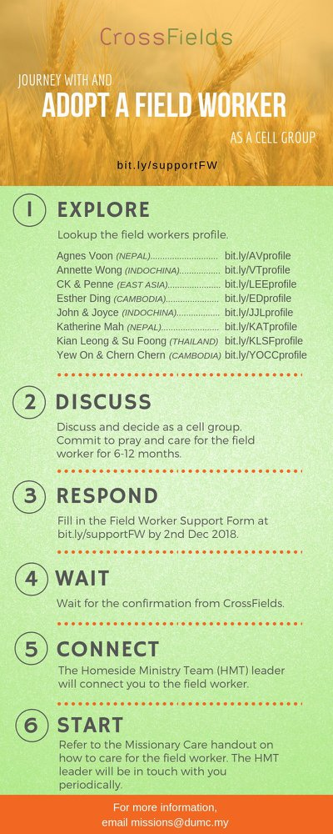

- CMS: Steps to Fill in the Salvation Form
- Select “More”
- “Form”
- Select “Form List” box
- Look for “Salvation Form”
- Fill in form of new salvation by “Change Respondent”
- Must have “E-mail” and “Mobile Phone”

UPCOMING

PREACHING SCHEDULE

28 & 29 Sep | Are you the One? | Jose Philips
5 & 6 Oct | Stepping Forward | Senior Pr Chris Kam
12 & 13 Oct | Studies in the Psalms: Our Ups and Downs in Life | Rev Philip Deas

Go to: http://www.dumc.my/resources/sermons/ for the latest info.

EVENT HIGHLIGHTS

  - Join The Celebrations in DUMC@Puchong at 10am Every Sunday
Bring your friends and family members living around the Puchong area. Look for DUMC@Puchong on Waze or Google Maps. (Please park at IOI Business Park Level B2)

  - DUMC CHRISTMAS CHOIR AUDITIONS
Calling all singers! Sign up at dumc.my/Christmas2019

  - AFTER7
5 Oct | 7.00pm-10.00pm | DC (1st Saturday of every month)
Food, fun, friendship made alive here again! See you then!
Info? Follow our Instagram, after7.my

  - W2W ENCOUNTER
22-24 Nov | Grand Kampar Hotel A weekend getaway specially for women. Early bird registration opens next week.
Register at bit.ly/ew-nov19 or Info Counter!

  - CHURCH PRAYER ALTAR
Every Saturday | 7.00 -9.00am | Room 101 & 102
Let us come and seek the face of God. Prayer precedes everything.

  - WANT TO JOIN THE DUMC FAMILY?
Here are the steps:
> Join a Cell Group (You can get help at our CG Kiosk)
> Attend Basic Christianity 101
> Attend DUMC 101
> Join an Encounter Weekend
> Baptism & Membership Interview Sign up at the Info Counter or online at dumc.my/equip

  - IMPACT
2020·YOU·ME·theNATIONS
DUMC is turning 40 in 2020! It’s time to look outwards — beyond the four walls of our church. Info? Visit the IMPACT info booth or go to bit.ly/IMPACTleaflet

EQUIP COURSES 2019

DUMC 101 (Note: Membership Requirement)
Saturday | 12 Oct | 8.30am-1.00pm

PRAYER 101
Sundays | 22 Sep-17 Nov | 8.00am-9.45am

BASIC CHRISTIANITY 101 (Note: Membership Requirement)
Saturdays | 28 Sep & 5 Oct | 8.30am-1.00pm

SPIRITUAL RETREAT: RHYTHM OF GRACE
Thursday to Sunday | 31 Oct-3 Nov Register via: bit.ly/SROct2019

MINISTRY 202
Saturdays | 12 & 19 Oct | 8.30am-1.00pm

LIBRARY HOURS
Saturdays | 1.30pm-4.45pm
Sundays | 9.30am-1.30pm
Weekdays | CLOSED
Find out more about Equip courses at the Info Counter in Concourse 2, or online at http://dumc.my/equip

