CONTENTS

Worship
Word
Works
Upcoming:
Preaching Schedule
Event Highlights
Equip courses

WORSHIP (Praise and Prayer)

- Malaysia – Education
Pray for:
- Revamping of our school curricula to raise education standards to international levels to fill the country’s future needs.
- Our education system to be based on world-class values and standards, and to be effective in preparing the next generation to be ethical, wise, productive, caring and united to take the nation forward.
- Provision for the retraining of staff where it is needed.

- Displaced Iraqi Youth in Jordan
Tent Schools International (TSI) is raising funds for a secondary school for displaced Iraqi youth in Jordan. TSI is partnering with the Good Shepherd Center to serve 117 Iraqi refugee kids whose families fled their homes due to ISIS activity. The traumatic experiences these kids experienced will reap destructive consequences - they are at higher risk of destructive habits such as suicide and depression. They are also more easily lured into a life of extremism. Since many of these kids are without refugee status, they are often unable to attend public schools in Jordan. Furthermore, these kids and their families face cruel biases in their country of refuge. (Source: Mission Network News)
Pray:
- For the Iraqi kids’ guidance and for their parents who are displaced in Jordan with them. Pray these kids will know they are deeply cared for and loved. Pray they know God loves them and values them in every possible way.
- That Iraqi youth in Jordan will have opportunity for secondary school education; which is vital for breaking extremism cycle. Pray for setting up of secondary schools and availability of staff and volunteers to deal with the special challenges of children who have experienced trauma.
- These Iraqi youth will be able to attend college and potentially gain both work and life skills to help them build a healthy, productive life.

WORD (60 minutes)

Are you the One?
(Luke 7:18-20)
Jose Philip

BIG IDEA: He is the One!

- Read the scripture passage.
- Do a THREE-MINUTE SUMMARY of the sermon highlighting the KEY POINTS. Do not preach the whole sermon, as majority of your members would have heard the sermon already. Allocate more time for sharing in the cell through the application questions below.
- Sermon Resource at: http://www.dumc.my/resources/sermons/

Reflection & Application Questions:

- We trust in Jesus not for what He could do for us but who He is to us. What do you understand about this statement and how does this change your perspective as a Christian?

- Jesus modelled to us His patience and willingness to forgive. Jose shared that In Luke 7:39, if we can’t offer forgiveness then all we could offer is ridicule. Share a situation where you find it challenging to offer forgiveness. How would verse 47 help you in this regard?

- Is Jesus the One in whom you found your life? Jesus has called us to talk to Him about our lives. Do you still doubt that God has forgiven you? Get into a groups of 3 to share a need and pray for one another.

Note to Word facilitator:
As you are preparing for this session, this is a great time to pray that the Holy Spirit will guide you to use the questions efficaciously. You can select, modify or entirely create your own questions, according to the needs of your CG, especially if you feel that there are too many questions than required for the allocated time.

Note to Cell Groups that have children during meeting:
We recognise several cell groups in DUMC may have 5 or more children joining them during Cell Group meetings. We would like to get them engaged as well during the session therefore we are suggesting for CGs to use Manna Pad and assign someone in rotation to facilitate them after worship. Here is the link to the Manna Pad materials http://dumc.my/resources/downloads/

WORKS (Ministry and Bearing Witness)

Cell leaders to ask these two important questions or share with one another during Works session in every CG meeting.

    - Who have I met, praying for and sharing Christ with?
    - What is the Holy Spirit saying about the community I am in?

- Share Your Story (Your Story, His Glory)
- Whether your story is about how you came to know Christ, illness healed, an act of kindness in your times of need, or of how you served people or how people have served you, give glory to God. Share your story so that people will be encouraged and God's love is known.
- If there are any good testimonies, ask your members to write out their testimonies and submit to the church: http://dumc.my/connect/individual-care/share-your-story/

- Personal: Bible Reading and Journaling
- Subscribe to the Bible Reading Plan app: YouVersion – OwnIt365 New Testament (NT)+ Plan.
- Request one of your members to share a journal entry. Pair up members to share with, and pray for one another.

- Scripture Memory
Every cell meeting, do get your cell members to recite the following together:

Galatians 5:25 (Theme verse for 2019)
Since we live by the Spirit, let us keep in step with the Spirit.

Galatians 2:20 (added from March 2019)
I have been crucified with Christ and I no longer live, but Christ lives in me. The life I now live in the body, I live by faith in the Son of God, who loved me and gave himself for me.

- CrossFields
Crossing into the harvest field with the message of the Cross.

Sarawak Penan | 30 Nov-6 Dec
Sarawak Iban | 11-18 Dec
Myanmar | 4-11 Nov
Cambodia | 14-22 Nov
Vietnam | 5 - 10 Dec
Nepal | 5-15 Dec

MCPP1 | 19 - 20 Oct | Empress Hotel (Sepang)

Website: dumc.my/missions
Mission trip dates: bit.ly/CF2019cal

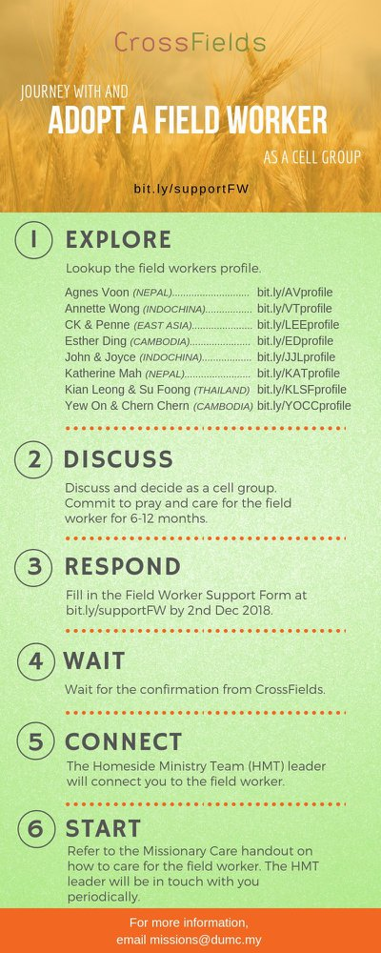

- CMS: Steps to Fill in the Salvation Form
- Select “More”
- “Form”
- Select “Form List” box
- Look for “Salvation Form”
- Fill in form of new salvation by “Change Respondent”
- Must have “E-mail” and “Mobile Phone”

UPCOMING

PREACHING SCHEDULE

5 & 6 Oct | Stepping Forward: God Will Send Me | Senior Pr Chris Kam
12 & 13 Oct | Studies in the Psalms: Storms, Shipwrecks & Snakebites | Rev Philip Deas
19 & 20 Oct | Stepping Forward | Pr Dr Daniel Ho
26 & 27 Oct | Stepping Forward | Pr Chris M

Go to: http://www.dumc.my/resources/sermons/ for the latest info.

EVENT HIGHLIGHTS

  - Join The Celebrations in DUMC@Puchong at 10am Every Sunday
Bring your friends and family members living around the Puchong area. Look for DUMC@Puchong on Waze or Google Maps. (Please park at IOI Business Park Level B2)

  - DUMC CHRISTMAS CHOIR AUDITIONS
Calling all singers! Sign up at dumc.my/Christmas2019

  - AFTER7
5 Oct | 7.00pm-10.00pm | DC (1st Saturday of every month)
Food, fun, friendship made alive here again! See you then!
Info? Follow our Instagram, after7.my

  - W2W ENCOUNTER
22-24 Nov | Grand Kampar Hotel A weekend getaway specially for women. Early bird registration opens next week.
Register at bit.ly/ew-nov19 or Info Counter!

  - CHURCH PRAYER ALTAR
Every Saturday | 7.00 -9.00am | Room 101 & 102
Let us come and seek the face of God. Prayer precedes everything.

  - WANT TO JOIN THE DUMC FAMILY?
Here are the steps:
> Join a Cell Group (You can get help at our CG Kiosk)
> Attend Basic Christianity 101
> Attend DUMC 101
> Join an Encounter Weekend
> Baptism & Membership Interview Sign up at the Info Counter or online at dumc.my/equip

  - IMPACT
2020·YOU·ME·theNATIONS
DUMC is turning 40 in 2020! It’s time to look outwards — beyond the four walls of our church. Info? Visit the IMPACT info booth or go to bit.ly/IMPACTleaflet
  - TUESDAY ENCOUNTER NIGHT (3rd & 4th Tuesdays of every month)
15 Oct | 8.30pm-10.00pm | Hall 3, DC
22 Oct | 8.30pm-10.00pm | DUMC@Puchong
Come together and be refreshed by His presence.
Info? Contact forerunners@dumc.my

  - CROSSFIELDS PRAYER MEETING
5 Oct | 9.00am-11.00am | Room 103, DC
Let’s come and pray for the nations. Breakfast starts at 8.15 am. Info? Contact Eunice at 03-79587388

EQUIP COURSES 2019

DUMC 101 (Note: Membership Requirement)
Saturday | 12 Oct | 8.30am-1.00pm

PRAYER 101
Sundays | 22 Sep-17 Nov | 8.00am-9.45am

SPIRITUAL RETREAT: RHYTHM OF GRACE
Thursday to Sunday | 31 Oct-3 Nov Register via: bit.ly/SROct2019

MINISTRY 202
Saturdays | 12 & 19 Oct | 8.30am-1.00pm

BMEW (Note: Membership Requirement)
Weekend Away | 19-20 Oct | Empress Hotel

BIBLE 101
Saturdays | 16 & 23 Nov | 8.30am-1.00pm

LIBRARY HOURS
Saturdays | 1.30pm-4.45pm
Sundays | 9.30am-1.30pm
Weekdays | CLOSED
Find out more about Equip courses at the Info Counter in Concourse 2, or online at http://dumc.my/equip

