CONTENTS

Worship
Word
Works
Upcoming:
Preaching Schedule
Event Highlights
Equip courses

WORSHIP (Praise and Prayer)

- Malaysia – Education
Pray for:
- Nation - That God will keep our nation safe from those who would provoke racial and religious strife.
- Parliament
  - Good, just and righteous laws to be implemented.
  - Parliamentarians to work with wisdom, integrity and patience despite the long hours of perusing bills and debates, and make godly and informed decisions when facing complex issues.
- Church - That God will give us, His people, discernment to:
  - know the times we are living in
  - know what the Spirit is doing in our land
  - pray according to the purposes of God

- Missions – Choo Yew On & Chern Chern, Cambodia
Pray:
      - Field Council retreat and meetings (15-17 Oct) – Pray for good team building as there are 2 new council members; God’s wisdom to make right decisions for their agency in Cambodia.
      - Missions Annual Conference, Malaysia (18-20 Oct) – That the Lord will speak to the participants and challenge them to be involved in missions; for CC sharing her testimony and facilitating a workshop. ·
      - Spirit’s anointing and authority on YO as he brings a word in season at the Siem Reap Christian Fellowship.

WORD (60 minutes)

Storms, Shipwrecks and Snakebites
(Acts 27:18-26)
Rev. Phillip Deas, Northpoint Community Church

BIG IDEA: Just because you are moving in the right direction,
it doesn’t mean you won’t run into opposition!

- Read the scripture passage.
- Do a THREE-MINUTE SUMMARY of the sermon highlighting the KEY POINTS. Do not preach the whole sermon, as majority of your members would have heard the sermon already. Allocate more time for sharing in the cell through the application questions below.
- Sermon Resource at: http://www.dumc.my/resources/sermons/

Reflection & Application Questions:

- What is the Holy Spirit saying to you in this sermon? Did you respond to the challenge at the end? What were you responding to?
- Have you, like Paul, been in or are you currently in a storm, a shipwrecked or a snakebite situation?
- How would you now respond to IMPACT2020? As a CG, please discuss any possible project you can do together.

Note to Word facilitator:
As you are preparing for this session, this is a great time to pray that the Holy Spirit will guide you to use the questions efficaciously. You can select, modify or entirely create your own questions, according to the needs of your CG, especially if you feel that there are too many questions than required for the allocated time.

Note to Cell Groups that have children during meeting:
We recognise several cell groups in DUMC may have 5 or more children joining them during Cell Group meetings. We would like to get them engaged as well during the session therefore we are suggesting for CGs to use Manna Pad and assign someone in rotation to facilitate them after worship. Here is the link to the Manna Pad materials http://dumc.my/resources/downloads/

WORKS (Ministry and Bearing Witness)

Cell leaders to ask these two important questions or share with one another during Works session in every CG meeting.

    - Who have I met, praying for and sharing Christ with?
    - What is the Holy Spirit saying about the community I am in?

- Share Your Story (Your Story, His Glory)
- Whether your story is about how you came to know Christ, illness healed, an act of kindness in your times of need, or of how you served people or how people have served you, give glory to God. Share your story so that people will be encouraged and God's love is known.
- If there are any good testimonies, ask your members to write out their testimonies and submit to the church: http://dumc.my/connect/individual-care/share-your-story/

- Personal: Bible Reading and Journaling
- Subscribe to the Bible Reading Plan app: YouVersion – OwnIt365 New Testament (NT)+ Plan.
- Request one of your members to share a journal entry. Pair up members to share with, and pray for one another.

- Scripture Memory
Every cell meeting, do get your cell members to recite the following together:

Galatians 5:25 (Theme verse for 2019)
Since we live by the Spirit, let us keep in step with the Spirit.

Galatians 2:20 (added from March 2019)
I have been crucified with Christ and I no longer live, but Christ lives in me. The life I now live in the body, I live by faith in the Son of God, who loved me and gave himself for me.

- CrossFields
Crossing into the harvest field with the message of the Cross.

Sarawak Penan | 30 Nov-6 Dec
Sarawak Iban | 11-18 Dec
Myanmar | 4-11 Nov
Cambodia | 14-22 Nov
Vietnam | 5 - 10 Dec
Nepal | 5-15 Dec

MCPP1 | 19 - 20 Oct | Empress Hotel (Sepang)

Website: dumc.my/missions
Mission trip dates: bit.ly/CF2019cal

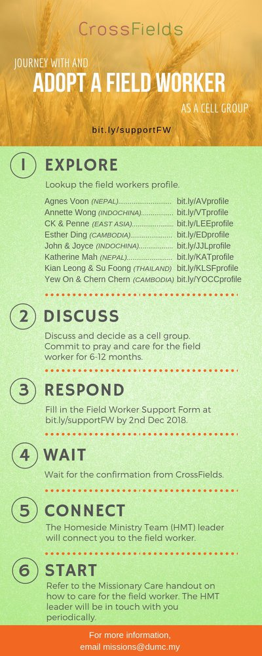

- CMS: Steps to Fill in the Salvation Form
- Select “More”
- “Form”
- Select “Form List” box
- Look for “Salvation Form”
- Fill in form of new salvation by “Change Respondent”
- Must have “E-mail” and “Mobile Phone”

UPCOMING

PREACHING SCHEDULE

19 & 20 Oct | Stepping Forward | Pr Dr Daniel Ho
26 & 27 Oct | Stepping Forward | Pr Chris M
2 & 3 Nov | Mission Heart of God 1 | Pr Kelvin Yong
9 & 10 Nov | Mission Heart of God 2 | Ross Winchester

Go to: http://www.dumc.my/resources/sermons/ for the latest info.
EVENT HIGHLIGHTS

  - Join The Celebrations in DUMC@Puchong at 10am Every Sunday
Bring your friends and family members living around the Puchong area. Look for DUMC@Puchong on Waze or Google Maps. (Please park at IOI Business Park Level B2)

  - CHRISTMAS CAROLLING
“Sing to the Lord, for he has done glorious things; let this be known to all the world.” Isaiah 12:5. In this Christmas season, share the truth of God's grace through the beautiful tunes of Christmas carols. Therefore, come join us for this year's Christmas Carolling! We are recruiting everyone who is interested or loves to carol.
Sign up at bit.ly/carolling2019dumc by November 3rd.

  - W2W ENCOUNTER
22-24 Nov | Grand Kampar Hotel A weekend getaway specially for women. Early bird registration opens next week.
Register at bit.ly/ew-nov19 or Info Counter!

  - CHURCH PRAYER ALTAR
Every Saturday | 7.00 -9.00am | Room 101 & 102
Let us come and seek the face of God. Prayer precedes everything.

  - WANT TO JOIN THE DUMC FAMILY?
Here are the steps:
> Join a Cell Group (You can get help at our CG Kiosk)
> Attend Basic Christianity 101
> Attend DUMC 101
> Join an Encounter Weekend
> Baptism & Membership Interview Sign up at the Info Counter or online at dumc.my/equip

  - IMPACT
2020·YOU·ME·theNATIONS
DUMC is turning 40 in 2020! It’s time to look outwards — beyond the four walls of our church. Info? Visit the IMPACT info booth or go to bit.ly/IMPACTleaflet

  - TUESDAY ENCOUNTER NIGHT (3rd & 4th Tuesdays of every month)
15 Oct | 8.30pm-10.00pm | Hall 3, DC
22 Oct | 8.30pm-10.00pm | DUMC@Puchong
Come together and be refreshed by His presence.
Info? Contact forerunners@dumc.my

EQUIP COURSES 2019

PRAYER 101
Sundays | 22 Sep-17 Nov | 8.00am-9.45am

SPIRITUAL RETREAT: RHYTHM OF GRACE
Thursday to Sunday | 31 Oct-3 Nov Register via: bit.ly/SROct2019

BMEW (Note: Membership Requirement)
Weekend Away | 19-20 Oct | Empress Hotel

BIBLE 101
Saturdays | 16 & 23 Nov | 8.30am-1.00pm

LIBRARY HOURS
Saturdays | 1.30pm-4.45pm
Sundays | 9.30am-1.30pm
Weekdays | CLOSED
Find out more about Equip courses at the Info Counter in Concourse 2, or online at http://dumc.my/equip

