CONTENTS

Worship
Word
Works
Upcoming:
Preaching Schedule
Event Highlights
Equip courses

WORSHIP (Praise and Prayer)

- Malaysia – Education
Pray for:
- The protection of children – including the stateless and refugees – through improved laws, policies and practices in order that they can grow in a safe, secure, and loving environment.
- Children with special needs, that they be loved and cared for.
- God will provide these children with opportunities and access to good education.

- Missions – Choo Yew On & Chern Chern, Cambodia
Pray:
- For God’s will to be done regarding the renewal of MoU with the University of Health Sciences; For it appears the doors are closing.
- For God’s guidance as they explore opportunities to continue serving in another government dental institution where aid is much needed.
- That their son’s peers would be willing to contribute in group assignments and for their lecturers to be compelled to provide guidance in their coursework.
- For two male varsity students (young believers) being discipled by Yew On, that they will grow in their understanding of their identity in Christ Jesus.

WORD (60 minutes)

God Will Send Me
(Genesis 12:1-5; Galatians 3:8, 9; John 6:5-13)
Chris Kam, Senior Pastor

BIG IDEA: Step Out of Your Comfort Zone!

- Read the scripture passage.
- Do a THREE-MINUTE SUMMARY of the sermon highlighting the KEY POINTS. Do not preach the whole sermon, as majority of your members would have heard the sermon already. Allocate more time for sharing in the cell through the application questions below.
- Sermon Resource at: http://www.dumc.my/resources/sermons/

Reflection & Application Questions:

    - What is the Holy Spirit saying to you in this sermon? Did you respond to the challenge at the end? What were you responding to?
    - What is it about the life of Abram in Gen 12 that spoke to you, in “Hear, Obey and Go?”
    - What were your thoughts when you first heard about IMPACT2020? How did you feel? For those who have attended an IMPACT2020 orientation training, what was your experience like? The CG can discuss any possible project they can do together.
    - Do you like changes in your life, meaning are you a person who is willing to step out of your comfort zone and try new things? Why or why not? What new things have you tried in the last 5 years?
    - What about your spiritual life? Are you at a plateau or is God seemingly stirring you to make a change to step out of your comfort zone?
    - What is your passion in life, be it a target group of a community or a cause? Have you done anything about it? Share with the CG your dreams. Pray for one another.

Note to Word facilitator:
As you are preparing for this session, this is a great time to pray that the Holy Spirit will guide you to use the questions efficaciously. You can select, modify or entirely create your own questions, according to the needs of your CG, especially if you feel that there are too many questions than required for the allocated time.

Note to Cell Groups that have children during meeting:
We recognise several cell groups in DUMC may have 5 or more children joining them during Cell Group meetings. We would like to get them engaged as well during the session therefore we are suggesting for CGs to use Manna Pad and assign someone in rotation to facilitate them after worship. Here is the link to the Manna Pad materials http://dumc.my/resources/downloads/

WORKS (Ministry and Bearing Witness)

Cell leaders to ask these two important questions or share with one another during Works session in every CG meeting.

    - Who have I met, praying for and sharing Christ with?
    - What is the Holy Spirit saying about the community I am in?

- Share Your Story (Your Story, His Glory)
- Whether your story is about how you came to know Christ, illness healed, an act of kindness in your times of need, or of how you served people or how people have served you, give glory to God. Share your story so that people will be encouraged and God's love is known.
- If there are any good testimonies, ask your members to write out their testimonies and submit to the church: http://dumc.my/connect/individual-care/share-your-story/

- Personal: Bible Reading and Journaling
- Subscribe to the Bible Reading Plan app: YouVersion – OwnIt365 New Testament (NT)+ Plan.
- Request one of your members to share a journal entry. Pair up members to share with, and pray for one another.

- Scripture Memory
Every cell meeting, do get your cell members to recite the following together:

Galatians 5:25 (Theme verse for 2019)
Since we live by the Spirit, let us keep in step with the Spirit.

Galatians 2:20 (added from March 2019)
I have been crucified with Christ and I no longer live, but Christ lives in me. The life I now live in the body, I live by faith in the Son of God, who loved me and gave himself for me.

- CrossFields
Crossing into the harvest field with the message of the Cross.

Sarawak Penan | 30 Nov-6 Dec
Sarawak Iban | 11-18 Dec
Myanmar | 4-11 Nov
Cambodia | 14-22 Nov
Vietnam | 5 - 10 Dec
Nepal | 5-15 Dec

MCPP1 | 19 - 20 Oct | Empress Hotel (Sepang)

Website: dumc.my/missions
Mission trip dates: bit.ly/CF2019cal

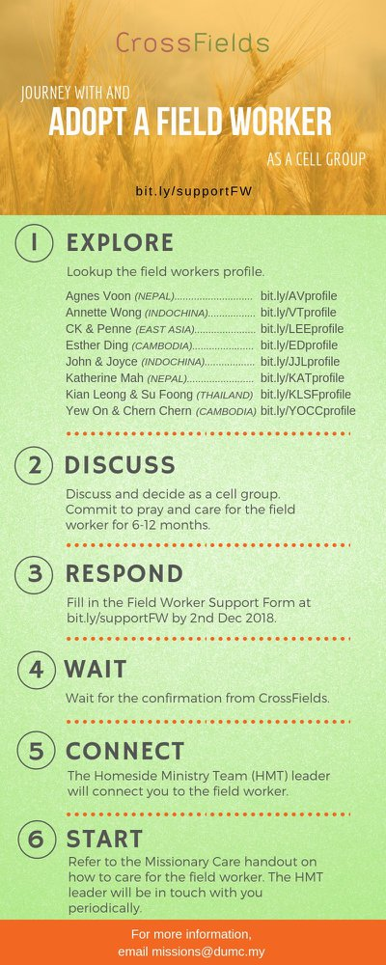

- CMS: Steps to Fill in the Salvation Form
- Select “More”
- “Form”
- Select “Form List” box
- Look for “Salvation Form”
- Fill in form of new salvation by “Change Respondent”
- Must have “E-mail” and “Mobile Phone”

UPCOMING

PREACHING SCHEDULE

12 & 13 Oct | Studies in the Psalms: Storms, Shipwrecks & Snakebites | Rev Philip Deas
19 & 20 Oct | Stepping Forward | Pr Dr Daniel Ho
26 & 27 Oct | Stepping Forward | Pr Chris M
2 & 3 Nov | Mission Heart of God 1 | Pr Kelvin Yong

Go to: http://www.dumc.my/resources/sermons/ for the latest info.

EVENT HIGHLIGHTS

  - Join The Celebrations in DUMC@Puchong at 10am Every Sunday
Bring your friends and family members living around the Puchong area. Look for DUMC@Puchong on Waze or Google Maps. (Please park at IOI Business Park Level B2)

  - DUMC CHRISTMAS CHOIR AUDITIONS
Calling all singers! Sign up at dumc.my/Christmas2019

  - W2W ENCOUNTER
22-24 Nov | Grand Kampar Hotel A weekend getaway specially for women. Early bird registration opens next week.
Register at bit.ly/ew-nov19 or Info Counter!

  - CHURCH PRAYER ALTAR
Every Saturday | 7.00 -9.00am | Room 101 & 102
Let us come and seek the face of God. Prayer precedes everything.

  - WANT TO JOIN THE DUMC FAMILY?
Here are the steps:
> Join a Cell Group (You can get help at our CG Kiosk)
> Attend Basic Christianity 101
> Attend DUMC 101
> Join an Encounter Weekend
> Baptism & Membership Interview Sign up at the Info Counter or online at dumc.my/equip

  - IMPACT
2020·YOU·ME·theNATIONS
DUMC is turning 40 in 2020! It’s time to look outwards — beyond the four walls of our church. Info? Visit the IMPACT info booth or go to bit.ly/IMPACTleaflet

  - TUESDAY ENCOUNTER NIGHT (3rd & 4th Tuesdays of every month)
15 Oct | 8.30pm-10.00pm | Hall 3, DC
22 Oct | 8.30pm-10.00pm | DUMC@Puchong
Come together and be refreshed by His presence.
Info? Contact forerunners@dumc.my

EQUIP COURSES 2019

DUMC 101 (Note: Membership Requirement)
Saturday | 12 Oct | 8.30am-1.00pm

PRAYER 101
Sundays | 22 Sep-17 Nov | 8.00am-9.45am

SPIRITUAL RETREAT: RHYTHM OF GRACE
Thursday to Sunday | 31 Oct-3 Nov Register via: bit.ly/SROct2019

MINISTRY 202
Saturdays | 12 & 19 Oct | 8.30am-1.00pm

BMEW (Note: Membership Requirement)
Weekend Away | 19-20 Oct | Empress Hotel

BIBLE 101
Saturdays | 16 & 23 Nov | 8.30am-1.00pm

LIBRARY HOURS
Saturdays | 1.30pm-4.45pm
Sundays | 9.30am-1.30pm
Weekdays | CLOSED
Find out more about Equip courses at the Info Counter in Concourse 2, or online at http://dumc.my/equip

